Supplementary Information

Supplement 1

Self-reported Line Infections

Number of line infections self-reported by participants

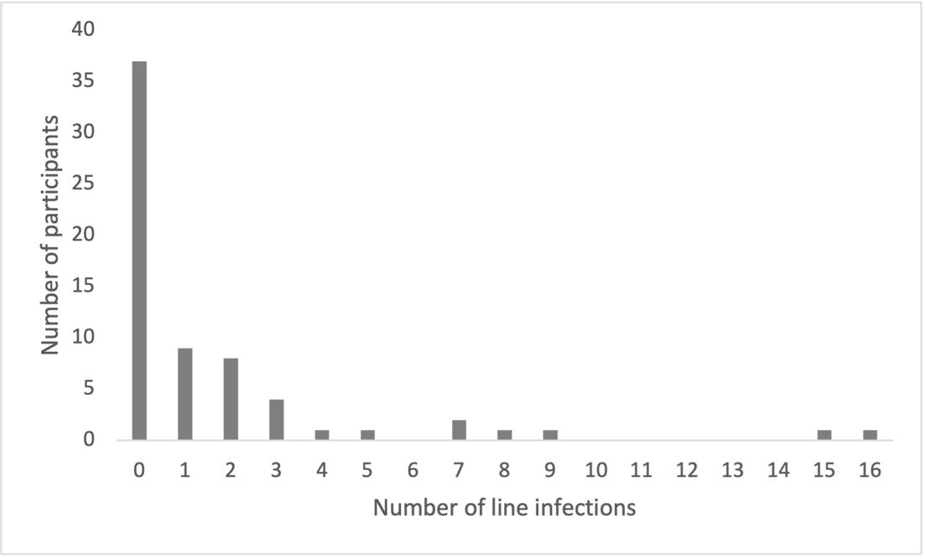

Supplement 2

Scree Plot

Scree Plot for determination of how many factors to retain in Principal Components Analysis

Supplement 3

Principal Component Analysis Correlation and Component Matrices

Principal Component Analysis Correlation Matrixª for the Line Care Routines Questionnaire
 | Q1 | Q2 | Q3 | Q4 | Q5 | Q6 | Q7 | Q8 | Q8 | Q10 | Q11 | Q12
Q2 | 0.537 | -
Q3 | -0.081 | -0.048 | -
Q4 | 0.315 | 0.141 | -0.086 | -
Q5 | 0.316 | -0.039 | -0.028 | 0.457 | -
Q6 | -0.147 | -0.125 | -0.019 | -0.067 | 0.052 | -
Q7 | 0.267 | 0.284 | -0.07 | 0.206 | 0.239 | -0.299 | -
Q8 | 0.479 | 0.462 | -0.071 | 0.5 | 0.338 | -0.2 | 0.336 | -
Q9 | 0.528 | 0.382 | 0.028 | 0.465 | 0.373 | -0.12 | 0.226 | 0.712 | -
Q10 | 0.111 | 0.099 | 0.02 | 0.035 | 0.057 | -0.177 | 0.024 | 0.153 | 0.066 | -
Q11 | 0.352 | 0.377 | -0.051 | 0.195 | 0.135 | -0.13 | 0.378 | 0.454 | 0.5 | -0.025 | -
Q12 | 0.247 | 0.124 | 0.052 | 0.082 | 0.127 | -0.083 | 0.215 | 0.171 | 0.223 | 0.227 | 0.506 | -
ªDeterminant = 0.028

 | Component
 | 1
Q1. It doesn’t really matter if I miss out the occasional step when following my line care procedure | 0.724
Q2. If someone hasn’t had a recent line infection, then they don’t need to be as strict with their line care | 0.593
Q3. It is important to follow the right steps in the right order when connecting and disconnecting my line to avoid infection
Q4. Sometimes I cannot be bothered to care for my line | 0.58
Q5. I find it difficult to be honest with medical professionals about how well I’m looking after my line | 0.473
Q6. I give myself a hard time when I don’t follow the line care procedure perfectly
Q7. I follow a strict series of steps when connecting/disconnecting my line | 0.534
Q8. I am not as careful with my line care when I am feeling down or tired, or if am busy | 0.821
Q9. I can be careless about line care | 0.801
Q10. I remind myself of the order of the steps in connecting/disconnecting my line
Q11. I miss out a step or two when connecting/disconnecting my line | 0.675
Q12. I engage in activities that might accidentally lead to a line infection | 0.428
Component Matrixª

Extraction Method: Principal Component Analysis
ª1 components extracted.

Supplement 4

Quantile regression results

Results from the quantile regression analysis of PF, SC, age and gender (dependent variable line infections)

Variable | Quantiles
Variable | 60% |  |  |  | 70% |  |  |  | 80% |  |  |  | 90%
Variable | Coeff. | SE | t | Pseudo R² | Coeff. | SE | t | Pseudo R² | Coeff. | SE | t | Pseudo R² | Coeff. | SE | t | Pseudo R²
PF | -0.04 | 0.02 | -1.49 | 0.04 | -0.03 | 0.05 | -0.60 | 0.08 | -0.01 | 0.06 | -0.10 | 0.11 | -0.01 | 0.11 | -0.08 | 0.27
SC | 0.81 | 0.71 | 1.15 | 0.04 | 0.65 | 1.33 | 0.48 | 0.08 | 0.35 | 1.69 | 0.20 | 0.11 | -1.63 | 3.10 | -0.53 | 0.27
Gender | 0.82 | 0.80 | 1.02 | 0.04 | 0.83 | 1.51 | 0.55 | 0.08 | 0.78 | 1.92 | 0.41 | 0.11 | 1.69 | 3.51 | 0.48 | 0.27
Age | 0.00 | 0.02 | -0.12 | 0.04 | -0.04 | 0.05 | -0.95 | 0.08 | -0.09 | 0.06 | -1.45 | 0.11 | -0.12 | 0.11 | -1.11 | 0.27
Note. PF = Psychological Flexibility; SC = Self-compassion; Coeff = coefficient; SE = standard error of the coefficient; Pseudo R² = pseudo coefficient of determination. None of the predictors were statistically significant (p>.05).
Values for the 10-50% quantiles were all zero, and therefore are not reported here.

Ordinary Least Squares (OLS) and quantile regression estimates for line infections
