To Prof. Salvatore Settineri

Editor in Chief of Mediterranean Journal of Clinical Psychology

Subject: submission of the manuscript: Children and Families’ mental health during the first COVID-19 lockdown in Italy

Palermo, 18/02/2021

Dear Prof. Salvatore Settineri

This study aimed to screen a wide range of emotional and behavioural variables during the first lockdown due to the COVID-19 pandemic in a sample of parents and children, residents in the southern part of Italy, and explore which variables could predict children’s wellbeing.
221 parents answered for 246 children. We found that children, assessed by the Strengths and Difficulties Questionnaire (SDQ), presented higher emotional distress and better prosocial behaviour than the Italian normative sample. Parents, assessed by the Depression Anxiety Stress Scale (Italian DASS-21) were more depressed than expected in the general population. Having developed a morbid attachment to an adult, a higher parental depression, and children’s suffering from nightmares explained the 31.9% of the total variance in children’s emotional distress.

We performed a factorial analysis of the ad hoc questionnaires; it suggested that the fear of the infection differed from the fear of the pandemic effects; both in parents and children. Not surprisingly, parents’ fear of the infection was related to children’s fear of the infection and children’s anxiety related to their parents’ fear of the pandemic effects and an avoidant parental communication approach about the pandemic.

Given the mainly descriptive aim of the study, we furnished 8 figures and 8 tables. We would be happy to modify the presentation, based on your reviewer’s comments.

We hope you could find interesting our results and consider them for publication in your journal. We all authors contributed significantly and agree for its publication in its form. We declare no possible conflict of interest, financial or otherwise, related to the submitted work

On behalf of all authors,
Laura Ferraro

Department of Biomedicine, Neuroscience, and Advanced Diagnosis, Institute of Psychiatry, University of Palermo, Via Gaetano La Loggia, n. 1, Palermo, 90129, Italy. E-mail: laura.ferraro@unipa.it. Tel 320 890 4741

Children and Families’ mental health during the first COVID-19 lockdown in Italy

Laura Ferraro^{1*}, Caterina La Cascia¹, Marco Daino¹, Giada Tripoli¹, Giuseppe Maniaci¹, Crocettarachele Sartorio¹, Fabio Seminerio¹, Rosa Lo Baido¹, Daniele La Barbera¹.

¹ Department of Biomedicine, Neuroscience, and Advanced Diagnosis, Institute of Psychiatry, University of Palermo, Via Gaetano La Loggia, n. 1, Palermo, 90129, Italy.

* Corresponding author: Laura Ferraro, Department of Biomedicine, Neuroscience, and Advanced Diagnosis, Institute of Psychiatry, University of Palermo, Via Gaetano La Loggia, n. 1, Palermo, 90129, Italy. E-mail: laura.ferraro@unipa.it

Abstract
Background: This study aimed to screen a wide range of emotional and behavioural variables during the first lockdown due to the COVID-19 pandemic in a sample of parents and children, residents in the southern part of Italy, and explore which variables could predict children’s wellbeing.
Methods: 221 parents completed the survey and gave information about 246 children. Ad hoc questionnaires were created and then exploratory reduced in factors. Strengths and Difficulties Questionnaire (SDQ) for parents assessed positive and negative behavioural attitudes in children. Depression Anxiety Stress Scale (Italian DASS-21) scored depression, anxiety and stress in parents.
Results: Children presented higher emotional distress (Mean difference (M_{diff})=0.6, 95% C.I. 0.2, 0.9, p=0.013) and better prosocial behaviour (M_{diff}=0.5, 95% C.I. 0.1, 0.9, p=0.011) than the Italian normative sample. Parents were more depressed than expected in the general population (M_{diff}=1.0, 95% C.I. 0.3, 1.6, p=0.005). Having developed a morbid attachment to an adult (B=0.37, 95% CI 0.05, 0.69, p=0.024), a higher parental depression (B=0.1, 95% CI 0.02, 0.18, p=0.014), and children’s suffering from nightmares (B=0.35, 95% CI 0.03, 0.67, p=0.032) explained the 31.9% of the total variance in children’s emotional distress. Children’s anxiety related to parents’ fear of the pandemic effects (r=0.32, p=0.001) and avoiding communicative approach (r=0.24, p=0.011).
Conclusion: The first lockdown determined emotional distress and regressive mechanisms in children, in the contest of higher parental discomfort, fear of the infection and avoidant communication. Following parent’s indications, it could be useful to provide families with informative and age-appropriate video and remote professional support.

Key words: COVID-19; children; communication; anxiety; depression; emotional distress; parents; regression.

1. Introduction
In 2019, a new type of coronavirus, named SARS-CoV-2, appeared in Wuhan, China. This virus caused atypical pneumonia, characterised by febrile respiratory syndrome; complications include acute cardiac injury, acute respiratory syndrome and secondary bacterial infection (Huang et al., 2020). Since the rapid spread of the virus, on January 23, 2020, the Chinese government implemented full or partial lockdown in Wuhan and other cities of the Hubei, affecting a total of about 57 million people in the effort to epidemic containment (Griffiths & Woodyatt, 2020). Italy was the first European country to face the outbreak of SARS-CoV-2; on March 9 2020, the government imposed a national lockdown to contrast the epidemic, including home confinement, social distancing, travel restrictions, and closure of schools, non-essential commercial and manufacturing activities. The World Health Organization (WHO) declared the 2019 Coronavirus disease (COVID-19) a pandemic on March 10 2020 (World Health Organization, 2020). For most countries worldwide, including Italy, this was the first experience with lockdown measure for a pandemic. Hence, there was a lack of information about its physical and psychological consequences.
School closure forced over 9 million Italian children and adolescents to stay home for about two months, resulting in a massive reduction of their social contacts and daily activities. Teachers from primary grade onwards provided online lectures to allow students to complete the academic year. Early shreds of evidence collected worldwide, show an impact of the social isolation, the pandemic and the parent’s stress on children and adolescents (Deolmi & Pisani, 2020).
To date, in Italy, research addressing mental health state for children during COVID-19 lockdown is growing. Confinement and routine’s changes negatively affected children and parents (Cusinato et al., 2020; Fioretti et al., 2020). Readjusting routines were difficult for children, who struggled with home learning, sleep patterns, and food intake (Di Giorgio et al., 2020; Mantovani et al., 2021). Indeed, compared to a vacation period, school routine makes children more physically active, reduces their time spent with electronic devices, and regulates their sleep timetable (Brazendale et al., 2017).
Children showed a wide range of psychological symptoms, such as anxiety or mood symptoms (Segre et al., 2020), low concentration, high levels of boredom, irritability and loneliness (Orgilés et al., 2020), increasing regressive and oppositive behaviours compared to pre-COVID 19 periods (Pisano et al., 2020), and difficulties in breathing as a somatic anxiety symptom (Smirni et al., 2020). Two studies evidenced contrasting differences between northern and southern regions in Italy. One study found a greater reaction of anxiety in children residents in the northern part than in Italy’s southern part (Liang et al., 2020). Another study found the opposite (Buzzi et al., 2020).
During this first lockdown, parents worked often remotely (Fegert et al., 2020), while others faced layoffs, firing or forced holidays. Thus, home confinement was challenging for parents, who had to care for their children on a full-time basis, follow up their educational needs and stimulate positive learning experiences with pre-schoolers, without any external social support. Hence, during the lockdown, parents were exposed to a greater risk of experiencing stress and negative emotions (Marchetti et al., 2020), with a potential cascading effect on family dynamics and children’s wellbeing (Spinelli et al., 2020).
Descriptions and insights about the new challenges of clinical psychology are desirable (Settineri & Merlo, 2020), and additional and more targeted research on children’s mental health during COVID-19 pandemic is needed (Racine et al., 2020), to identify more specific measures to preserve the wellbeing of the whole families.
Given the novelty and complexity of the phenomenon we are facing, this study aimed to describe children and parents’ health state and habits during the very early phase of the pandemic. It surveyed a convenience self-selected sample of parents, mostly resident in the southern part of Italy, that was less represented in previous studies.
The survey explored a wide number of variables: 1. families’ management of the government rules; 2. their lifestyles and routines during the lockdown; 3. their relationships and communication attitudes; 4. parents’ perception about feelings, strengths and difficulties of their children; 5. parent’s depression, anxiety, and stress levels; 6. their worries and feelings about the pandemic and the return of their children back to school and 7. their desires for help and support. Additionally, we wanted to exploratory test which of these variables affected children’s emotional wellbeing.

2. Methods

2. 1. Participants and Procedures
The survey was launched on the 23rd of May 2020, when the government reduced the most restrictive rules introduced during the lockdown. Two hundred twenty-one questionnaires were collected anonymously and voluntarily by caregivers, having at least one child aged 0-18 years, resident in Italy, between the 23rd of May and the 24th of June 2020, 63% of them (N=140) were filled-in within the 5th of June. The survey was administered through the platform Google Form and lasted around 15-minutes. Researchers shared the survey on social networks, via text or e-mail invitation. Participants were from 10 different Italy regions; most of them were living in the Southern part (N=183, 83%).

2.2. The Survey
2.2.1. Sociodemographic data and family status
An ad hoc questionnaire was created to collect 1. parents: gender, age, parental grade, educational achievement, number of children, employment status, changes in the parent’s work setting due to the pandemic; 2. children: gender, age, school, adoption, and special educational and mental health needs; 3. families’ conditions: family asset, annual family income and changes to them due to COVID-19 situation, number of home’s rooms, presence of pets, and the existence at home of at least one external place, like a balcony or a garden, number of components living together and their medical conditions, including COVID-19 diagnoses.

2.2.2. Management of the government’s rules and information in families. This section investigated families’ current condition of isolation, capacity to follow the government’s recommendations and knowledge about COVID 19. We explored sensitive or avoidant parents’ communication regarding COVID-19, and encouragement in emotional openness and new coping strategies development in children.

2.2.3. Families’ lifestyles during the lockdown. Information about regular schedules and daily routine for mealtimes and sleep hours, study and other entertainment habits; contacts with friends and parents, i.e. calls, video calls, instant messaging, social networking and videogaming; and time spent on physical activities and outdoor.

2.2.4. Families and children’s relationships. These questions investigated the quality of the relationship between children and parents and other significant adults, levels of children’s oppositive behaviours, and presence of children’s close confidants for advice and comfort.

2.2.5. Children’s emotions. Questions investigated difficulties in emotions, concentration, behaviour and ability to get along with others, and how these difficulties interfered with daily life. There were detected emotional reactions and feelings about COVID-19, fears of self and other’s infection, worries of losing scholastic year, friendships, future opportunities, and family’s money, and the presence of nightmares, anxiety and morbid attachment behaviours.

2.2.6. Strengths and Difficulties Questionnaire (SDQ). It was a self-report tool, designed for parents, to assess positive and negative behavioural attitudes in children between 4 and 16. The questionnaire contained 25 items divided into five areas: 1) Hyperactivity and attention disturbances; 2) Conduct disturbances; 3) Emotional difficulties; 4) Peer’s relationships; 5) Prosocial behaviours. We used the Italian version of the SDQ (Cronbach’s α ranged between 0.73 and 0.89) (Marzocchi et al., 2002).

2.2.7. Parents’ emotions. These questions examined parents’ worries about COVID-19, fear of self and others’ infection, and long-term impact of the pandemic on the economy and their job. They also collected worries about their child’s wellbeing, future, education, child’s time spent on screen, child’s behaviours, and worries about other family member not living in the same home. Parents were also questioned about their preoccupations about the future, safety and living conditions, home chores, finances, and the possibility of taking care of themselves. There were also collected their worries about children came back to school.

2.2.8. Depression Anxiety Stress Scale (Italian DASS-21). It was a self-report questionnaire created to score and differentiate between the core symptoms of depression, anxiety and stress. It consisted of 21 items which investigated three areas: 1) Depression, assessing a lack of incentive, low self-esteem, and dysphoria; 2) Anxiety, comprising somatic and subjective symptoms, as well as acute responses to fear; 3) Stress, referring to persistent arousal, tension, impatience and irritability. For this study, we used the Italian version of the DASS-21 (Cronbach’s α in a community sample: Anxiety, 0.74; Depression, 0.82; Stress, 0.85) (Bottesi et al., 2015).

2.2.9. Families’ perceived need for help in response to COVID-19. Participants described their desire to receive advice, support or help with their children’s response to COVID-19 situation, and in which areas would they like help; and how they would like to receive this help.

2.3. Ethics
According to the Helsinki declaration, the local ethics committee (protocol number 5/2020) approved the study, which was shared with the respect of individual privacy. A consent form was fully available by a link. All participants actively accepted to complete the survey by clicking the box “I accept the study’s terms”.

2.4. Statistical Analyses

Statistical analyses were performed using STATA 15 (StataCorp, 2017). Descriptive statistics of all study variables were computed. Spearman correlations were calculated to display the bivariate relationship among the single variables (ordinal and continuous). To compare SDQ and DASS-21 scores with those from the normative sample, we used Hartley-F summary non-parametric t-tests. To explore what affected children’s emotional wellbeing, we inserted correlated variables as predictors in a stepwise linear regression having emotional distress of children (SDQ) as the outcome and children’s gender, age and region as fixed terms.

Supplementary, we wanted to examine psychometric properties of the measures created ad hoc, by two-factor analyses for parents’ and children’s answers loading factors with eigenvalues ≥1.0, where Cronbach’s alpha and mean inter-item correlation (MIC) tested their internal consistency. Factors were then correlated to inform future study-directions.

3. Results

Parents who agreed to complete the survey were prevalently mothers (N=214, 96.8%), 39 years-old (sd=5.5), graduated (N=89, 40.3%) or post-graduate (N=86, 38.9%), having one (N=111, 50.3%) or two children (N=95, 42.9%). The 83.2% (N=184) were employed (38% full-time employed and 28.6% self-employed) at the time of the survey, and 41% were health-professionals (N=75). 65% of parents (N=115) declared to be in a smart-working position. The families’ medium earning was between 12.000 and 48.000 euro per year (N=175, 71%). However, 62% (N=137) suffered a decrease in total earning due to the COVID-19 emergency. During the lockdown, 86.4% of families (N=191) was living in the asset of mother and father (N=188) or two mothers (N=3) with children; in houses with four rooms (SD=1.3). 31% (N=68) of families also had a pet, and the 79.5% (N=175) had at least a balcony or other external places to use with their children (Table 1).

Table 1. Parent’s characteristics
Sex (N=221)
Female  Male | 214 (96.8)  7 (3.2)
Age (N=221) | 39.06 (5.5)
School  None  Compulsory  Second-Grade  Degree  Post-Degree | 1 (0.5)  2 (0.9)  43 (19.4)  89 (40.3)  86 (38.9)
Job (N=221)
Full-time parent  Student  Self-employed  Part-time employed  Full-time employed | 36 (16.2)  1 (0.5)  63 (28.6)  37 (17.7)  84 (38.0)
Health profession (N=184)
Yes  No | 75 (40.7)  109 (59.3)
Did your work change due to the COVID-19 emergency? (N=177)
No, I am still going working  No, I was already working from home  Yes, I am in smart-working now  Yes, I cannot work now  Yes, I lost my work | 30 (16.9)  4 (2.3)  115 (65)  22 (12.4)  6 (3.4)
Total familial earnings Euro / per year (N=221)
<=7.000  7.000 - 12.000  12.000 - 24.000  24.000 - 48.000  48.000 - 96.000  >96.000 | 6 (2.7)  25 (11.3)  74 (33.5)  83 (37.5)  32 (14.5)  1 (0.5)
Did the total earn decrease due to the COVID 19 emergency? (N=221)
Yes  No | 137 (61.9)  84 (38.1)
N° of children (N=221)
One  Two  Three | 111 (50.3)  95 (42.9)  15 (6.8)
Living conditions
Who lives in your home? (N=221)
Mother, father and child/children  Mother only  Two Mothers  Mother, father and other family members  Mother and other | 188 (85)  8 (3.5)  3 (1.4)  14 (6.4)  8 (3.7)
How many rooms? (N=221) | 4 (1.3)
Pets (N=221)
Yes  No | 68 (30.8)  153 (69.2)
External spaces (N=221)
Yes  No | 175 (79.5)  46 (20.5)

Parents gave information on 246 children (51.6% males), aged 5.8 years (SD=3.8). The 89.1% (N=219) of children were at the elementary or lower grade schools – 63.8% public schools (N=140) – at the time of the interview. Only two children were adopted, and only five had special educational needs or needed mental health support. Twenty-five parents filled-in the questionnaire for two children (Table 2).

Table 2. Child’s characteristics | N=246
Age | 5.8 (3.8)
Sex
Male  Female | 127 (51.6)  119 (48.4)
Adopted child
Yes  No | 2 (0.8)  244 (99.2)
Child’s school
None  Nursery  Kindergarten  Elementary School  Secondary school  College | 26 (10.6)  43 (17.5)  73 (29.7)  77 (31.3)  17 (6.1)  10 (4.1)
Private school (N=220)
Yes  No | 80 (36.2)  140 (63.8)
Special Educational needs (N=231)
Yes  No | 5 (2.2)  226 (97.8)
Mental health support (N=246)
Yes  No | 5 (2)  241 (98)

The referred health of families was generally good, with only 21% (N=46) of mothers, 14.3% (N=29) of fathers and 7.7% (N=16) of children presenting with one health problem. Only four among family members and two among children in the whole sample were diagnosed with COVID-19. Nine family members (N=2) and children (N=7) had only a suspect infection.

3.1. Management of the government’s rules and information in families. The 68.7% (N=152) of families were not isolated, but practising social distancing to be prudent at the interview time, while 13.1% (N=29) lived their lives before the lockdown. 95.9% (N=212) of parents declared to strictly follow the government’s recommendations to prevent the spread of COVID-19, and 70% (N=167) of children were referred to do the same. 76% of parents (N=168) declared good to very good information about COVID-19, but only 24.3% (N=58) of children were well-informed. 85% of parents (N=166) encouraged their children to put into practice some precautions in response to the emergency, 66% (N=119) normalized child’s worries about the current situation and 56.8% (N=104) took attentive conversations with their child about COVID-19. 23.6% (N=46) of parents tried to prevent their child from seeing or hearing information, and only 10% (N=19) avoided any conversation with their child about COVID-19 (Figure 1).

Figure 1. Parents’ information managing with children
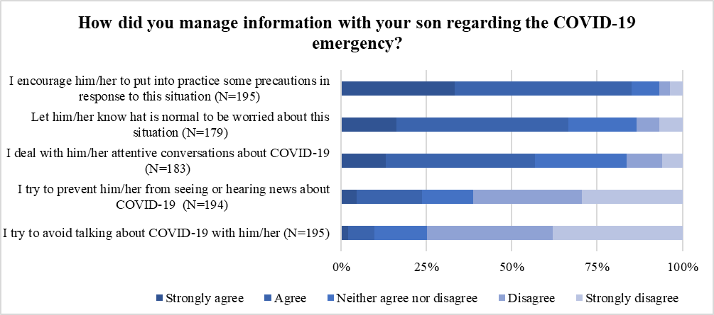
85%
66%
56.8%
23.6%
10%

3.2. Families’ lifestyles during the lockdown. Families challenged to maintain a similar scheduled routine, with 60% of them able to adequately preserve meal times and sleep hours (N=138, 59.5%), and study and other entertainments habits (N=143, 62.2 %) as before. Around 50% of children spent less than 30 minutes per day, wasting energies on physical activities (N=107, 43.5%) or staying outdoor (N=128, 52.1%). Children, stayed in contact at least once a day with their friends by Whatsapp and SMS (N=77, 53.8%), or playing videogames (N=77, 49%), while 43.5% (N=87) used video-calls. The preferred way to contact other family members was by video-calls (N=144, 66.7%), calls (N=125, 64.4%), and Whatsapp and SMS (N=83, 55.7%), used once a day at least (Figure 2).

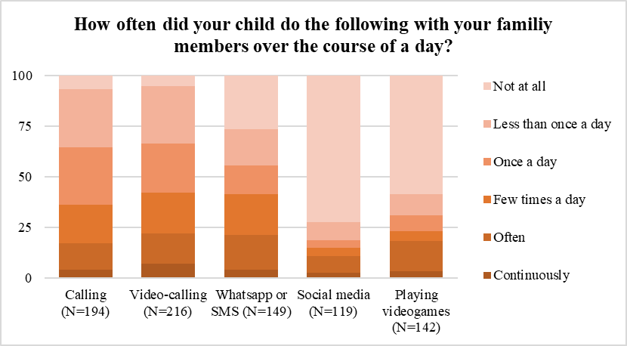



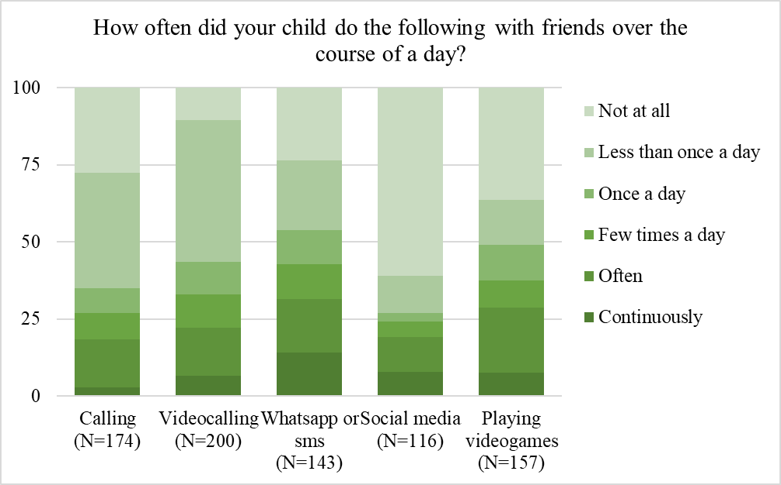



Figure 2. Children’s contacts with other family members and friends
64.4%
66.7%
55.7%
53.8%
49%
43.5%

3.3. Families and children’s relationships. Parents referred a good emotional relationship with their child in the 75% of cases (N=171) and between the child and other adults (N=141, 62.6%) or children at home (N=59, 48%). The partner’s relationship was referred good in the 79.3% of cases (N=176), while conflictual communication was very low. Lastly, parents perceived that their child would have no problems turning to an adult for advice and comfort (N=61, 63%), and referred at least a good friend their child confiding in (N=41, 46.9%) on an adequate basis (Figure 3).

Figure 3. Children’s close relationships
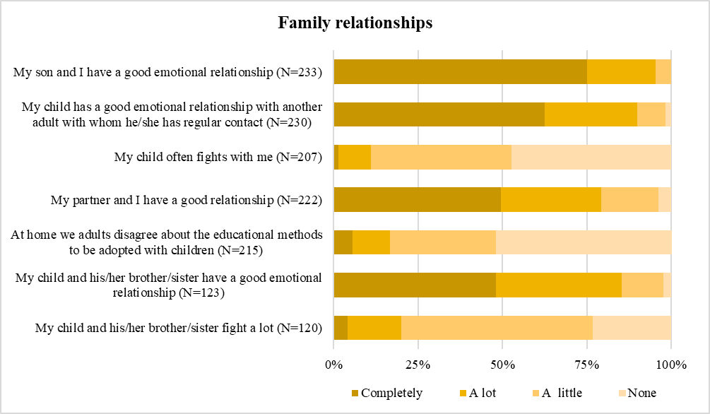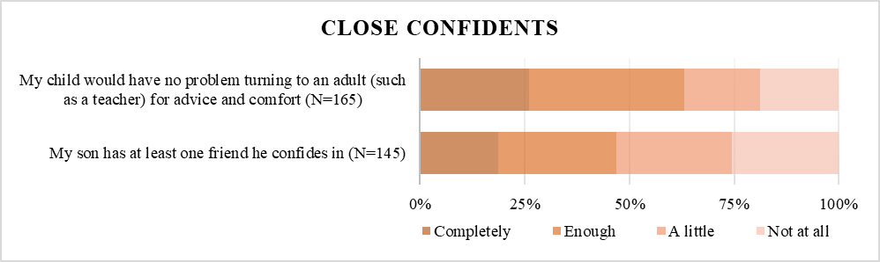
75%
62.6%
79.3%
63%
46.9%

3.4. Children’s emotions. Parents refer that 79.6% of children (N=125) think that COVID-19 is a serious problem and more than 30% of them is worried that friends, family members (N=63, 39.6%) or their selves (N=50, 31.6%) could contract it. Losing friends (N=43, 27.4%) and school (N=42, 25.1%) are worries present in at least 25% of the sample. 34.9% (N=67) developed a morbid attachment for a family member, while 24.7% (N=42) experimented with nightmares and 15.7% (N=27) developed anxiety of separation during the lockdown period (Figure 4).

Figure 4. Child’s worries
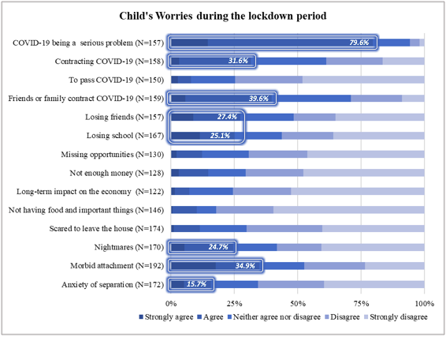

The Strengths and Difficulties Questionnaire (SDQ) was filled-in for 165 children and resulted in sub-clinical scores in each of the four difficulties subscales (all scores lower than four) and in the strength subscale (scores higher than four). However, nearly one in three scored mild to severe emotional distress (29.5%) and problematic peer relationships (30.2%), with the former presented higher scores than the Italian normative sample. The Emotional Distress (Cronbach’s α=0.72) and the Prosocial Behaviour scales (Cronbach’s α=0.71), had the best reliability and presented higher scores than the Italian normative sample, thus indicating higher emotional suffering (Mean difference (M_{diff})=0.6, 95% C.I. 0.2, 0.9, p=0.013) and better prosocial behaviour (M_{diff}=0.5, 95% C.I. 0.1, 0.9, p=0.011) than that expected in the general population. Parents scored their child’s difficulties as mild in the 43% of the cases (N=37), and that 70% of children suffered from less than one month (N=19, 22%) or 1-5 months (N= 41, 47%). More than 25% of parents indicated that some of the difficulties scored at the SDQ thoroughly caused a severe family discomfort (N=27, 27.6%) and interfered with the family life (N=25, 25.5%) (Table 3).

Table 3. Summary t-test comparison of the sample’s scores at SDQ subscales with the Italian normative sample
N=165 | M (SD) | Cronbach’s α | Differences with the normative sample ^{b}
N=165 | M (SD) | Cronbach’s α | Hartley test (F) | M_{diff} (95% C.I.) | p
Emotional distress | 2.6 (2.2) | 0.72 | 1.05 | 0.5 (0.1, 0.9)* | 0.011
Behavioural problems | 2.0 (2.4) | 0.43 | 1.20** | 0.1 (-0.2, 0.5)ª | 0.453
Hyperactivity | 3.1 (1.9) | 0.55 | 2.47** | -0.2 (-0.6, 0.2) ª | 0.311
Peer relationships | 1.8 (1.3) | 0.3 | 2.36** | 0.05 (-0.21, 0.31) ª | 0.708
Prosocial behaviour | 7.1 (2.1) | 0.71 | 1.61** | 0.6 (0.2, 0.99) ^{a*} | 0.003
*p<0.005; **p<0.001. ^{a.} Equal variances not assumed. ^{b} Bottesi et al., 2015.

3.5. Parent’s emotions. Parent’s worries were mainly due to the awareness of COVID-19 being a serious problem (N=193, 87.3%). More than 70% of parents were worried that friends or family members could contract it (N=170, 77%) and the pandemic’s long-term impact on the economy and their job (N=161, 72,9%). 57.9% (N=128) were also worried to contract the virus. More than 40% were worried to pass COVID-19 to others (N= 99, 44.8%), and about total familial earning (N= 97, 43.9%) (Figure 5).

Figure 5. Parent’s worries
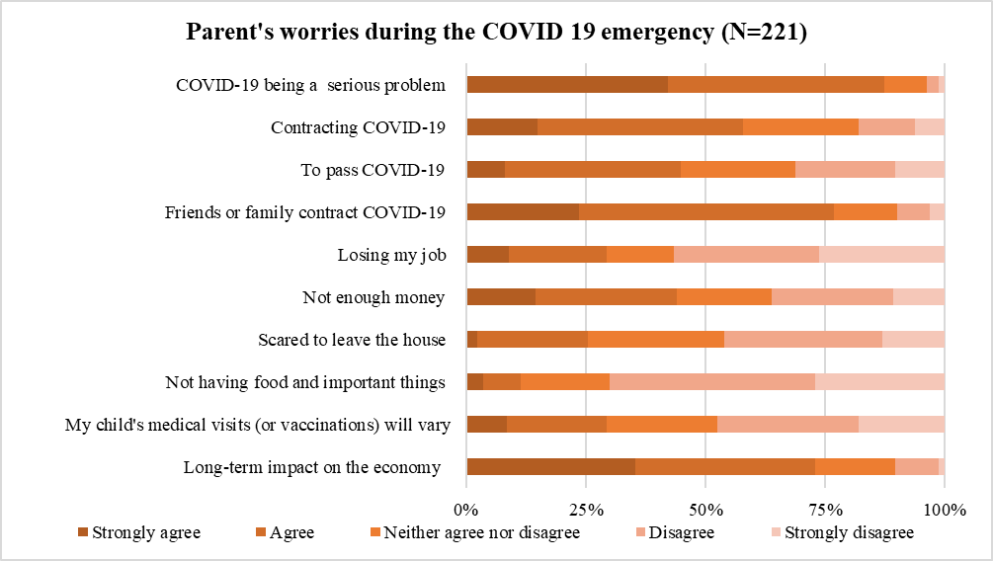
87.3%
77%
72.9%
57.9%
44.8%
43.9%

During the lockdown, more than 60% of parents were worried about their child’s wellbeing (N= 175, 79.2%), future (N=142, 66.4%), and education (N=132, 64.4%). At least 50% referred worries about the child’s time spent in front to screens 54.6% (N=118) and their child’s behaviour (N=109, 49.3%). Almost 60% was worried about other family members, not living in the same home (N=129, 58.9%). At least 40% of parents expressed preoccupation about their future plans (N=104, 48.1%), their safety (N=95, 44.6%), and living conditions (N= 97, 44.5%), the home chores (N=86, 40%)), their finances (N=91, 43.1%) and the possibility to take care of their selves (N=85, 40.3%) (Figure 6).

Figure 6. Parent’s long-term worries
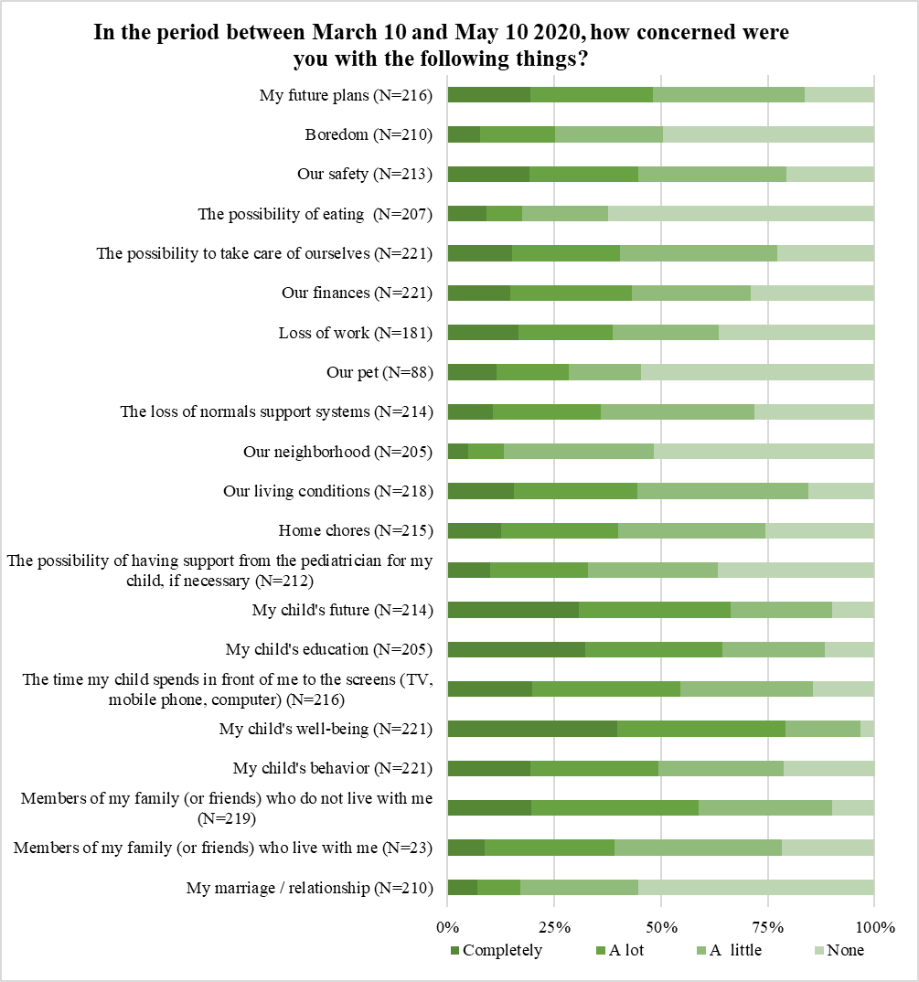
79.2%
66.4%
64.4%
54.6%
54.6%
48.1%
44.6%
44.5%
40%
43.1%
40.3%

Finally, we asked parents how much they were worried about their child’s perspective coming back to school. Most concerns were about negative emotions of the children to have to stay away from others at school (N=103, 52.8%), and the absence of support to children in the transition to a new class or school (N=82, 50.6%). 46% of parents were also worried that their children could contract COVID-19 at school (N=94) (Figure 7).

Figure 7. Parents and their children’s school
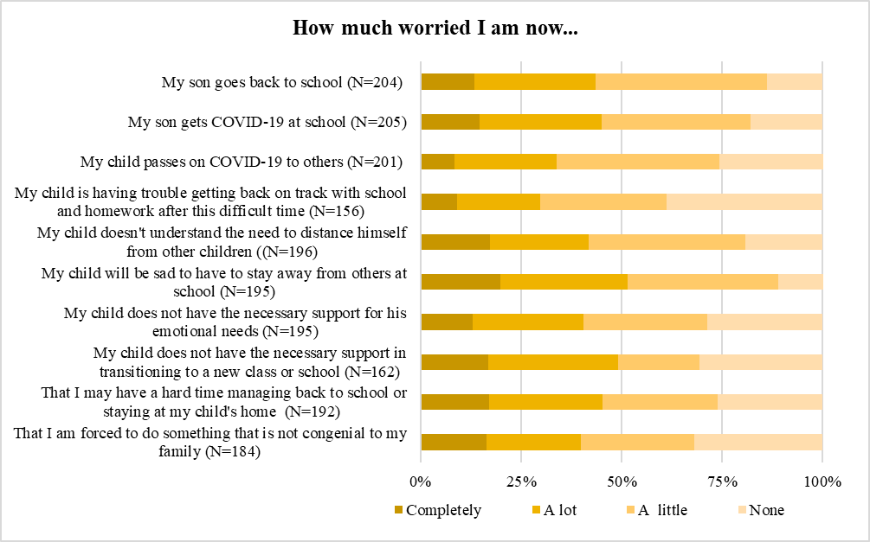
52.8%
50.6%
46%

At the DASS all scores were subclinical, but participants were more depressed than the community Italian sample (M_{diff}=1.0, 95% C.I. 0.3, 1.6, p=0.005) (Table 4).

Table 4. Summary t-test comparison of the sample’s scores at DASS 21 with the Italian normative sample
N=221 | M (SD) | Cronbach’s α | Differences with the normative sample^{b}
N=221 | M (SD) | Cronbach’s α | Hartley test (F) | M_{diff} (95% C.I.)ª | p
DASS 21 Depression | 4.5 (4.7) | 0.90 | 2.15** | 1.0 (0.3, 1.6)* | 0.005
DASS 21 Anxiety | 2.9 (3.9) | 0.84 | 2.29** | 0.54 (-0.3, 1.1) | 0.068
DASS 21 Stress | 6.8 (5.2) | 0.91 | 1.89** | 0.43 (-0.3, 1.2) | 0.277
DASS 21 Total | 14.3 (12.4) | 0.94 | 2.25** | 2.02 (0.1, 3.8) * | 0.032
*p<0.005; **p<0.001. ^{a.} Equal variances not assumed. ^{b} (Marzocchi et al., 2002).

3.6. Families’ perceived need for help in response to COVID-19. The two/thirds of the sample (N=150, 68%) reported that there could be helpful to receive advice, support or help with their child’s response to the COVID-19 situation, in the managing of their behaviours, emotions (N=140, 86.4%), and educational needs (N=126, 77.8%), and making sure that they came out from the social isolation (N=139, 82.7%). They also indicated the preferred ways to receive this support online, by personalized support from a professional (N=124, 83.2%), written material (N=115, 74.7%), and videos (N=104, 80.7%) (Figure 8).

Figure 8. Families need for help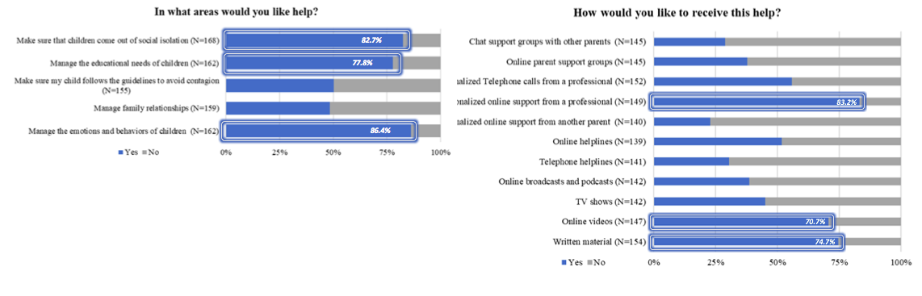

3.7. Which variables related to children’s Emotional distress?
Emotional distress was higher in older children (r=0.173, p=0.028), and related to higher parents’ scores in depression (r=0.324, p>0.001), anxiety (r=0.271, p=0.001) and stress (r=0.225, p=0.006) at DASS. Children with higher emotional distress were also more worried about losing opportunities in their future (r=0.214, p=0.024), suffered from nightmares (r=0.262, p=0.002) and anxiety of separation (r=0.311, p<0.001), and developed a morbid attachment to an adult (r=0.377, p<0.001) during the lockdown. There was also a correlation between higher emotional distress and frequent fights between the child and the parent (r=0.234, p=0.004), and brothers or sisters (r=0.295, p=0.004). Children with lower emotional distress were, instead, more likely to have preserved a similar routine as before the lockdown in the meal and sleep times (r=-0.185, p=0.019), in studying and playing times (r=-0.227, p=0.004). They spent more hours in daily physical activities (r=-175, p=0.028), and they were more likely to turn to an adult for advice and comfort (r=-194, p=0.024).
By analyzing these variables as predictors in a stepwise linear regression having emotional distress as the outcome and gender, age and region as fixed terms, having developed a morbid attachment to an adult explained a 15.3% of the variance more than the sociodemographic variables alone (B=0.37, 95% CI 0.05, 0.69, p=0.024), a higher parental depression added another 4.8% (B=0.1, 95% CI 0.02, 0.18, p=0.014), and children’s suffering from nightmares increased another 4% of the predictive power (B=0.35, 95% CI 0.03, 0.67, p=0.032). The model explained the 31.9% of the total variance in children’s emotional distress (Table 5).

Table 5. Model Summary Regression to Predict Emotional Distress of Children During the Lockdown
Model | R | R² | R²_{Adj} | SE _{estimate} | R²_{Change} | F_{Change} |  | df1 | df2 | p-value
1 | 0.279ª | 0.078 | 0.045 | 1.980 | 0.078 | 2.364 |  | 3 | 84 | 0.077
2 | 0.481^{b} | 0.231 | 0.194 | 1.819 | 0.153 | 16.549 |  | 1 | 83 | 0.000
3 | 0.528^{c} | 0.279 | 0.235 | 1.772 | 0.048 | 5.431 |  | 1 | 82 | 0.022
4 | 0.565^{d} | 0.319 | 0.269 | 1.733 | 0.040 | 4.783 |  | 1 | 81 | 0.032
a. Predictors: (Constant), Region, children’s sex, children’s age.
b. Predictors: (Constant), Region, children’s sex, children’s age, morbid attachment.
c. Predictors: (Constant), Region, children’s sex, children’s age, morbid attachment, DASS_D
d. Predictors: (Constant), Region, children’s sex, children’s age, morbid attachment, DASS_D, nightmers.

3.8. Exploratory analysis
Parents’ attitude and worries about COVID-19 during lockdown were assessed with 15 items created ad hoc, rated on a five-point scale ranging from 0 (strongly disagree) to 4 (strongly agree) (Figure 1 and 5). Exploratory factor analysis (EFA) suggested a four-factor solution: 1) fear of infection (five items; α=0.85; MIC=0.54); 2) fear of pandemic effects (five items; α=0.76; MIC=0.54); 3) focused parenting (three items; α=0.83; MIC=0.62); 4) avoidant parenting (two items; α=0.69; MIC=0.66) (Table 6).

Table 6. Exploratory Factor Analysis on Parents’ Attitude and Worries About COVID-19
 | Fear of infection | Fear of pandemic effects | Focused parenting | Avoidant parenting
I’m worried to contract COVID-19 | 0.85
I’m concerned that friends or family may contract COVID-19 | 0.84
I’m scared to leave the house during this time | 0.76
I’m worried to pass COVID-19 to someone else | 0.76
I think COVID-19 is a serious problem | 0.72
I’m worried about losing my job |  | 0.84
I’m worried about the family’s incomes |  | 0.83
I’m worried that we’ll not have enough food and primary resources during the emergency |  | 0.65
I’m concerned about long-term impact that COVID-19 will have on economy and my job plans |  | 0.63
I’m concerned about variation on my child’s medical examinations (or vaccinations) |  | 0.47
All the conversations I have with my child about current situation and COVID-19 are dealt seriously |  |  | 0.88
I talk my son about how it’s normal to be worried about the current COVID-19 situation |  |  | 0.88
I encourage my son to take some precautions in response to the COVID-19 situation |  |  | 0.84
I try to avoid talking my son about COVID-19 |  |  |  | 0.87
I try to prevent my child from seeing or hearing news or information about COVID-19 |  |  |  | 0.87

Emotional reactions and feelings about COVID-19 experienced by children, were assessed with 9 ad hoc questions rated on a five-point scale ranging from 0 (strongly disagree) to 4 (strongly agree) (Figure 4). Exploratory factor analysis (EFA) suggested a two-factor solution: 1) fear of infection (four items; α=0.75; MIC=0.45); 2) anxiety (five items; α=0.83; MIC=0.89) (Table 7).

Table 7. Exploratory Factor Analysis on Children’s Worries About COVID-19
 | Anxiety | Fear of infection
He/she is worried about losing friends | 0.82
He/she is anxious when one of our family leaves the house | 0.81
He/she is worried about losing school year | 0.72
He/she has developed a morbid attachment to me or to other family’s members | 0.72
He/she has nightmares during this time | 0.71
He/she is worried about contracting COVID-19 |  | 0.85
He/she is concerned that friends of family may contract COVID-19 |  | 0.81
He/she is scared to leave the house during this time |  | 0.65
He/she thinks COVID-19 as a serious problem |  | 0.61

Parents and children’s fear of infection were related each-other (r=0.32, p=0.001), while children’s anxiety was higher if parents had higher fear of the pandemic effects (r=0.32, p=0.001) and when they adopted an avoiding communicative approach to the situation (r=0.24, p=0.011) (Table 8).

Table 8. Exploratory Factor Analysis on Parent’s Worries About COVID-19
 | 1. | 2. | 3. | 4. | 5. | 6.
1. Parent’s fear of infection | -
2. Parent’s fear of pandemic effects | 0.02 | -
3. Focused parenting | -0.05 | 0.06 | -
4. Avoidant parenting | 0.05 | 0.05 | -0.05 | -
5. Child anxiety | 0.04 | 0.32* | 0.03 | 0.24* | -
6. Child fear of infection | 0.32* | 0.08 | 0.16 | -0.02 | -0.05 | -
*Sig. at ≤0.05

4. Discussion

This study aimed to screen a wide range of emotional and behavioural variables during the first lockdown in a sample of parents, residents in the southern part of Italy, and explore which variables could predict children’s wellbeing in these challenging times.
Our sample was very similar to other Italian studies’ samples in terms of the higher proportion of mothers answering, as compared to fathers, their mean age, employment state and education (Liang et al., 2020; Marchetti et al., 2020; Orgilés et al., 2020; Pisano et al., 2020; Spinelli et al., 2020). Mothers from middle-income families were represented, thus profiling the median audience of such online surveys, available to fill-in a medially lengthy questionnaire about their children’s psychological wellbeing. This evidence suggests the implementation of future studies to reach a more representative sample than those generally described.

There were several protective factors (Spinelli et al., 2020): such as living in a region at low-risk at the moment of the survey, in houses that were generally big enough for a four-component median family, with at least an external place to use, and in families experimenting a good health condition of their components and no conflictual relationships. On the other hand, most families experimented with a decreased income, professional uncertainty, and a new working condition at home (smart-working), which probably increased their negative emotions (Cusinato et al., 2020; Delmastro & Zamariola, 2020).

Parents reported several worries about their children’s safety, education and future, resulting in higher levels of depression than expected in the general population (see also Romero et al., 2020). Our sample was almost entirely constituted of mothers, who were at risk of developing distress (Mazza et al., 2020), probably because they managed the most of the additional housework and childcare during the pandemic (Del Boca et al., 2020). They were in a condition where they had to balance personal life, work from home, and raise little children (Benassi et al., 2020; Bruno et al., 2020; Marchetti et al., 2020) by providing to their educational needs in a new condition of online lessons.

Indeed, parents referred to contrasting emotions about the perspective of their children’s coming back to school, with a balance between fear of the infection at school and worries about children’s isolation and loss of sustain.

Families tried to maintain the same routine as before, but it was inevitably changed due to the government’s instructions, that families mostly followed. Previous literature (Wang et al., 2020) and guidelines on preserving children’s mental health (Dalton et al., 2019; GOV.UK, 2020) highlighted the value of routines in providing safety and stability in the context of uncertainty, and correlations in our sample confirmed this intuition.

Parents were concerned about their children’s increased screen-time. Indeed, coupled with other risk factors, it has been related to increasing weight in children (Pietrobelli et al., 2020) and risk to develop problematic online gambling (Frisone et al., 2020). On the other hand, phones, video calls, and video games were the only way children could stay in contact or play with their friends and other family’s members. Future studies should focus on the brain’s impact after this experience, which forced all of us to connect for so long only through the new technologies, probably impacting the developing minds more than others.

Two third of children showed good emotional wellbeing and non-clinical scores on SDQ. However, emotional distress was medially higher in our sample than the general population, together with a better propensity to prosocial behaviours. Indeed, parents referred to a good attitude of their children in their close relationships, which let us wish about “a sort of new herd immunity” against these isolation times, as Settineri and Merlo suggests (2020).

Most of the children were in the early stage of their development (five-six years old); their emotional distress increased at increasing age, it was mostly expressed with nightmares and morbid attachment with an adult, and related to higher parental depression (see also Spinelli et al., 2020). This finding suggests a regressive mechanism in a contest with higher familial discomfort.

The factorial analysis of the questionnaires administered suggested that the fear of the infection differed from the fear of the pandemic effects; both in parents and children. Not surprisingly, parents’ fear of the infection was related to children’s fear of the infection and children’s anxiety related to their parents’ fear of the pandemic effects and an avoidant parental communication approach about the pandemic.

This last result is of particular interest and let speculate that avoiding an argument capable of upsetting adults could produce anxiety in children. This pandemic contributed to creating an underlying uncertainty, which has become media noise, an “infodemic” defined as an overload of online and offline information (WHO World Health Organization, 2020). On the other hand, it has constituted a sense of disorientation and displacement of the “common man,” who failed in the first part of this experience to get a clear idea to support his adaptation skills effectively. In this context, the management of information sources becomes a primary task for parents. Parents should adopt a communicative approach, sustain their self-efficacy (Morelli et al., 2020), receive doubts and fears of the child, and providing useful information to prevent the contagion (Romero et al., 2020).
Previous studies highlighted the importance of sensitive and effective communication about life-threatening events (Dalton et al., 2019) because when children experience lack of information, they attempt to make sense of the situation on their own, with the risk of a misinterpretation (Christ & Christ, 2006; Edwards & Davis, 1997). Therefore, addressing families information management is an essential component of a community-led response to COVID-19 pandemic (Dalton et al., 2020).
Finally, parents perceived a need for help with their child’s response to the pandemic situation and declared to prefer online personalised professional support, videos or written material. To date, no guidelines were developed for the Italian population, nor the international guidelines were translated into Italian languages. This lack of information from public health institutions needs to be addressed, providing parents with knowledge such as 1. Distress and mental disturbances’ signals in children and adolescents; 2. Best practices and attitude to talk about COVID-19 topic and negative emotions associated; 3. Strategies to maintain or develop new healthy schedules and routines and regularly keep in contact with significant ones; 4. Support with online learning, providing hardware facilities and classroom services tips and tutorials; 5. Monitoring healthy screen times.

5. Limitations
This study results should be interpreted in light of its limitations. Firstly, no data on the effects of the COVID-19 pandemic were available at the investigation time. Therefore, we used a cross-sectional online survey to recruit an Italian sample which experienced home confinement. Due to the cross-sectional study design causality cannot be inferred, further longitudinal data are needed. Moreover, we used only parent self-report measures to collect children’s information, with the risk of potential bias. We used ad hoc questionnaires to capture specific COVID-19-related factors along with validated psychological assessment measures. Finally, the sample was little but comparable to other Italian study samples regarding sociodemographic characteristics.

6. Conclusion

This pandemic is becoming a colossal sociological and psychological experiment, representing a generalized traumatic experience, and a pressure for the mass psyche. During its first wave, Sicily and other southern regions went into the lockdown without any direct perception of the pandemic. Indeed, a reduced number of positive COVID-19 cases was detected, as our sample also reports. However, the unpredictability of the situation, which became a psychological, economic, and social emergency, made a massive change to our ability to adapt to the world, the relationships, and life. Our “mental tissue” was devoid of defensive mechanisms, and a sort of “anticipatory grief” (Settineri & Merlo, 2020) was probably part of our response to this situation. Children are particularly at-risk, and we are now sadly aware that the pandemic will be a long-lasting problem and new extraordinary measures will probably be adopted to prevent further disasters. This study suggests that the first lockdown impacted parents and children of a population considered at low-risk and residents in the southern part of Italy. It determined emotional distress and regressive mechanisms in rising children, when verbal communication became crucial, in the contest of higher parental discomfort, fear of the infection and avoidant communication. Following parent’s indications, it could be useful to provide them with informative and age-appropriate video and professional support to motivate children to seek healthy lifestyles and guidelines on communication approaches to promote families’ wellbeing during the pandemic.

Conflicts of interest

The authors declare that the research was conducted in

the absence of any commercial or financial relationships

that could be construed as a potential conflict of interest.

Funding

No funding source to disclose.

Bibliography
Benassi, E., Vallone, M., Camia, M., & Scorza, M. (2020). Women during the Covid-19 lockdown: more anxiety symptoms in women with children than without children and role of the resilience. Mediterranean Journal of Clinical Psychology, 8(3), 1–19.
Bottesi, G., Ghisi, M., Altoè, G., Conforti, E., Melli, G., & Sica, C. (2015). The Italian version of the Depression Anxiety Stress Scales-21: Factor structure and psychometric properties on community and clinical samples. Comprehensive Psychiatry. https://doi.org/10.1016/j.comppsych.2015.04.005
Brazendale, K., Beets, M. W., Weaver, R. G., Pate, R. R., Turner-McGrievy, G. M., Kaczynski, A. T., Chandler, J. L., Bohnert, A., & von Hippel, P. T. (2017). Understanding differences between summer vs. school obesogenic behaviors of children: The structured days hypothesis. International Journal of Behavioral Nutrition and Physical Activity, 14(1). https://doi.org/10.1186/s12966-017-0555-2
Bruno, G., Panzeri, A., Granziol, U., Alivernini, F., Chirico, A., Galli, F., Lucidi, F., Spoto, A., Vidotto, G., & Bertamini, M. (2020). The Italian COVID-19 Psychological Research Consortium (IT C19PRC): General Overview and Replication of the UK Study. Journal of Clinical Medicine, 10(1), 52. https://doi.org/10.3390/jcm10010052
Buzzi, C., Tucci, M., Ciprandi, R., Brambilla, I., Caimmi, S., Ciprandi, G., & Marseglia, G. L. (2020). The psycho-social effects of COVID-19 on Italian adolescents’ attitudes and behaviors. Italian Journal of Pediatrics, 46(1), 69. https://doi.org/10.1186/s13052-020-00833-4
Christ, G. H., & Christ, A. E. (2006). Current Approaches to Helping Children Cope with a Parent’s Terminal Illness. CA: A Cancer Journal for Clinicians, 56(4), 197–212. https://doi.org/10.3322/canjclin.56.4.197
Cusinato, M., Iannattone, S., Spoto, A., Poli, M., Moretti, C., Gatta, M., & Miscioscia, M. (2020). Stress, Resilience, and Well-Being in Italian Children and Their Parents during the COVID-19 Pandemic. International Journal of Environmental Research and Public Health, 17(8297). https://doi.org/doi:10.3390/ijerph17228297
Dalton, L., Rapa, E., & Stein, A. (2020). Protecting the psychological health of children through effective communication about COVID-19. The Lancet Child and Adolescent Health, 4(5), 346–347. https://doi.org/10.1016/S2352-4642(20)30097-3
Dalton, L., Rapa, E., Ziebland, S., Rochat, T., Kelly, B., Hanington, L., Bland, R., Yousafzai, A., Stein, A., Betancourt, T., Bluebond-Langner, M., D’Souza, C., Fazel, M., Fredman-Stein, K., Harrop, E., Hochhauser, D., Kolucki, B., Lowney, A. C., Netsi, E., & Richter, L. (2019). Communication with children and adolescents about the diagnosis of a life-threatening condition in their parent. In The Lancet (Vol. 393, Issue 10176, pp. 1164–1176). Lancet Publishing Group. https://doi.org/10.1016/S0140-6736(18)33202-1
Del Boca, D., Oggero, N., Profeta, P., & Rossi, M. (2020). Women’s and men’s work, housework and childcare, before and during COVID-19. Review of Economics of the Household, 18(4), 1001–1017. https://doi.org/10.1007/s11150-020-09502-1
Delmastro, M., & Zamariola, G. (2020). Depressive symptoms in response to COVID-19 and lockdown: a cross-sectional study on the Italian population. Scientific Reports, 10(1), 1–10. https://doi.org/10.1038/s41598-020-79850-6
Deolmi, M., & Pisani, F. (2020). Psychological and psychiatric impact of COVID-19 pandemic among children and adolescents. Acta Bio-Medica : Atenei Parmensis, 91(4), e2020149. https://doi.org/10.23750/abm.v91i4.10870
Di Giorgio, E., Di Riso, D., Mioni, G., & Cellini, N. (2020). The interplay between mothers’ and children behavioral and psychological factors during COVID-19: an Italian study. European Child and Adolescent Psychiatry, 1, 3. https://doi.org/10.1007/s00787-020-01631-3
Edwards, M., & Davis, H. (1997). Counselling Children with Chronic Medical Conditions. Wiley-Blackwell.
Fegert, J. M., Vitiello, B., Plener, P. L., & Clemens, V. (2020). Challenges and burden of the Coronavirus 2019 (COVID-19) pandemic for child and adolescent mental health: A narrative review to highlight clinical and research needs in the acute phase and the long return to normality. In Child and Adolescent Psychiatry and Mental Health (Vol. 14, Issue 1, p. 20). BioMed Central. https://doi.org/10.1186/s13034-020-00329-3
Fioretti, C., Palladino, B. E., Nocentini, A., & Menesini, E. (2020). Positive and Negative Experiences of Living in COVID-19 Pandemic: Analysis of Italian Adolescents’ Narratives. Frontiers in Psychology, 11, 3011. https://doi.org/10.3389/fpsyg.2020.599531
Frisone, F., Alibrandi, A., & Settineri, S. (2020). Mediterranean Journal of Clinical Psychology. Mediterranean Journal of Clinical Psychology, 8(3), 1–15. https://doi.org/10.6092/2282-1619/mjcp-2457
GOV.UK. (2020). Guidance for parents and carers on supporting children and young people’s mental health and wellbeing during the coronavirus (COVID-19) pandemic -.
Griffiths, J., & Woodyatt, A. (2020). Wuhan coronavirus: Thousands of cases confirmed as China goes into emergency mode. CNN.
Huang, C., Wang, Y., Li, X., Ren, L., Zhao, J., Hu, Y., Zhang, L., Fan, G., Xu, J., Gu, X., Cheng, Z., Yu, T., Xia, J., Wei, Y., Wu, W., Xie, X., Yin, W., Li, H., Liu, M., … Cao, B. (2020). Clinical features of patients infected with 2019 novel coronavirus in Wuhan, China. The Lancet, 395(10223), 497–506. https://doi.org/10.1016/S0140-6736(20)30183-5
Liang, Z., Delvecchio, E., Buratta, L., & Mazzeschi, C. (2020). ``Ripple effect{‘‘}: Psychological responses and coping strategies of Italian children in different COVID-19 severity areas. REVISTA DE PSICOLOGIA CLINICA CON NINOS Y ADOLESCENTES, 7(3), 49–58. https://doi.org/10.21134/rpcna.2020.mon.2054
Mantovani, S., Bove, C., Ferri, P., Manzoni, P., Cesa Bianchi, A., & Picca, M. (2021). Children ‘under lockdown’: voices, experiences, and resources during and after the COVID-19 emergency. Insights from a survey with children and families in the Lombardy region of Italy. European Early Childhood Education Research Journal, 1–16. https://doi.org/10.1080/1350293X.2021.1872673
Marchetti, D., Fontanesi, L., Mazza, C., Di Giandomenico, S., Roma, P., & Verrocchio, M. C. (2020). Parenting-Related Exhaustion During the Italian COVID-19 Lockdown. Journal of Pediatric Psychology, 45(10), 1114–1123. https://doi.org/10.1093/jpepsy/jsaa093
Marzocchi, G., Di Pietro, M., Vio, C., Bassi, E., Filoramo, G., & Salmaso, A. (2002). Il questionario SDQ per insegnanti (Strength and Difficulties Questionnaire): uno strumento di screening per difficoltà comportamentali ed emotive in età evolutiva. DIFFICOLTÀ DI APPRENDIMENTO, 8, 75–84.
Mazza, C., Ricci, E., Marchetti, D., Fontanesi, L., Di Giandomenico, S., Verrocchio, M. C., & Roma, P. (2020). How Personality Relates to Distress in Parents during the Covid-19 Lockdown: The Mediating Role of Child’s Emotional and Behavioral Difficulties and the Moderating Effect of Living with Other People. International Journal of Environmental Research and Public Health, 17(17), 6236. https://doi.org/10.3390/ijerph17176236
Morelli, M., Cattelino, E., Baiocco, R., Trumello, C., Babore, A., Candelori, C., & Chirumbolo, A. (2020). Parents and Children During the COVID-19 Lockdown: The Influence of Parenting Distress and Parenting Self-Efficacy on Children’s Emotional Well-Being. Frontiers in Psychology, 11. https://doi.org/10.3389/fpsyg.2020.584645
Orgilés, M., Morales, A., Delvecchio, E., Mazzeschi, C., & Espada, J. P. (2020). Immediate psychological effects of the COVID-19 quarantine in youth from Italy and Spain. PsyAr- Xiv Preprints. https://doi.org/10.31234/osf.io/qaz9w
Pietrobelli, A., Pecoraro, L., Ferruzzi, A., Heo, M., Faith, M., Zoller, T., Antoniazzi, F., Piacentini, G., & Fearnbach, S Nicole Heymsfield, S. B. (2020). Effects of COVID-19 Lockdown on Lifestyle Behaviors in Children with Obesity Living in Verona, Italy: A Longitudinal Study. Obesity (Silver Spring), 28(8), 1382–1385. https://doi.org/10.1002/oby.22861. Epub 2020 Jul 10.
Pisano, L., Galimi, D., & Cerniglia, L. (2020). A qualitative report on exploratory data on the possible emotional/behavioral correlates of Covid-19 lockdown in 4-10 years children in Italy. PsyAr- Xiv Preprints. https://doi.org/10.31234/osf.io/stwbn
Racine, N., Cooke, J. E., Eirich, R., Korczak, D. J., McArthur, B. A., & Madigan, S. (2020). Child and adolescent mental illness during COVID-19: A rapid review. In Psychiatry Research (Vol. 292). Elsevier Ireland Ltd. https://doi.org/10.1016/j.psychres.2020.113307
Romero, E., López-Romero, L., Domínguez-álvarez, B., Villar, P., & Gómez-Fraguela, J. A. (2020). Testing the effects of covid-19 confinement in spanish children: The role of parents’ distress, emotional problems and specific parenting. International Journal of Environmental Research and Public Health, 17(19), 1–23. https://doi.org/10.3390/ijerph17196975
Segre, G., Campi, R., Scarpellini, F., Clavenna, A., Zanetti, M., & Bonati, M. (2020). Interviewing children: the impact of the COVID-19 quarantine on children’s changes in routine and psychological distress.&nbsp; https://doi.org/10.21203/rs.3.rs-64515/v1
Settineri, S., & Merlo, E. M. (2020). Editorial: Fear of Contamination. Mediterranan Journal of Clinical Psychology, 8(1), 1–8.
Smirni, P., Lavanco, G., & Smirni, D. (2020). Anxiety in Older Adolescents at the Time of COVID-19. Journal of Clinical Medicine, 9(10), 3064. https://doi.org/10.3390/jcm9103064
Spinelli, M., Lionetti, F., Pastore, M., & Fasolo, M. (2020). Parents’ Stress and Children’s Psychological Problems in Families Facing the COVID-19 Outbreak in Italy. Frontiers in Psychology, 11(July), 1–7. https://doi.org/10.3389/fpsyg.2020.01713
StataCorp. (2017). Stata Statistical Software: Release 15 (No. 15). StataCorp LP.
Wang, G., Zhang, Y., Zhao, J., Zhang, J., & Jiang, F. (2020). Mitigate the effects of home confinement on children during the COVID-19 outbreak. In The Lancet (Vol. 395, Issue 10228, pp. 945–947). Lancet Publishing Group. https://doi.org/10.1016/S0140-6736(20)30547-X
WHO World Health Organization. (2020). Managing the COVID-19 infodemic: Promoting healthy behaviours and mitigating the harm from misinformation and disinformation.
World Health Organization. (2020). WHO Director-General’s opening remarks at the media briefing on COVID-19 - 11 March 2020. WHO.

