The multiple group IRT measurement invariance analysis of the Self-Compassion Scale in ten international samples

Appendix
Differential Test Functioning (DTF) comparisons between countries

We present here detailed results of all Differential Test Functioning (DTF) comparisons. All compared pairs will contain the following output:

1) Textual output:
a) Signed DTF score (sDTF.score): difference between expected total scores in the focal group and the reference group (average area above and below test score functions).
b) Standardized (percentual) signed DTF score (sDTF(%).score): percent average bias between group total scores.
c) Unsigned DTF score (uDTF.score): difference between expected total scores in the focal group and the reference group (total area between test score functions).
d) Standardized (percentual) unsigned DTF score (uDTF(%).score).
e) Confidence intervals (CIs): range of confidence intervals using a multiple imputation estimate (with 1000 draws) of the expected test scores.
f) P-value (P(sDTF.score = 0): null hypothesis test for the sDTF statistic. Insignificant value means that the signed DTF score (difference between expected total scores in the focal group and the reference group) is negligible.

2) Graphical output:
Test score functions (expected total scores (T) for the focal group – blue – and the reference group – red – plotted against the latent ability (Θ)). Each plot is drawn with imputed confidence envelopes based on a multiple imputation estimate (with 1000 draws).

Each output contains two comparisons: the Self-uncompassionate responding subscale and the Self-compassionate respondingate responding subscale.

Graphical display provided very useful information: Figure 1 shows test score functions of Australian and Korean samples of Self-compassionate responding (left) and Self-uncompassionate responding (right) subscales – expected total scores plotted against the latent ability (θ). As far as Self-compassionate responding subscale is concerned, we could clearly see large difference between curves from -4 to -1 values of θ, and then from 0 to 4, but in the opposite direction. Although the differences were very large (the unsigned DTF is 2.40, which was 3.68% of distortion), their impact on difference in expected total score (the signed DTF) was only -0.04 and insignificant at the 0.05 level. We could conclude that no significant DTF was present at the total score level. However, there were differences at particular levels of the latent ability (θ): respondents with very high and very low levels of Self-uncompassionate responding answered differently in Australian and Korean samples, but in opposite directions, so the effect was cancelled out. As regards the Self-uncompassionate responding subscale, the situation was very different: again, we could see a large difference between curves from 0 to 4 values of θ, but this difference was not fully compensated by the difference between -4 to 0 in the opposite direction. The amount of differences was virtually the same as in the Self-compassionate responding subscale (the unsigned DTF is 2.95, which was 4.54% of distortion), but the lack of compensation led to a larger impact on the difference in expected total score: the signed DTF is 2.02 and significant at the 0.05 level. Each curve had a 95% confidence interval envelope.

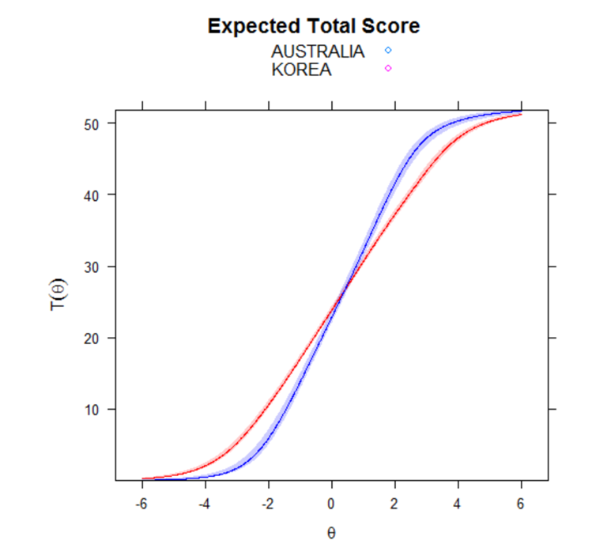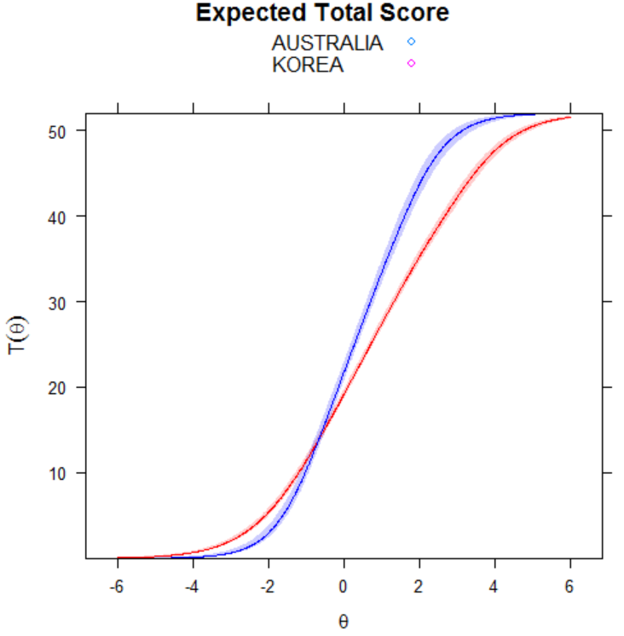
Expected total score between Australia and Korea for Self-compassionate responding | Expected total score between Australia and Korea for Self-uncompassionate responding

Figure 1. Test score functions in Australian and Korean samples for Self-compassionate responding and Self-uncompassionate responding subscales.

The test score functions of Czech and German samples in the Self-uncompassionate responding subscale are depicted on Figure 2. The values of the unsigned and signed DTF were both 2.44, and significant. Although there was systematic difference across all the range of latent ability, we could see that the largest difference lies between 0 and 4.

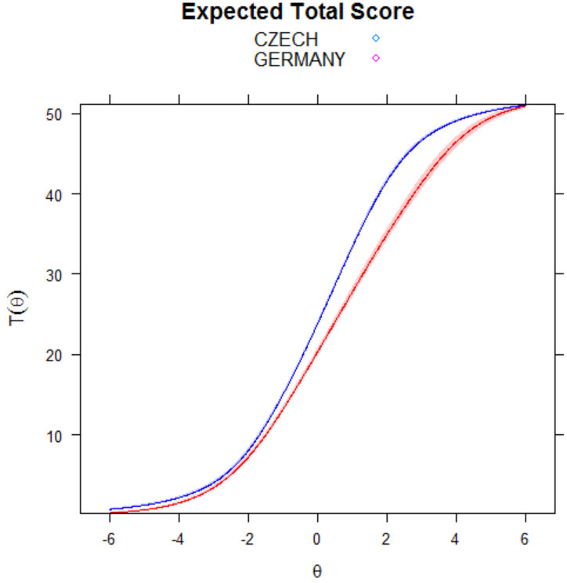
Expected total score between Czech and German samples
for Self-compassionate responding

Figure 2. Test score functions of Czech and German samples for the Self-uncompassionate responding subscale.

Samples: USA – AUSTRALIA
Self-uncompassionate responding
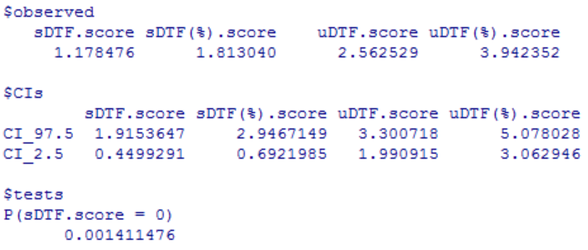
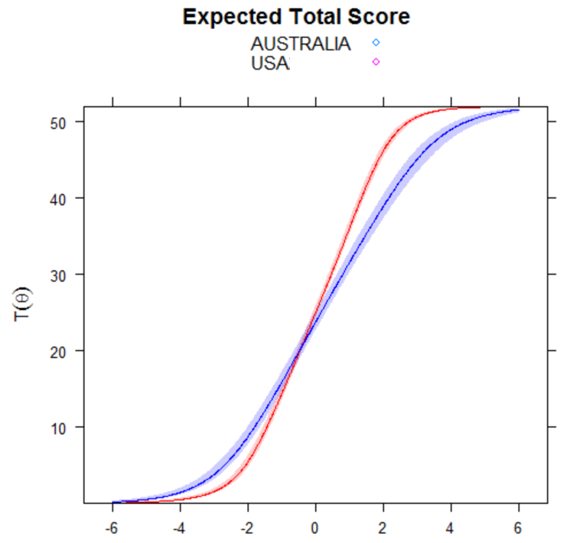

Samples: USA – AUSTRALIA
Self-compassionate responding
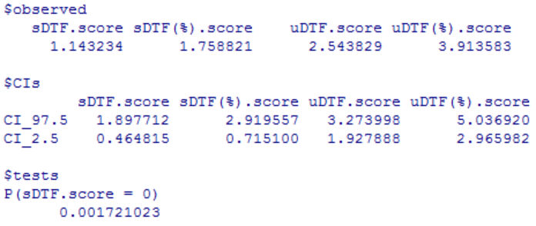
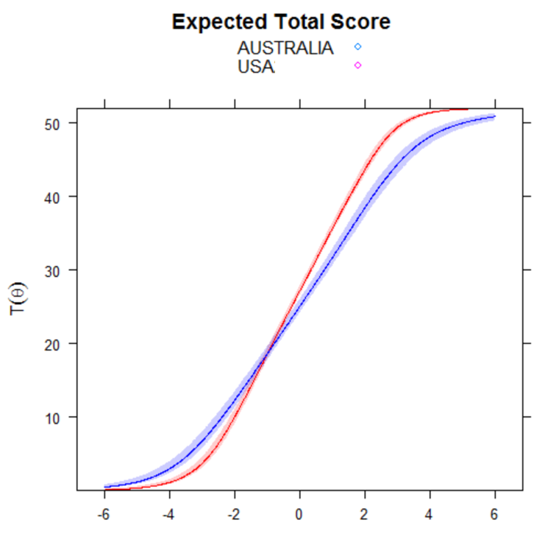

Samples: AUSTRALIA – CZECH REPUBLIC
Self-uncompassionate responding
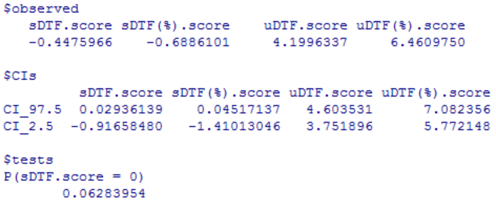
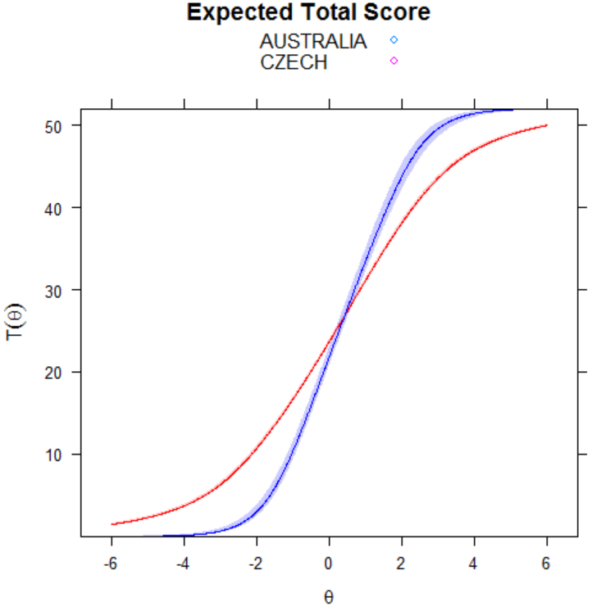

Samples: AUSTRALIA – CZECH REPUBLIC
Self-compassionate responding
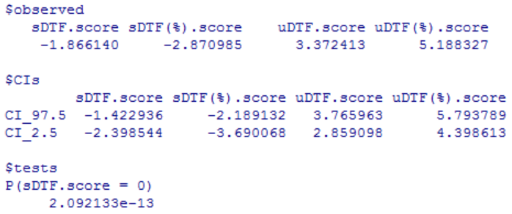
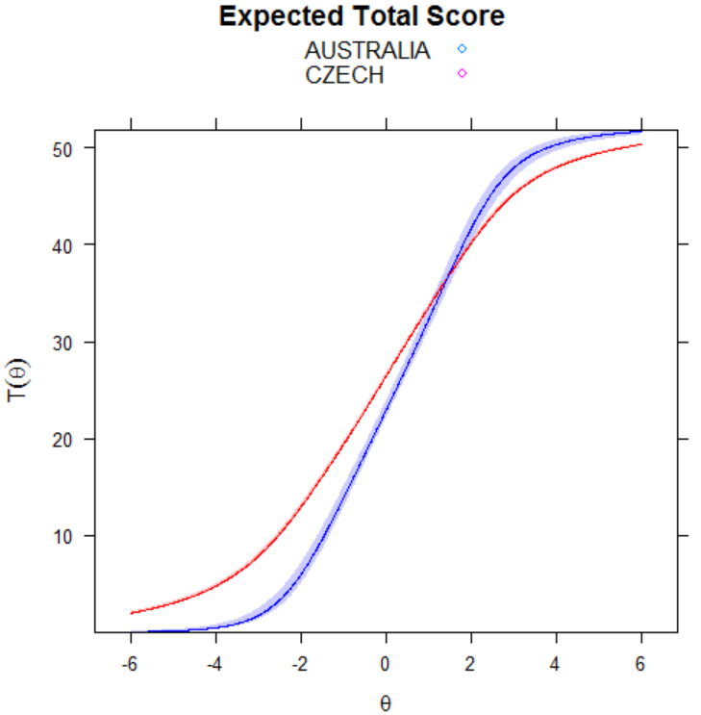

Samples: AUSTRALIA – GERMANY
Self-uncompassionate responding
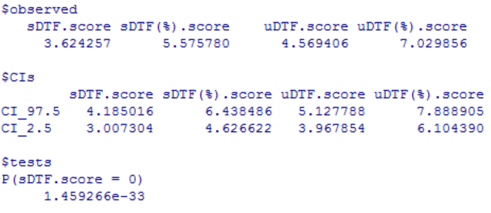
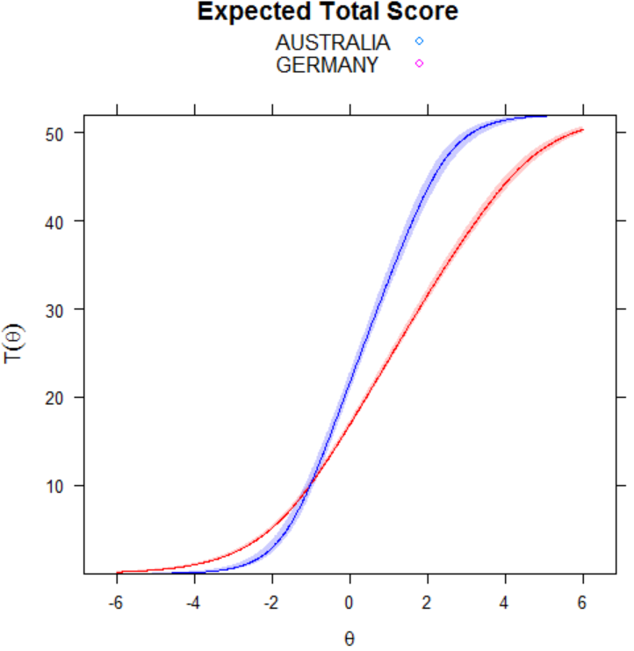

Samples: AUSTRALIA – GERMANY
Self-compassionate responding
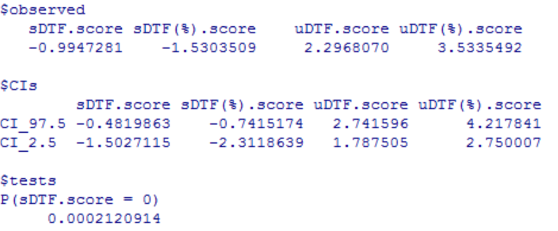
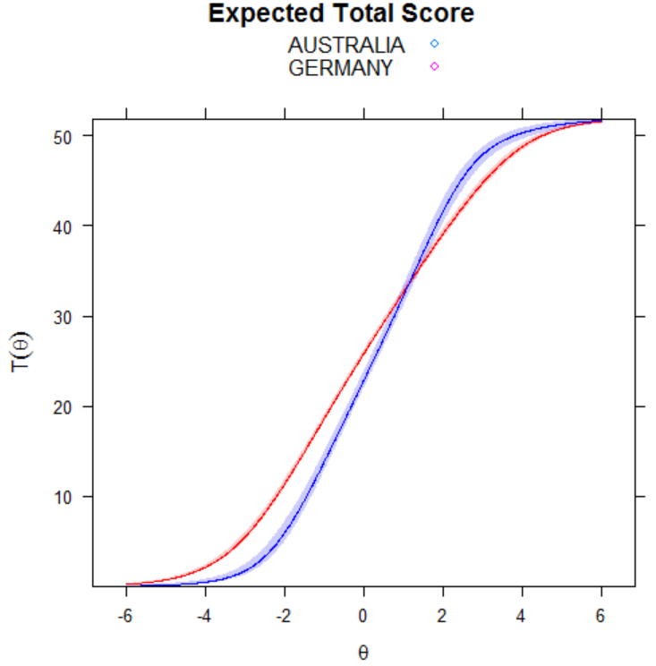

Samples: AUSTRALIA – CHINA
Self-uncompassionate responding
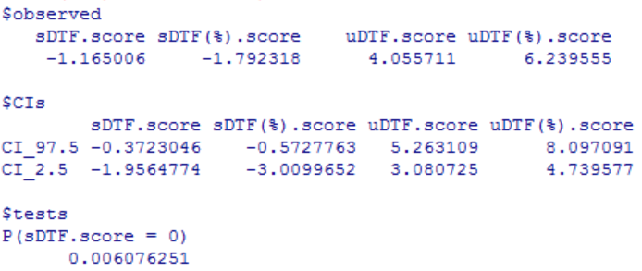
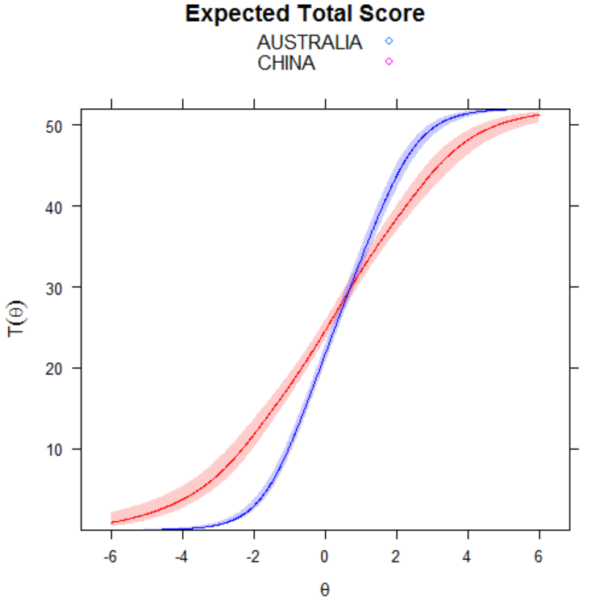

Samples: AUSTRALIA – CHINA
Self-compassionate responding
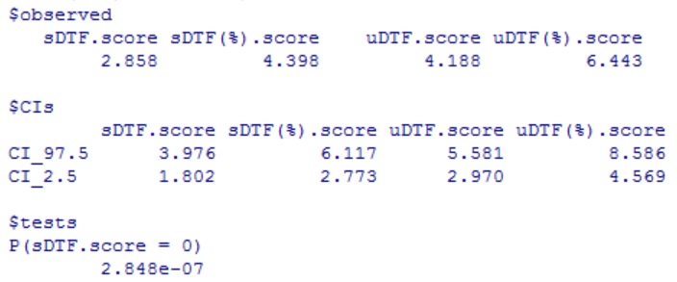
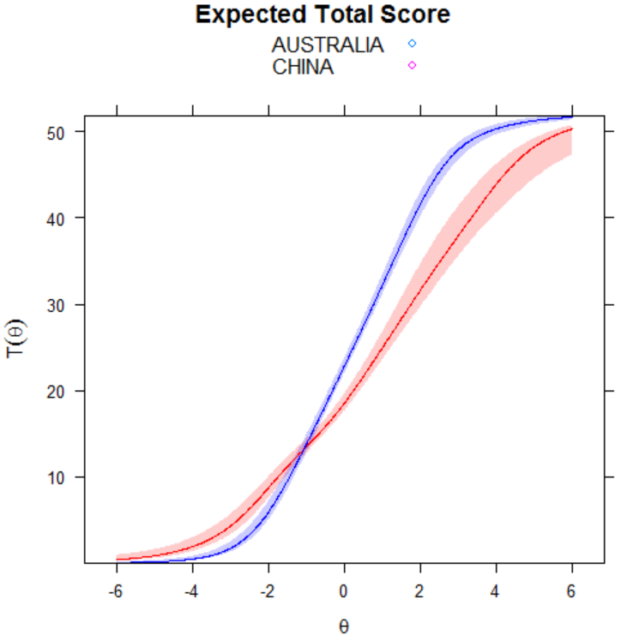

Samples: AUSTRALIA – ITALY
Self-uncompassionate responding
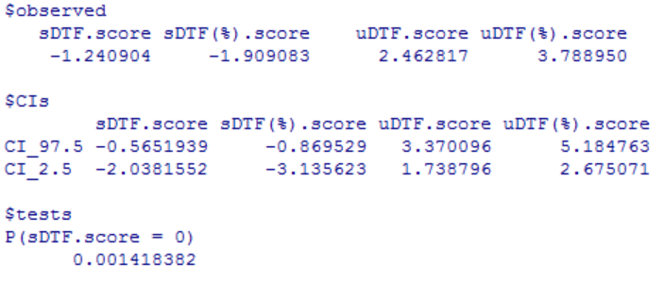
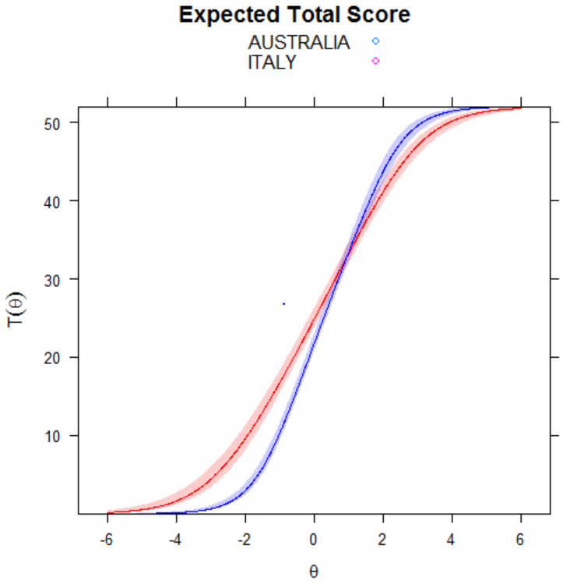

Samples: AUSTRALIA – ITALY
Self-compassionate responding
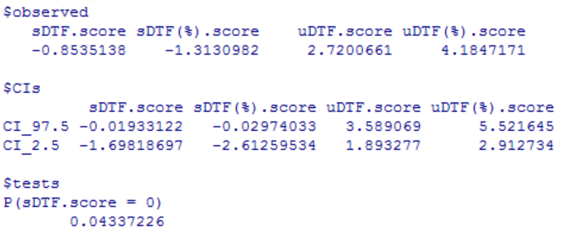
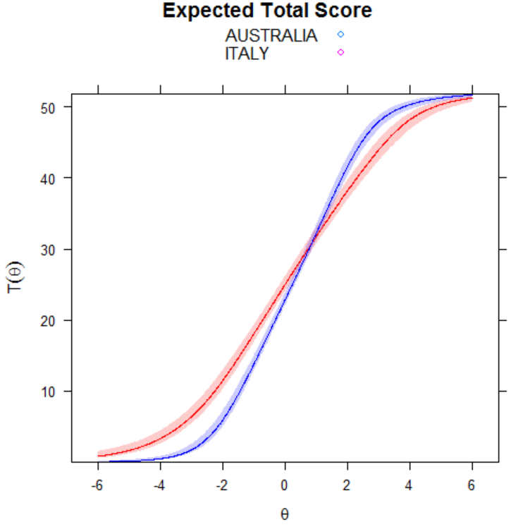

Samples: AUSTRALIA – KOREA
Self-uncompassionate responding
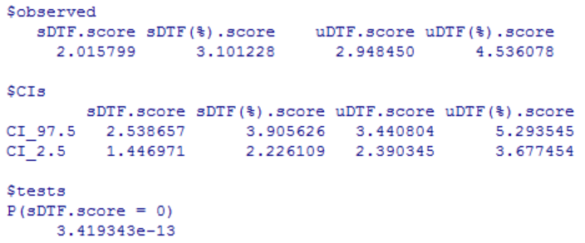

Samples: AUSTRALIA – KOREA
Self-compassionate responding
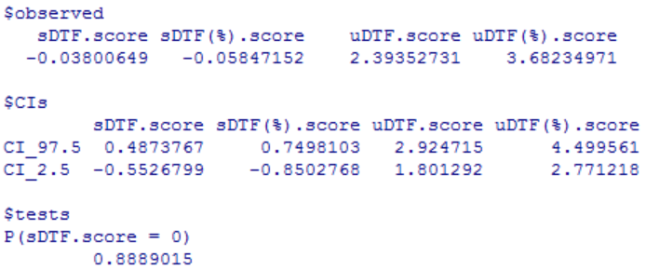
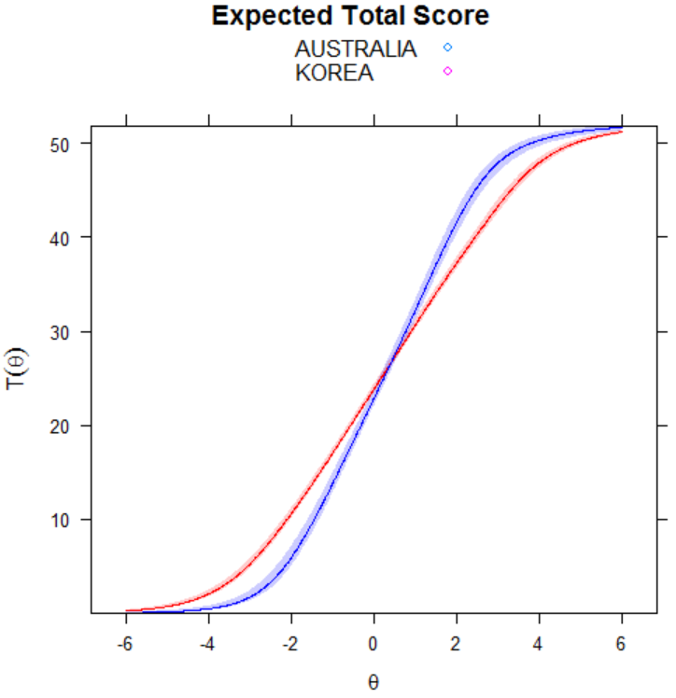

Samples: AUSTRALIA – PORTUGAL
Self-uncompassionate responding
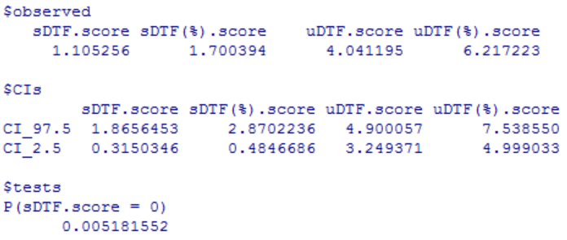
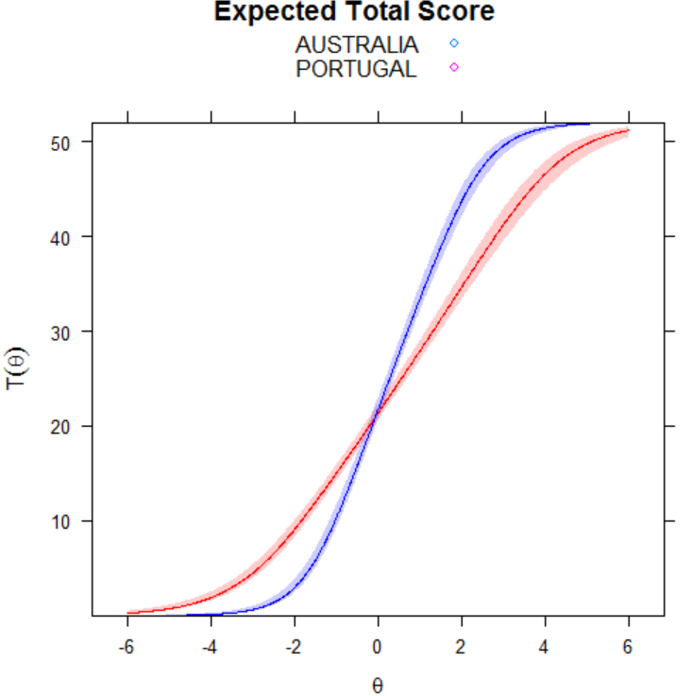

Samples: AUSTRALIA – PORTUGAL
Self-compassionate responding
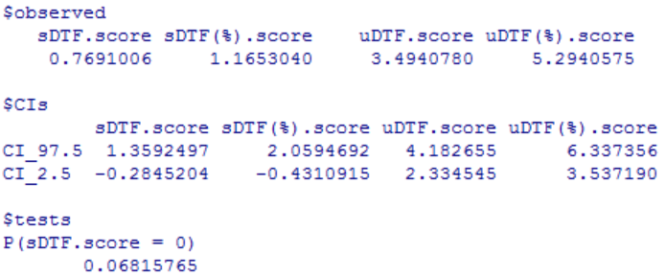
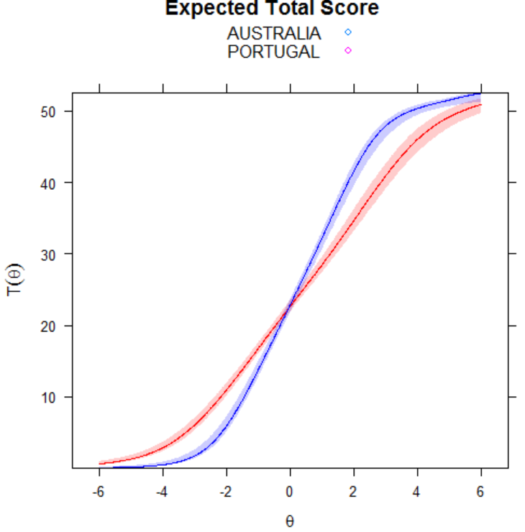

Samples: AUSTRALIA – SLOVAKIA
Self-uncompassionate responding
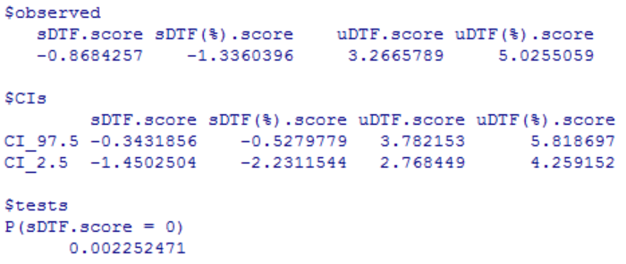
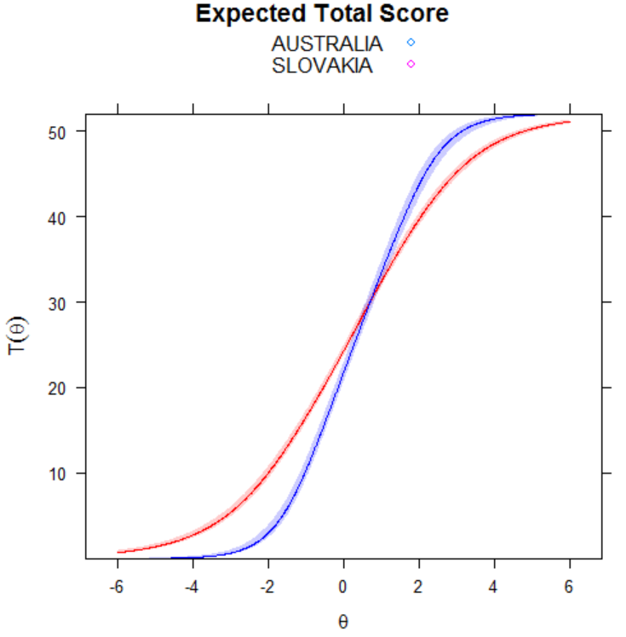

Samples: AUSTRALIA – SLOVAKIA
Self-compassionate responding
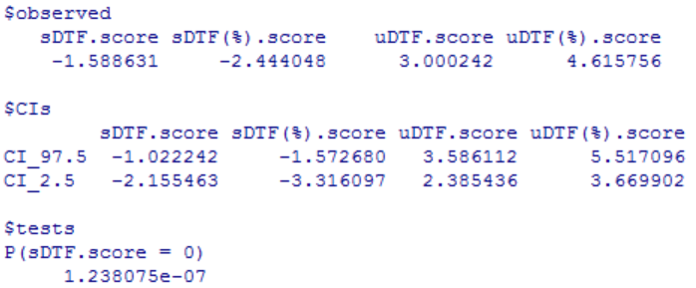
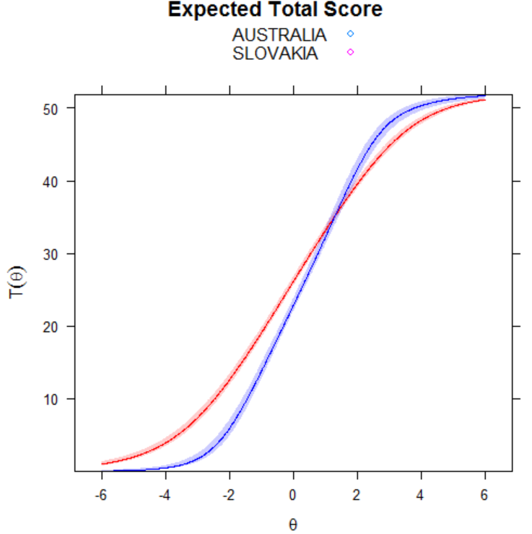

Samples: AUSTRALIA – TURKEY
Self-uncompassionate responding
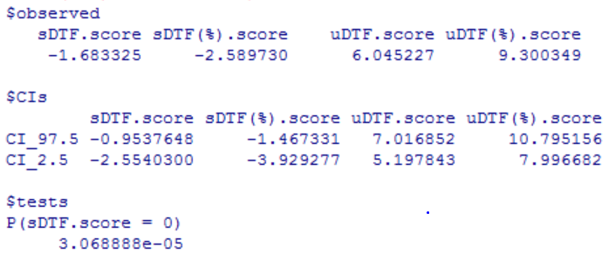
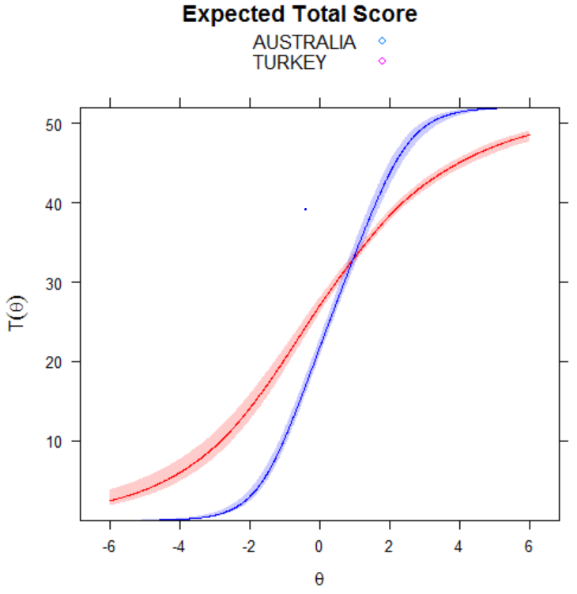

Samples: AUSTRALIA – TURKEY
Self-compassionate responding
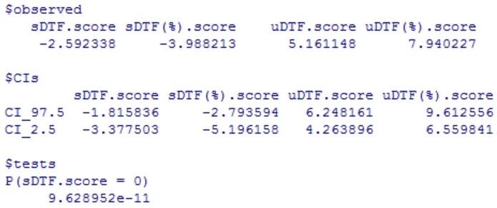
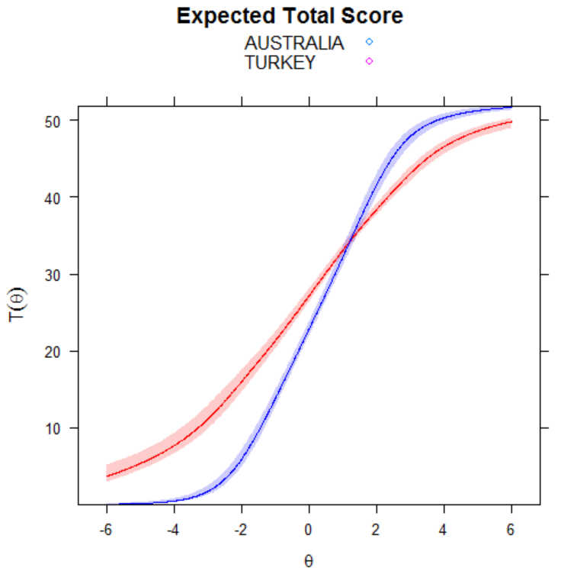

Samples: CZECH REPUBLIC – GERMANY
Self-uncompassionate responding
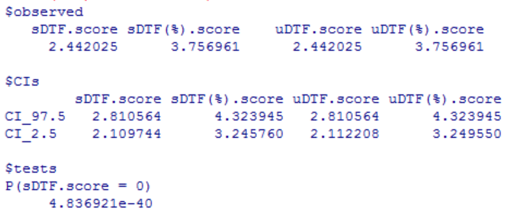

Samples: CZECH REPUBLIC – GERMANY
Self-compassionate responding
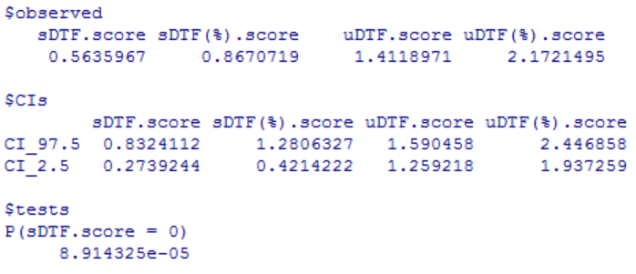
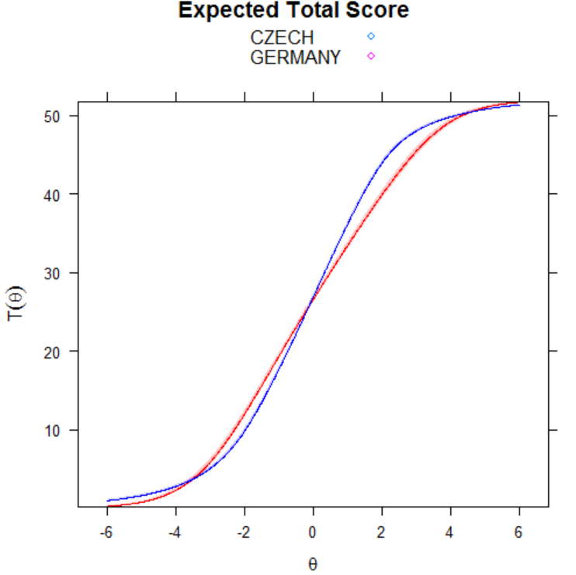

Samples: CZECH REPUBLIC – CHINA
Self-uncompassionate responding
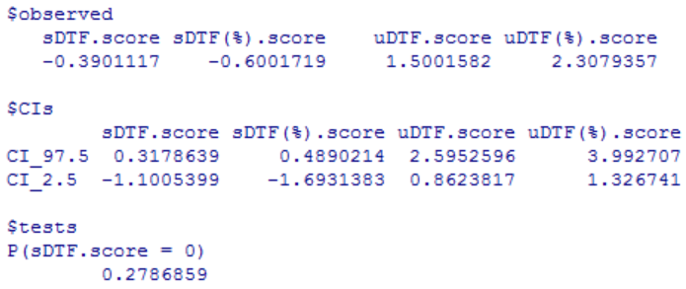
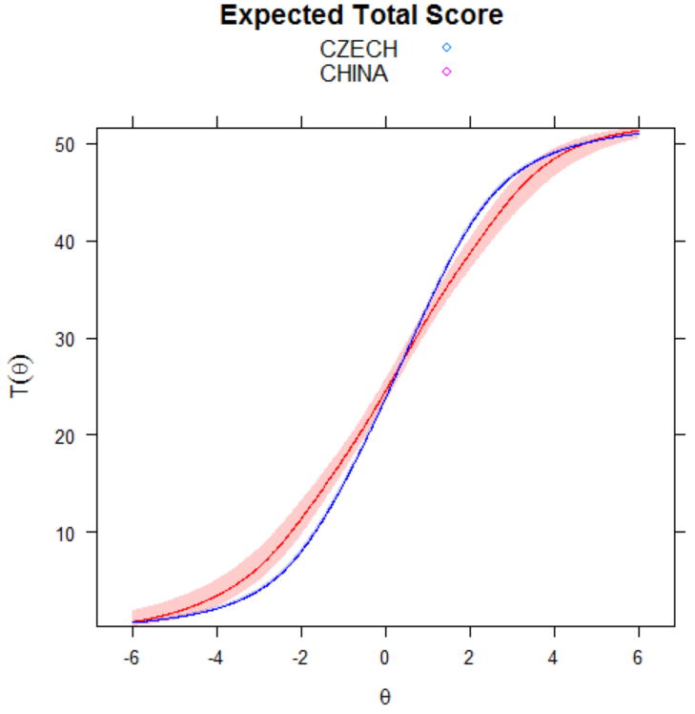

Samples: CZECH REPUBLIC – CHINA
Self-compassionate responding
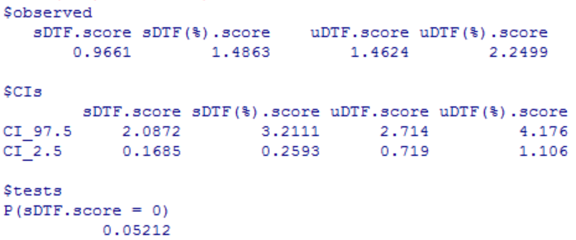
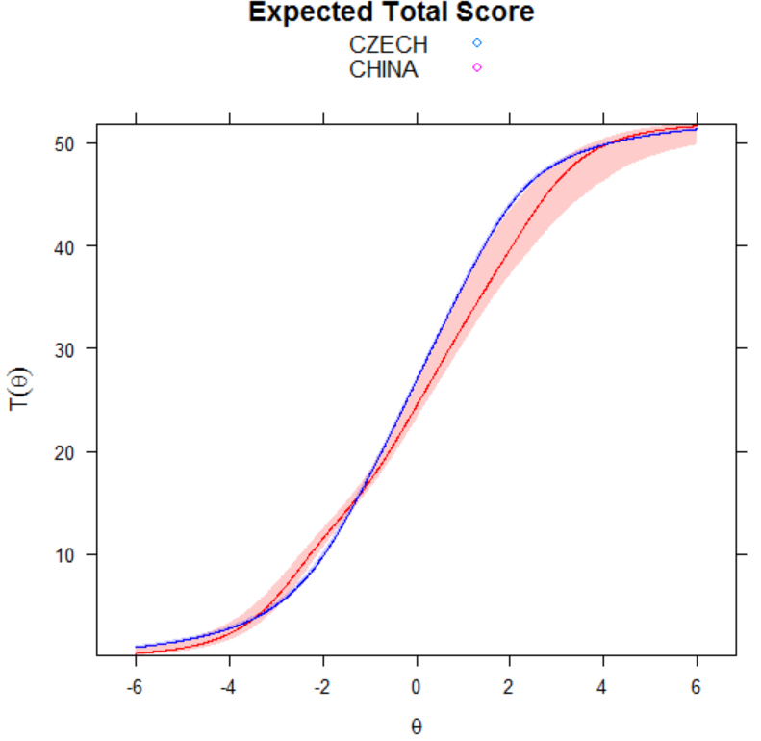

Samples: CZECH REPUBLIC – ITALY
Self-uncompassionate responding
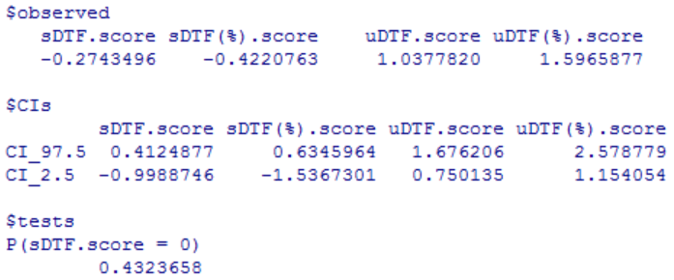
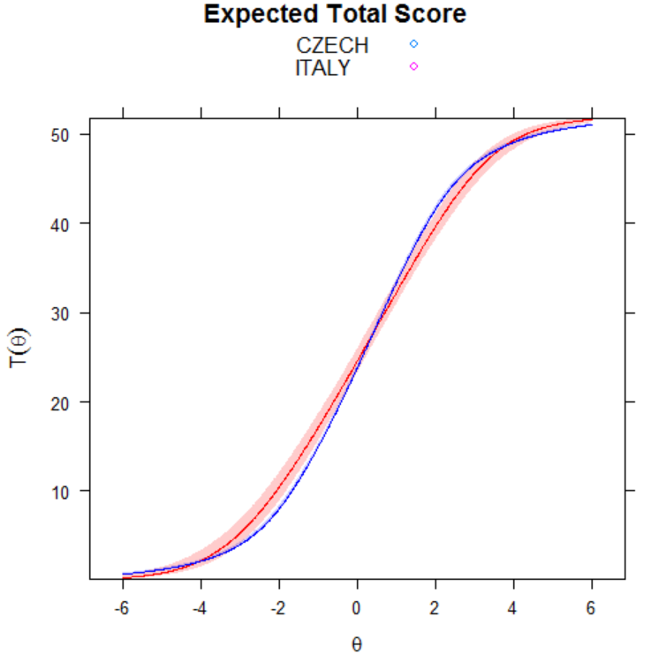

Samples: CZECH REPUBLIC – ITALY
Self-compassionate responding
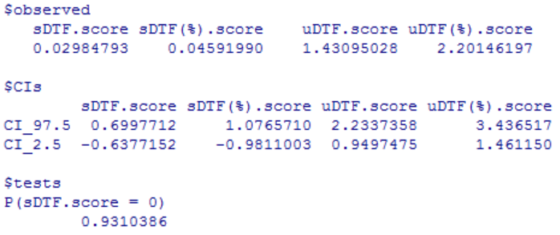
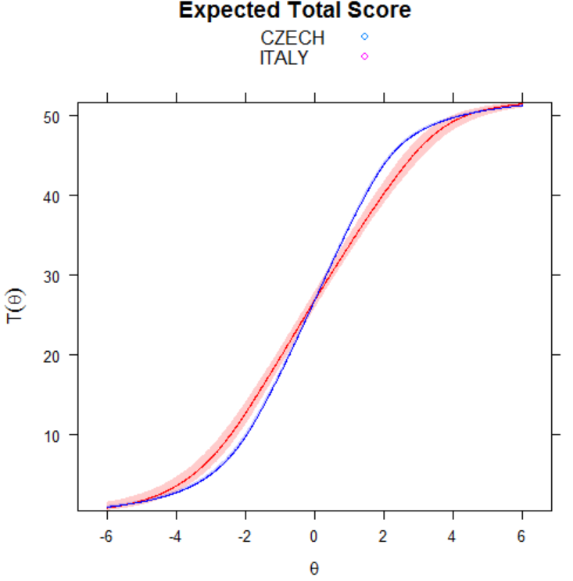

Samples: CZECH REPUBLIC – KOREA
Self-uncompassionate responding
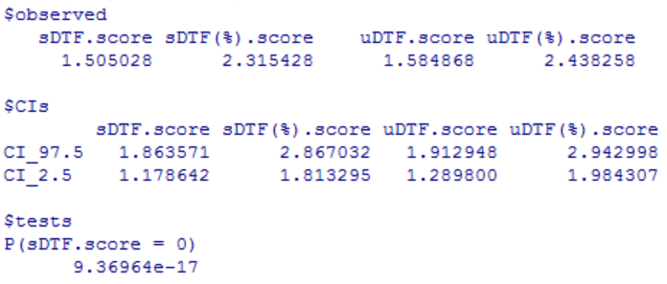
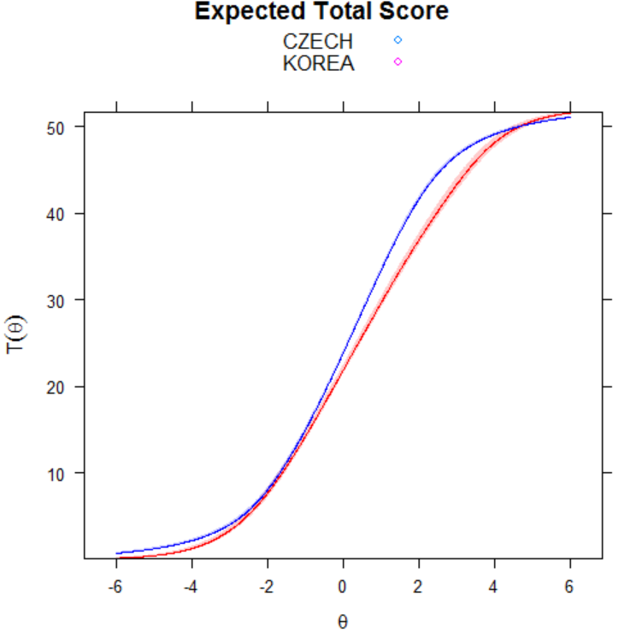

Samples: CZECH REPUBLIC – KOREA
Self-compassionate responding
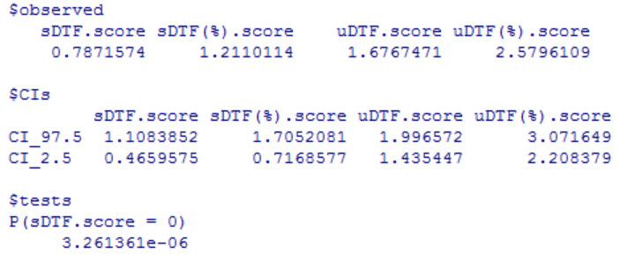
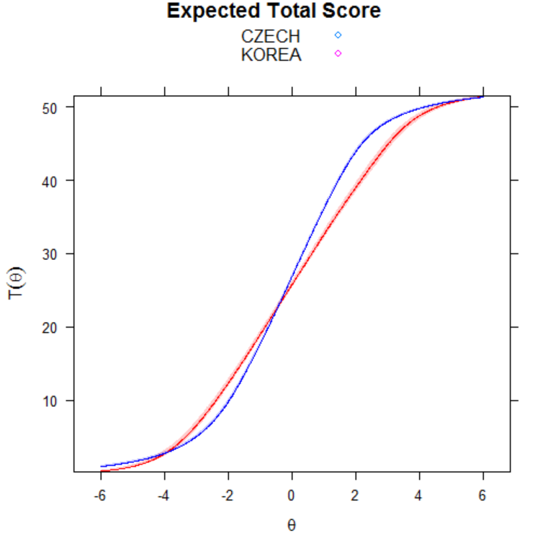

Samples: CZECH REPUBLIC – PORTUGAL
Self-uncompassionate responding
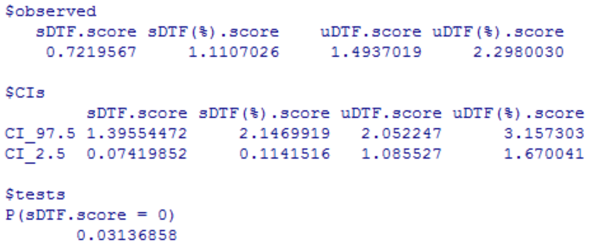
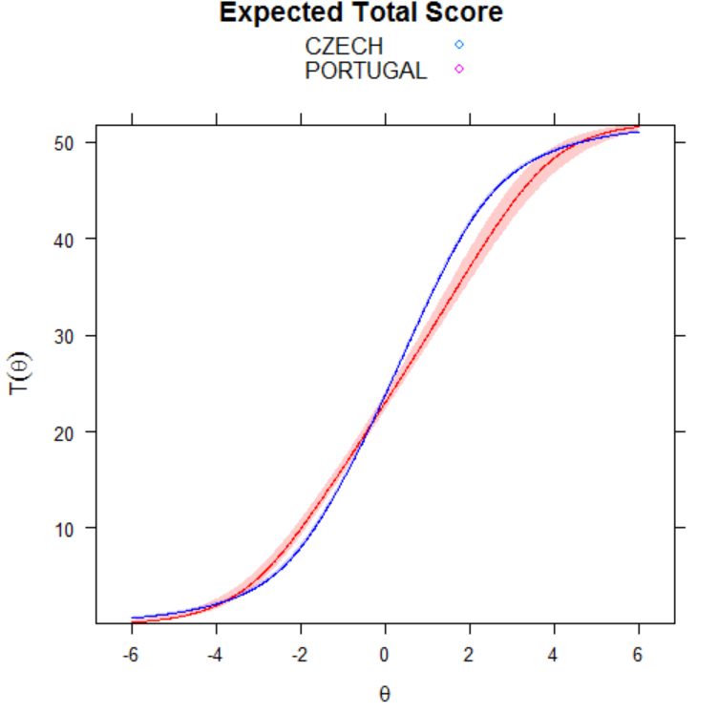

Samples: CZECH REPUBLIC – PORTUGAL
Self-compassionate responding
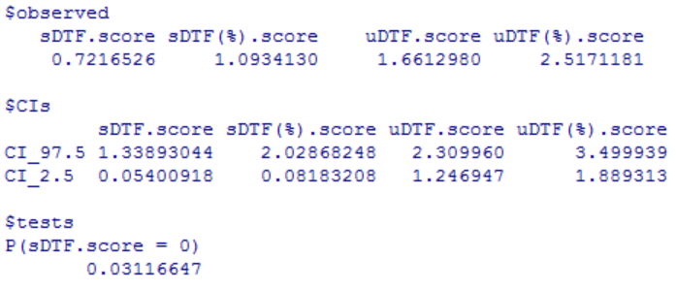
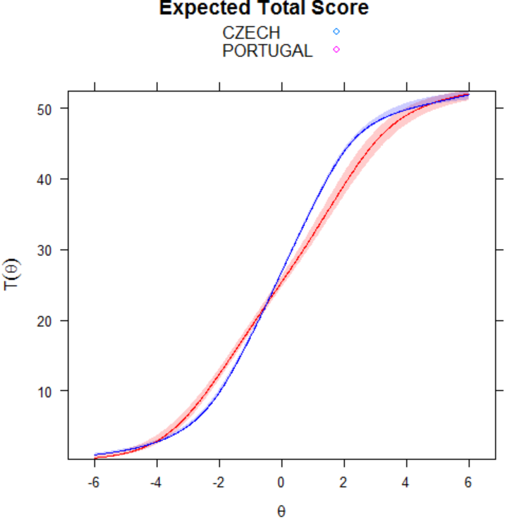

Samples: CZECH REPUBLIC – SLOVAKIA
Self-uncompassionate responding
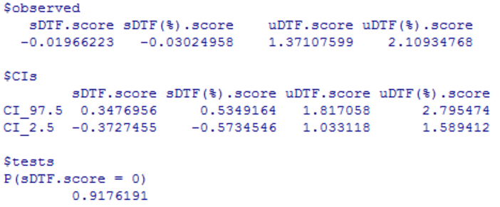
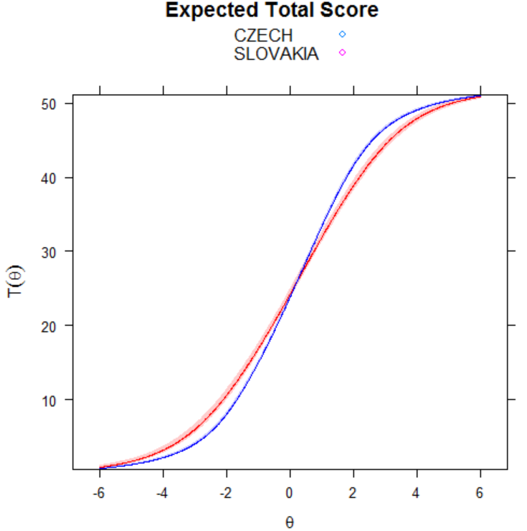

Samples: CZECH REPUBLIC – SLOVAKIA
Self-compassionate responding
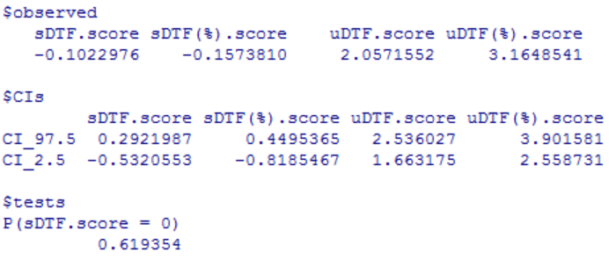
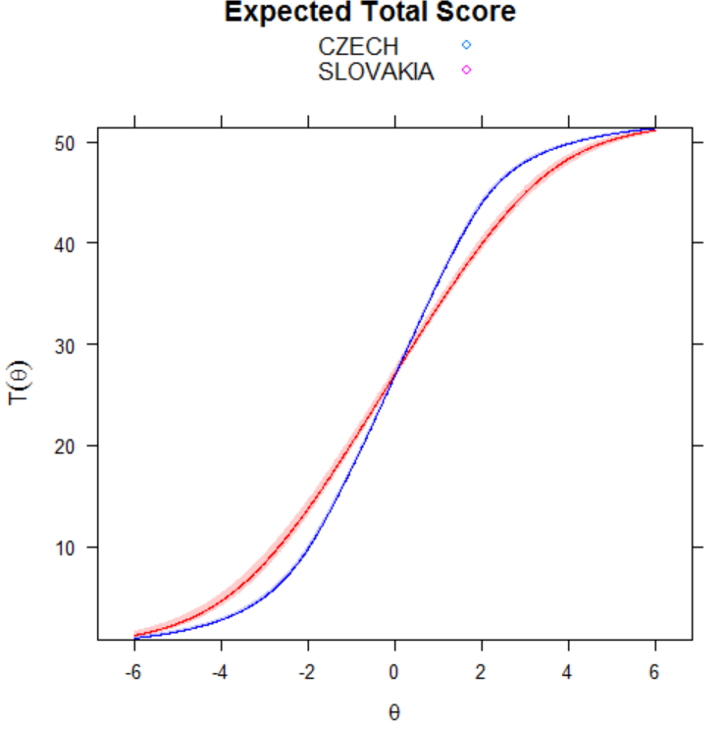

Samples: CZECH REPUBLIC – TURKEY
Self-uncompassionate responding
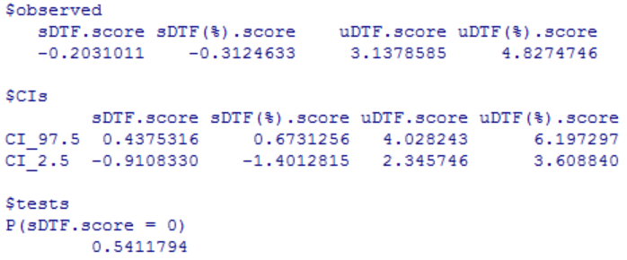
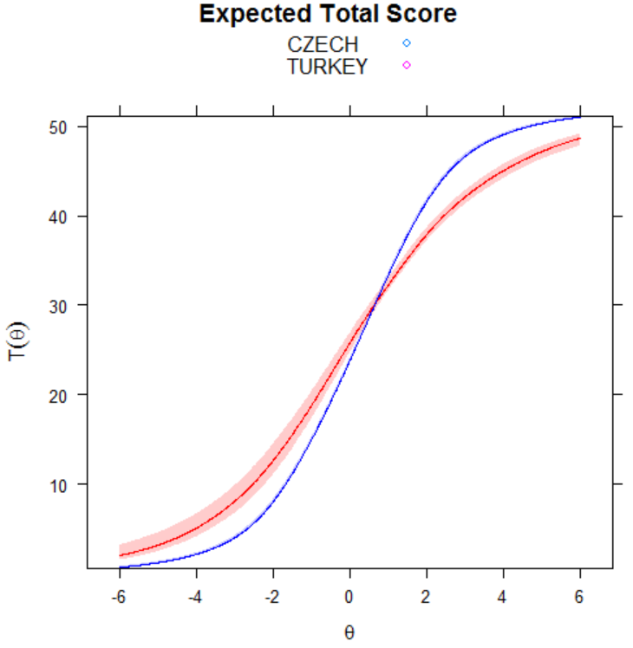

Samples: CZECH REPUBLIC – TURKEY
Self-compassionate responding
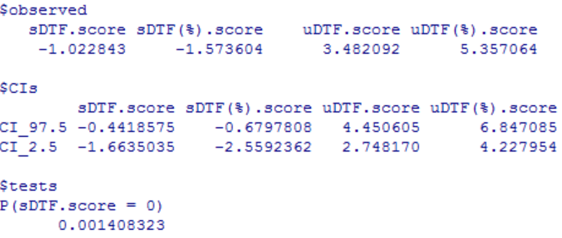
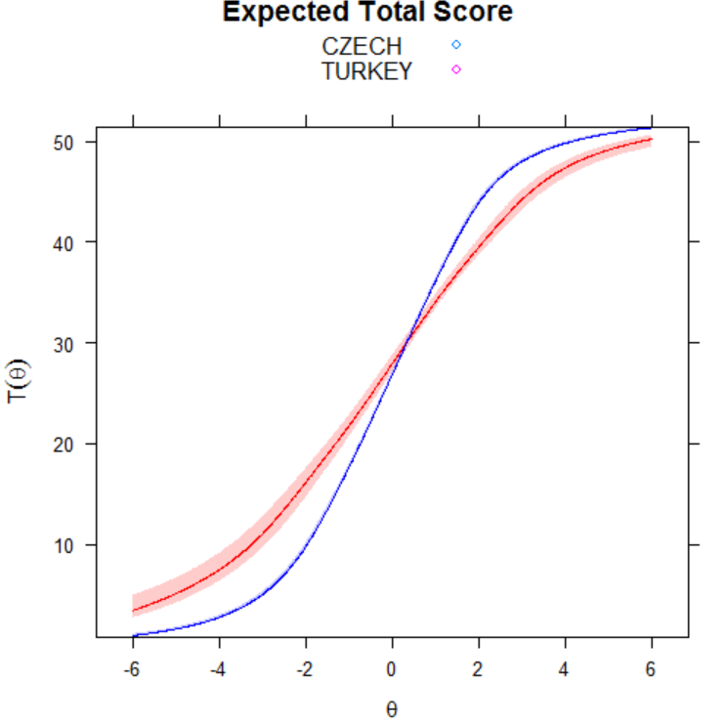

Samples: CZECH REPUBLIC – USA
Self-uncompassionate responding
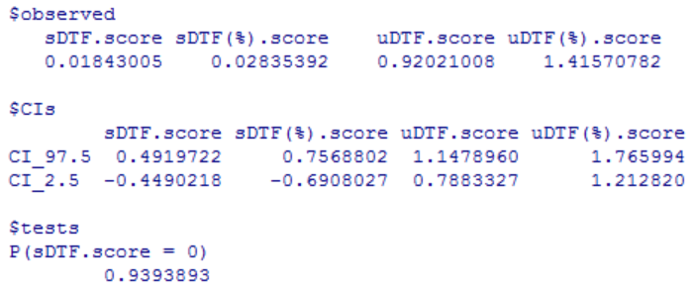
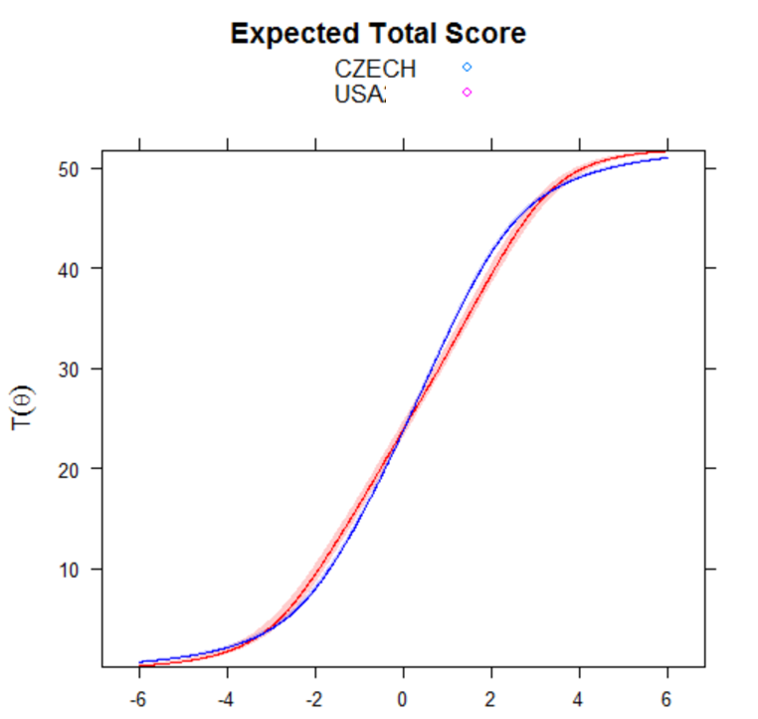

Samples: CZECH REPUBLIC – USA
Self-compassionate responding
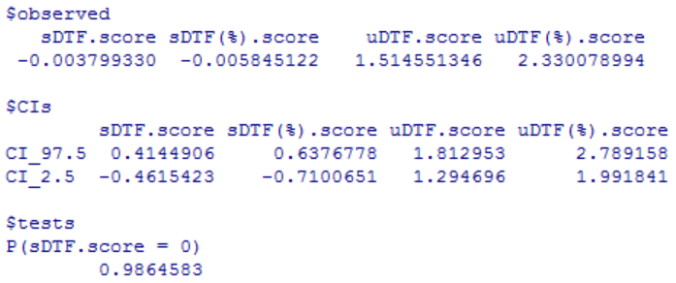
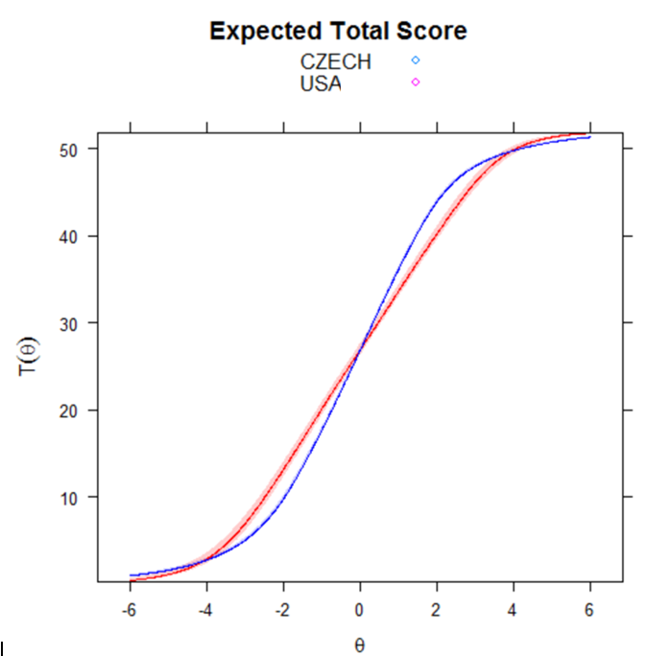

Samples: TURKEY – USA
Self-uncompassionate responding
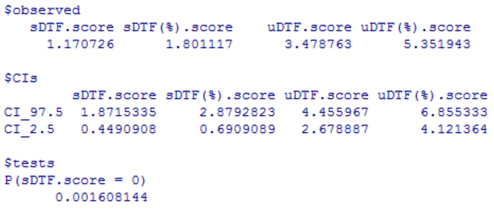
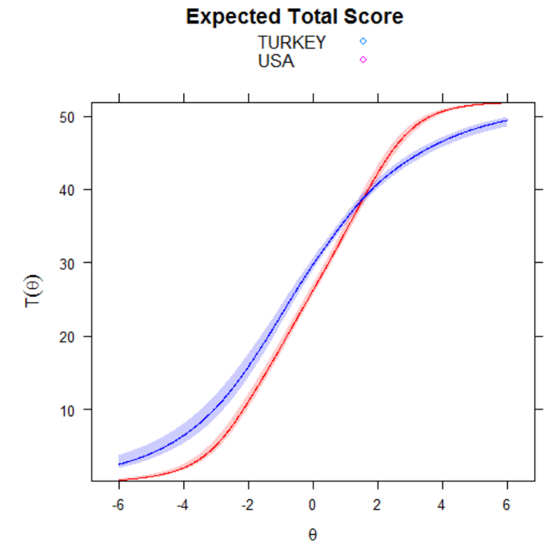

Samples: TURKEY – USA
Self-compassionate responding
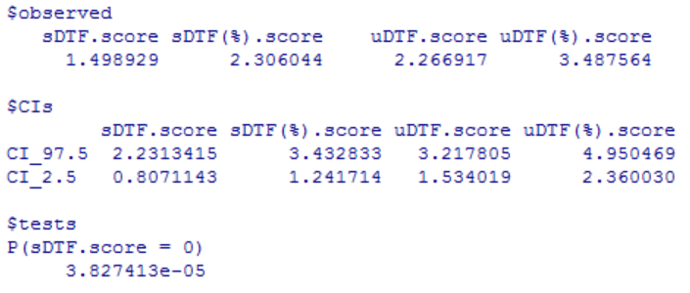
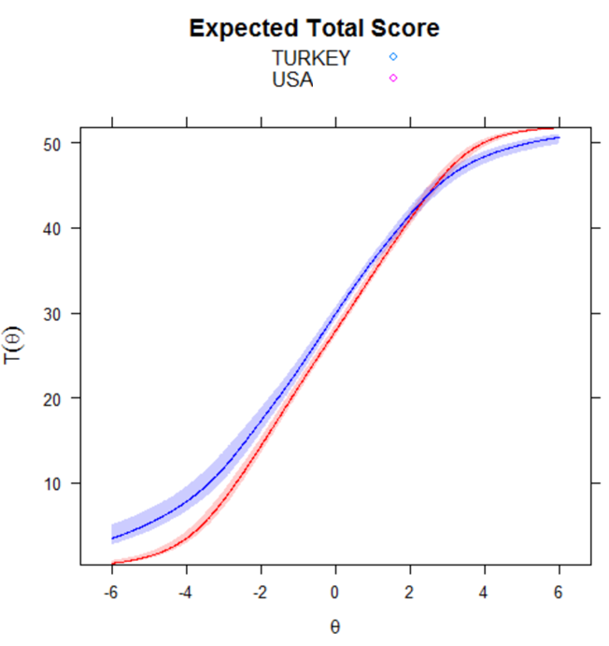

Samples: GERMANY – CHINA
Self-uncompassionate responding
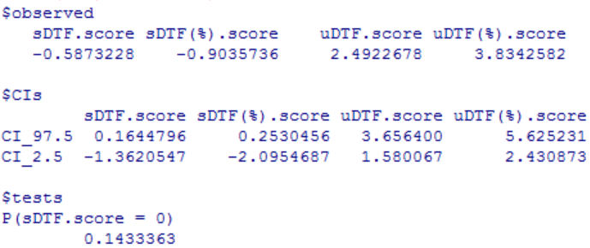
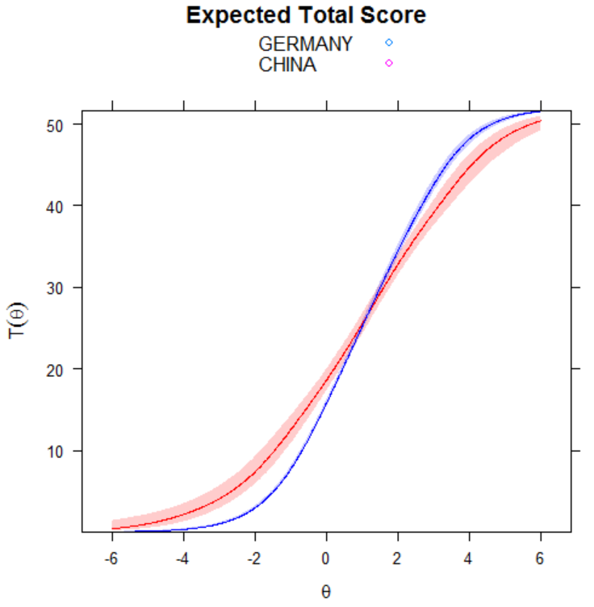

Samples: GERMANY – CHINA
Self-compassionate responding
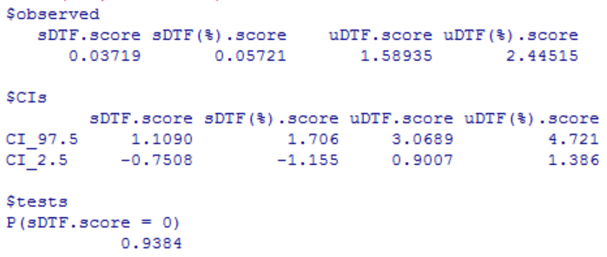
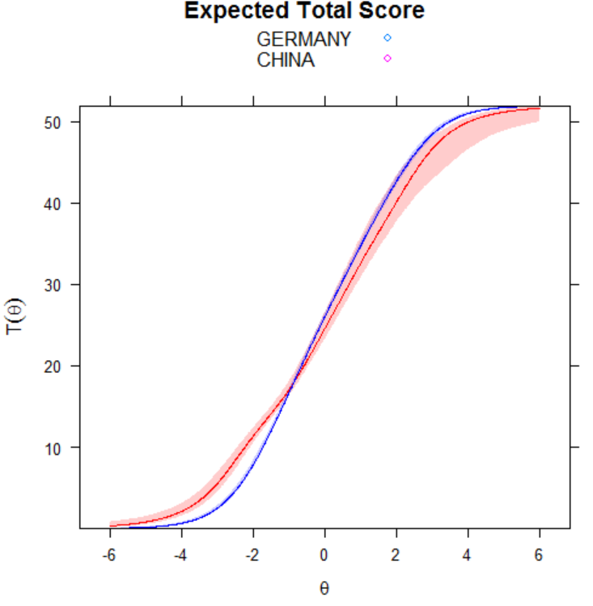

Samples: GERMANY – ITALY
Self-uncompassionate responding
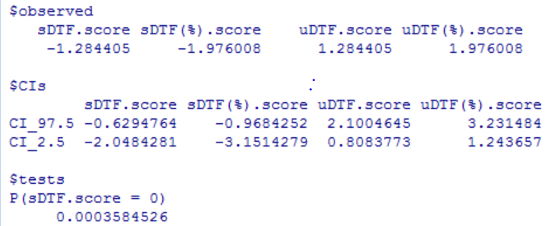
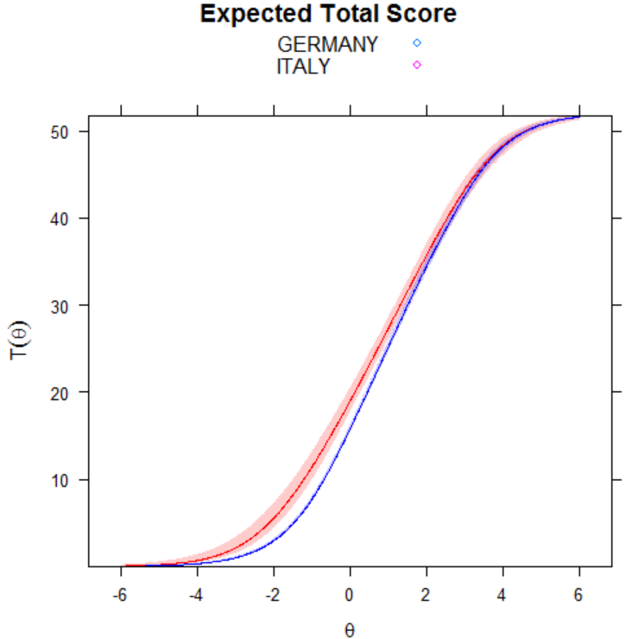

Samples: GERMANY – ITALY
Self-compassionate responding
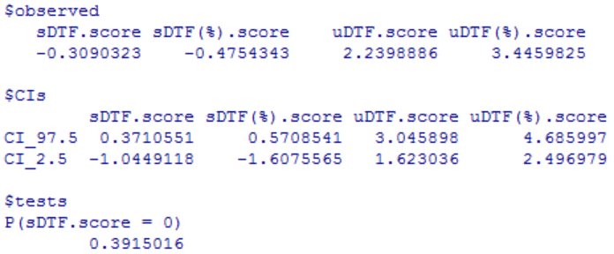
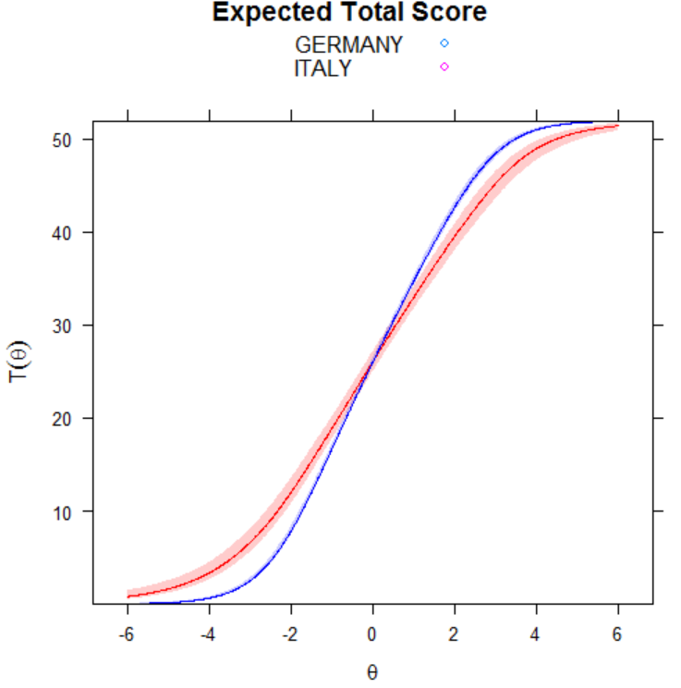

Samples: GERMANY – KOREA
Self-uncompassionate responding
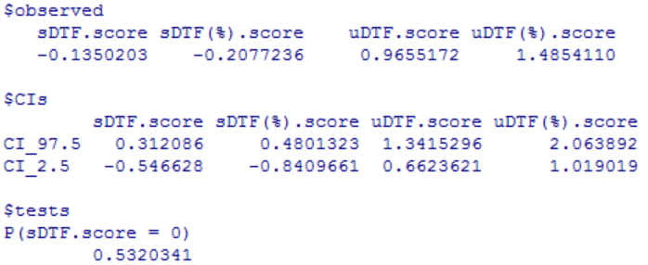
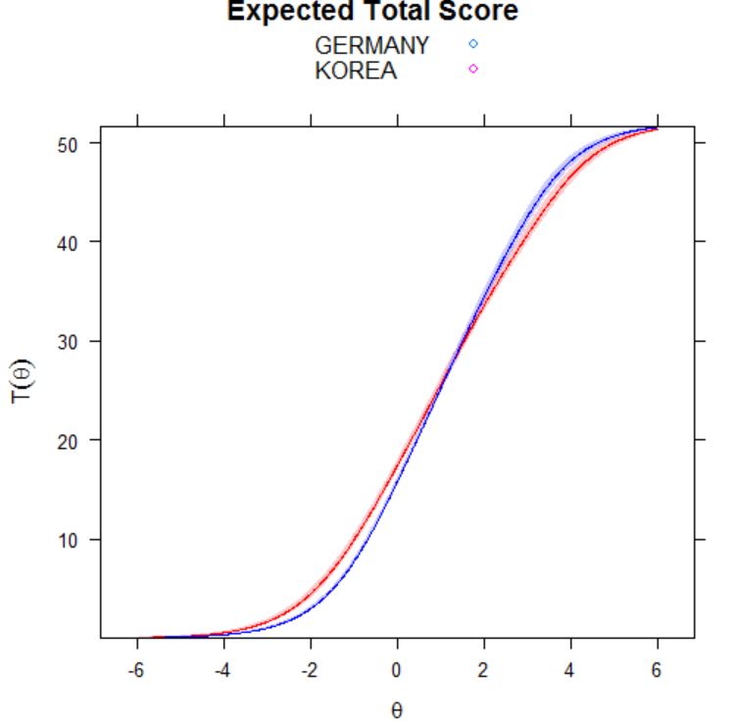

Samples: GERMANY – KOREA
Self-compassionate responding
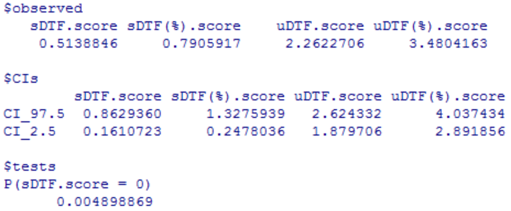
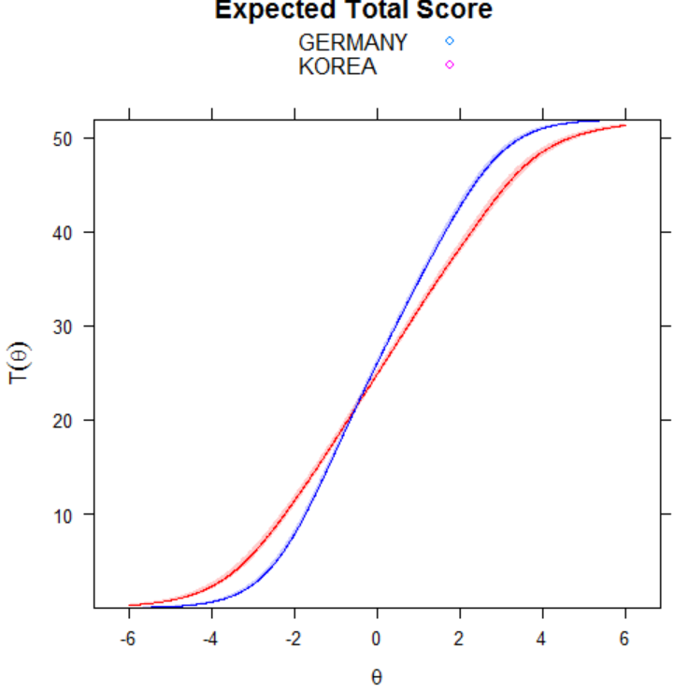

Samples: GERMANY – PORTUGAL
Self-uncompassionate responding
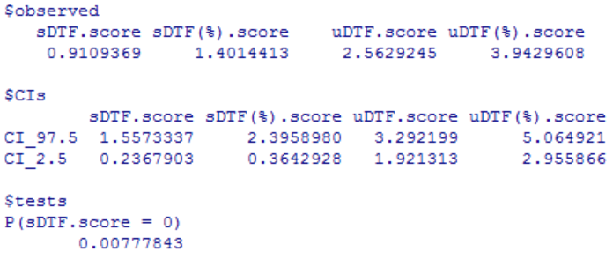
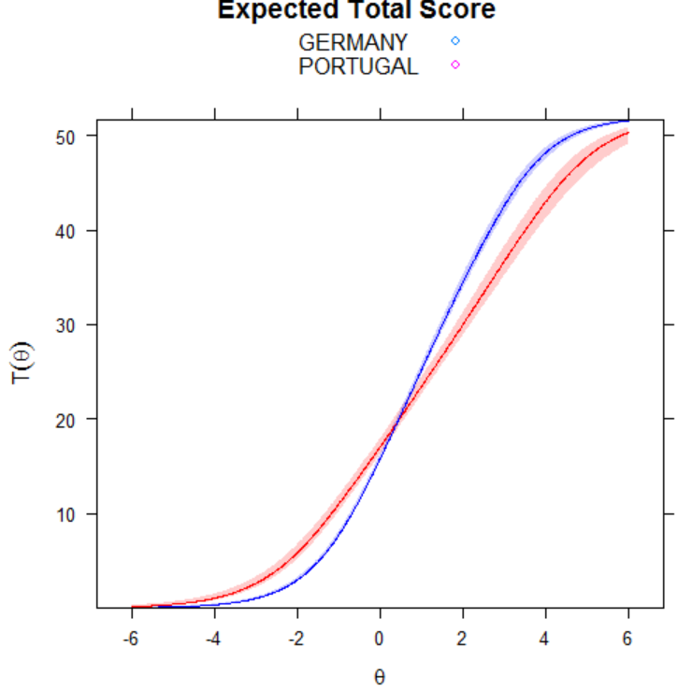

Samples: GERMANY – PORTUGAL
Self-compassionate responding
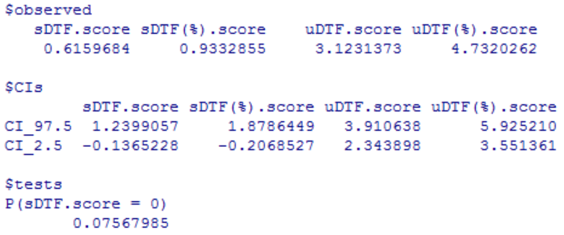
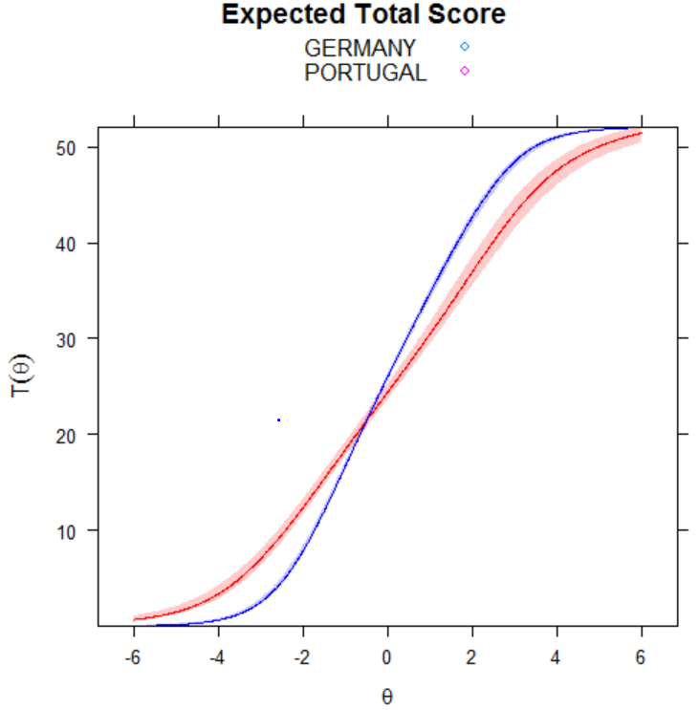

Samples: GERMANY – SLOVAKIA
Self-uncompassionate responding
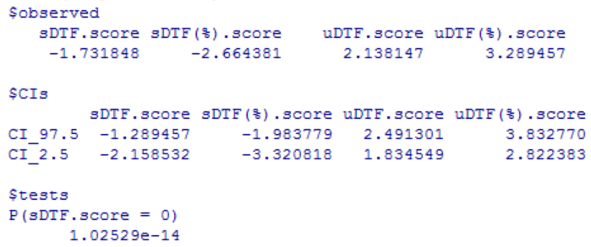
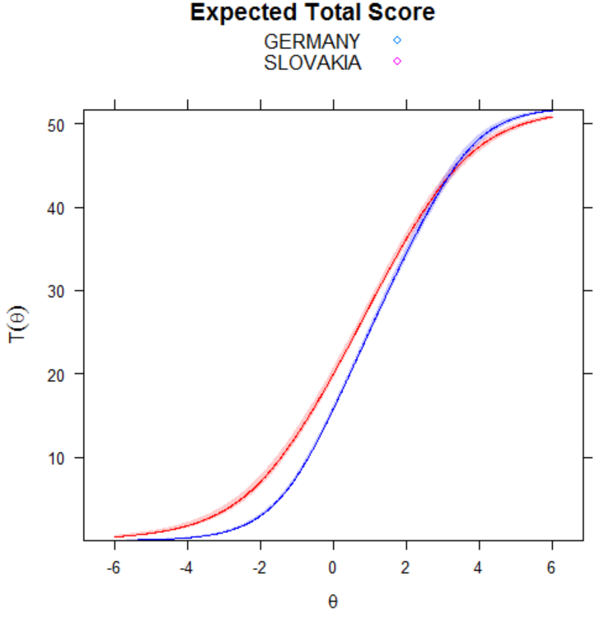

Samples: GERMANY – SLOVAKIA
Self-compassionate responding
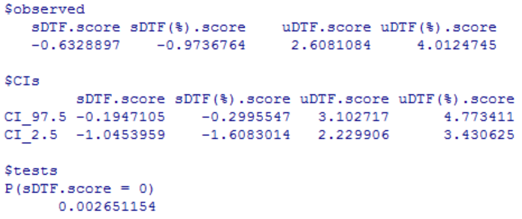
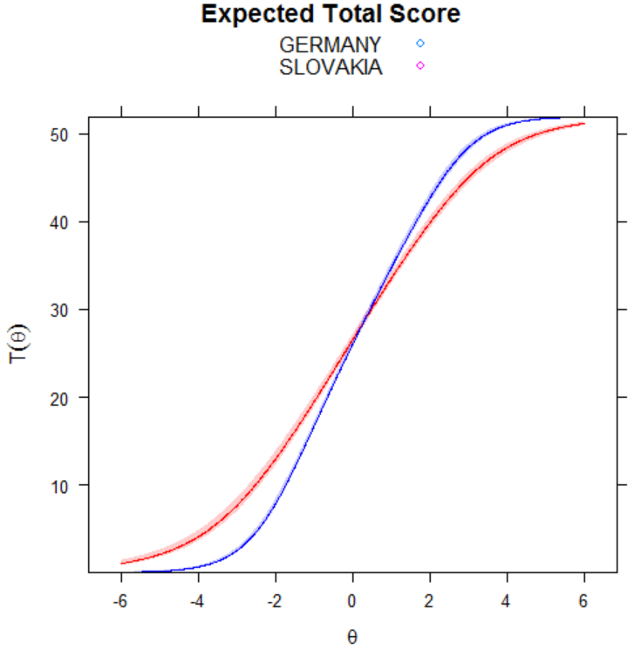

Samples: GERMANY – TURKEY
Self-uncompassionate responding
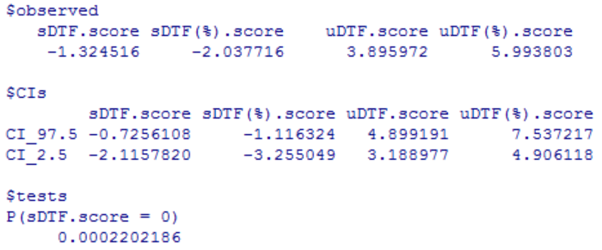
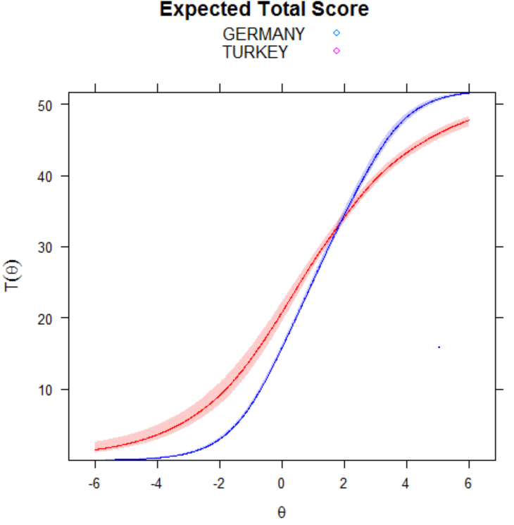

Samples: GERMANY – TURKEY
Self-compassionate responding
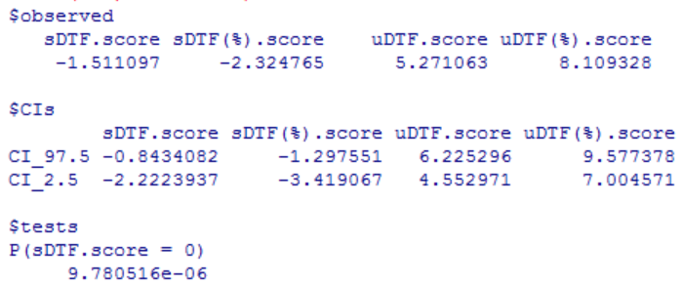
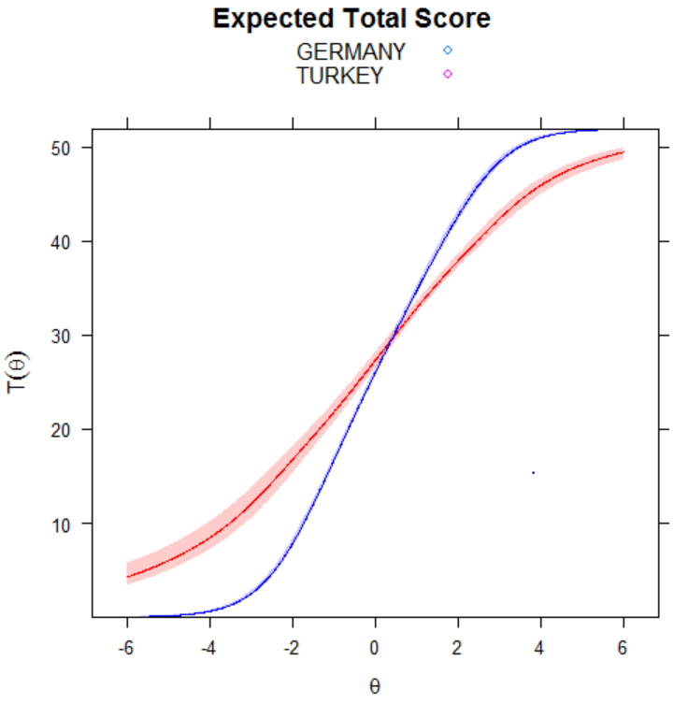

Samples: GERMANY – USA
Self-uncompassionate responding
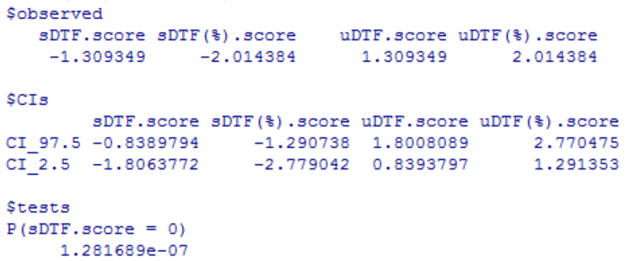
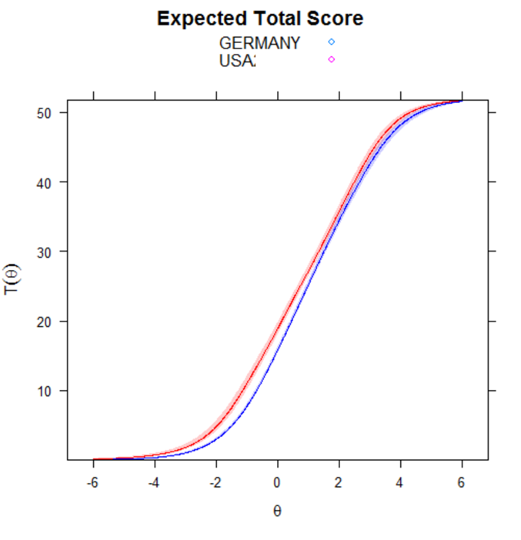

Samples: GERMANY – USA
Self-compassionate responding
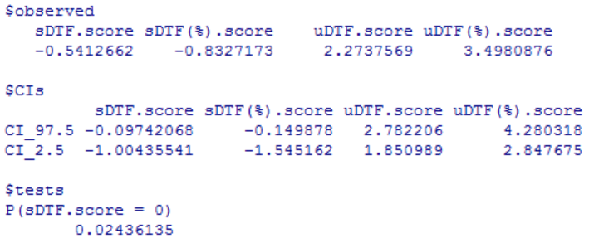
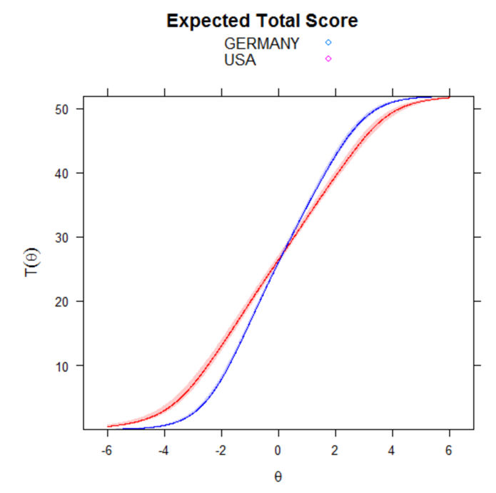

Samples: SLOVAKIA - TURKEY
Self-uncompassionate responding
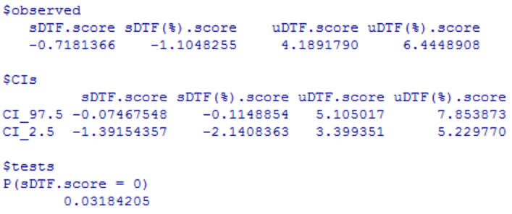
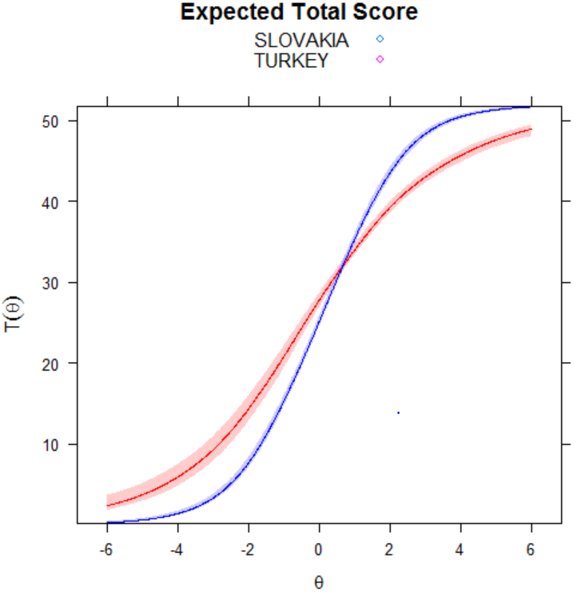

Samples: SLOVAKIA - TURKEY
Self-compassionate responding
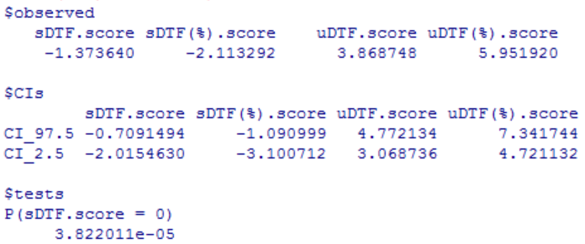
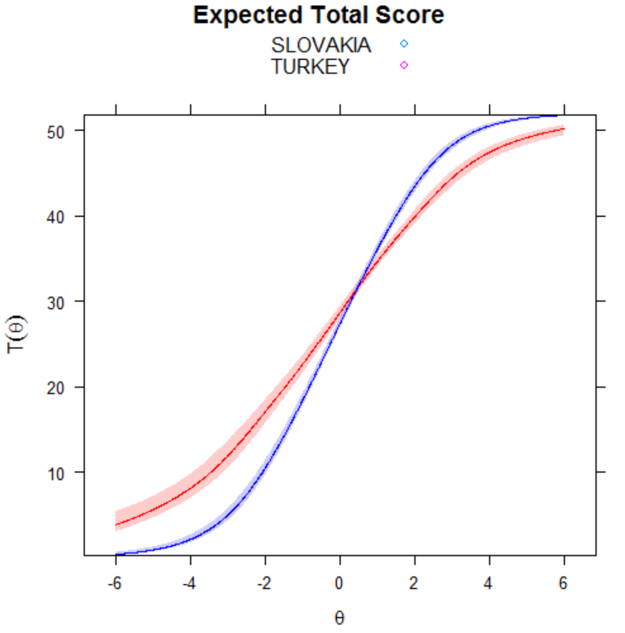

Samples: SLOVAKIA – USA
Self-uncompassionate responding
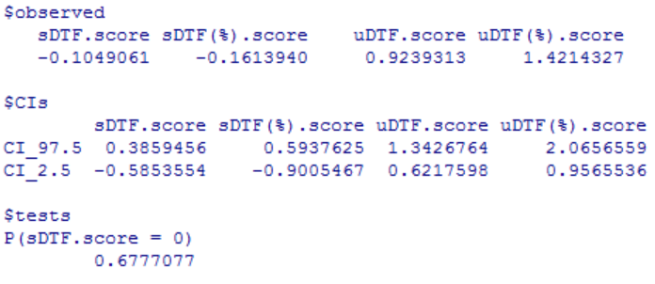
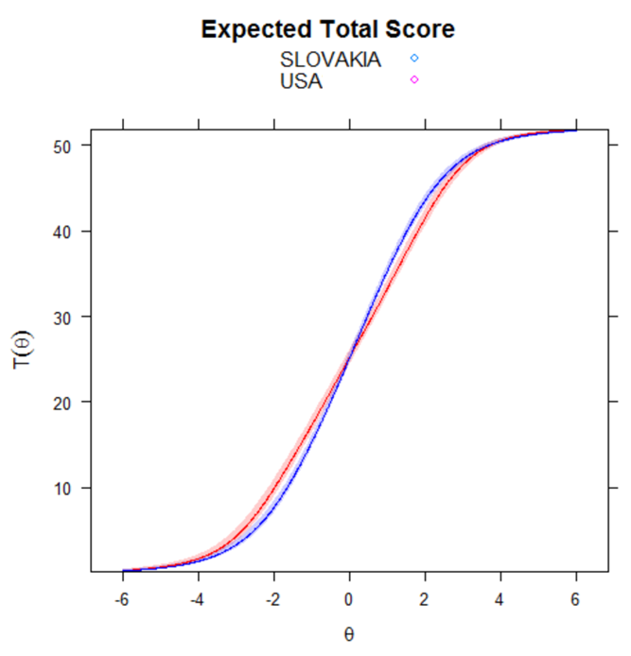

Samples: SLOVAKIA – USA
Self-compassionate responding
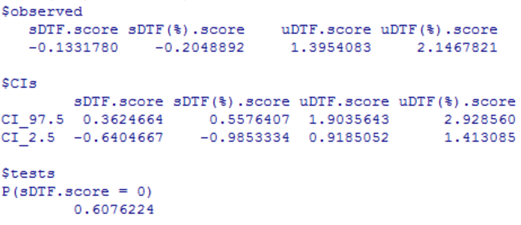
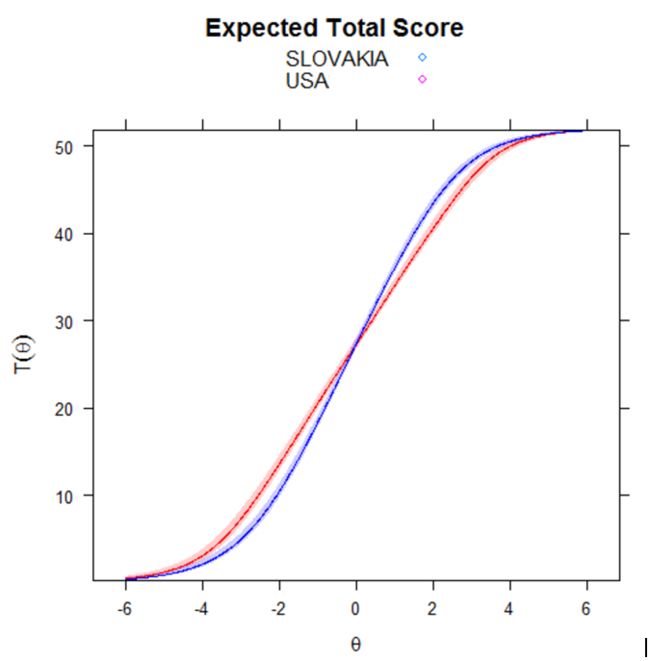

Samples: PORTUGAL – SLOVAKIA
Self-uncompassionate responding
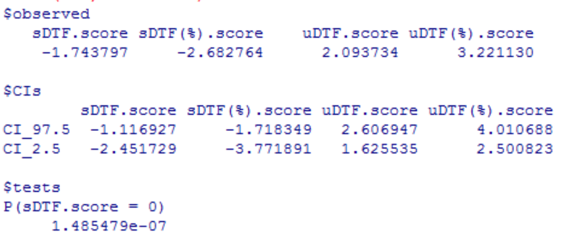
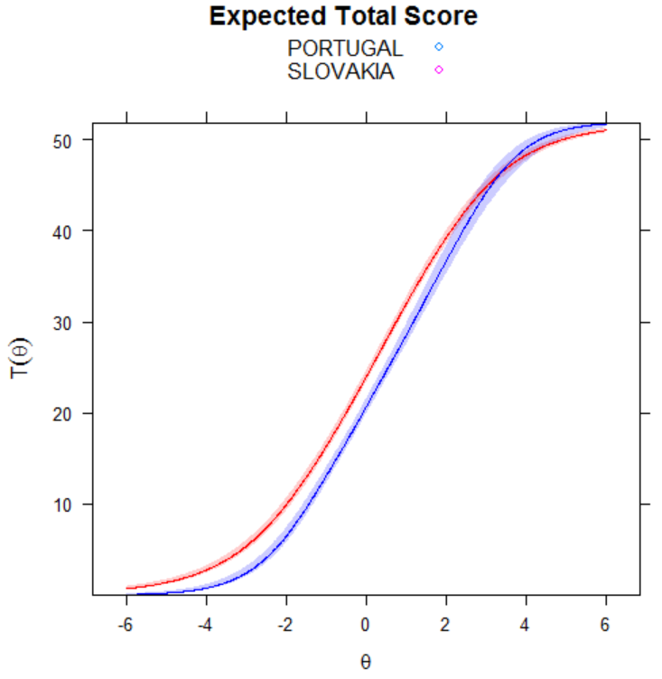

Samples: PORTUGAL – SLOVAKIA
Self-compassionate responding
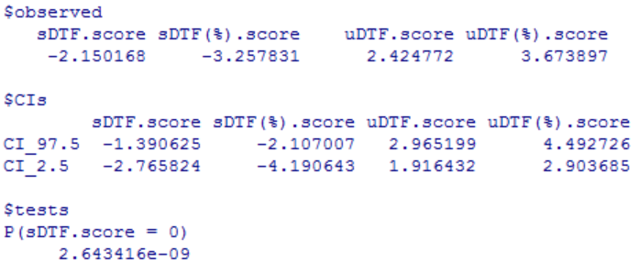
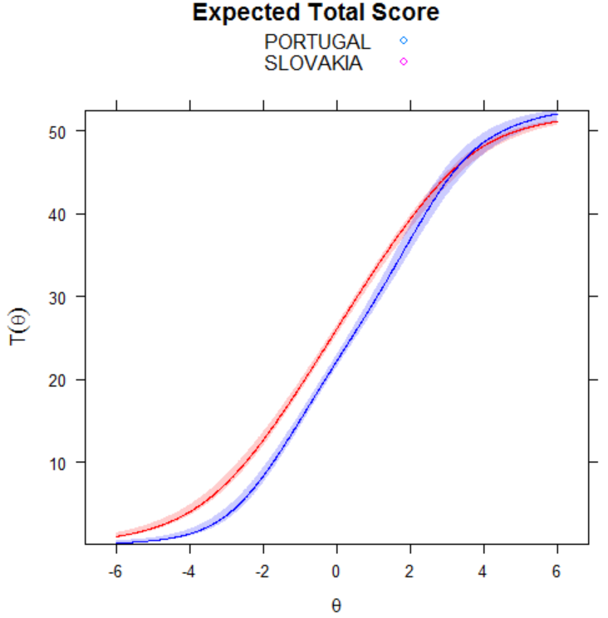

Samples: PORTUGAL – TURKEY
Self-uncompassionate responding
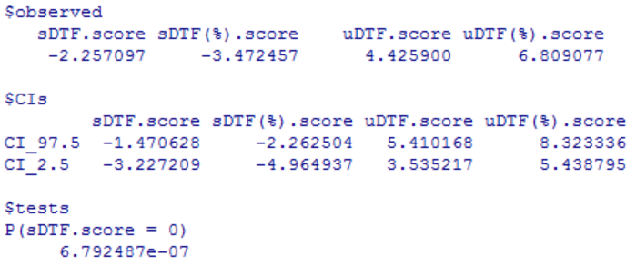
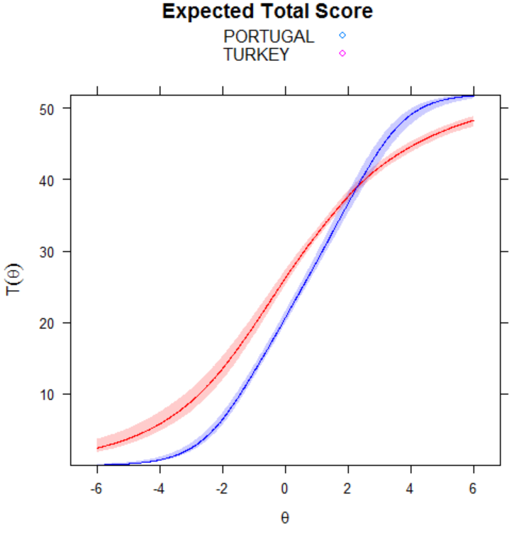

Samples: PORTUGAL – TURKEY
Self-compassionate responding
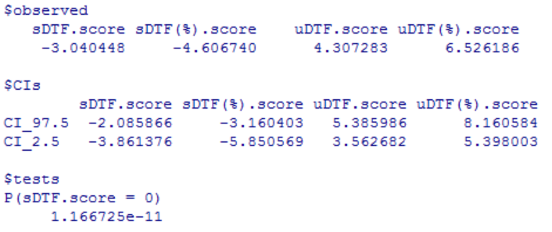
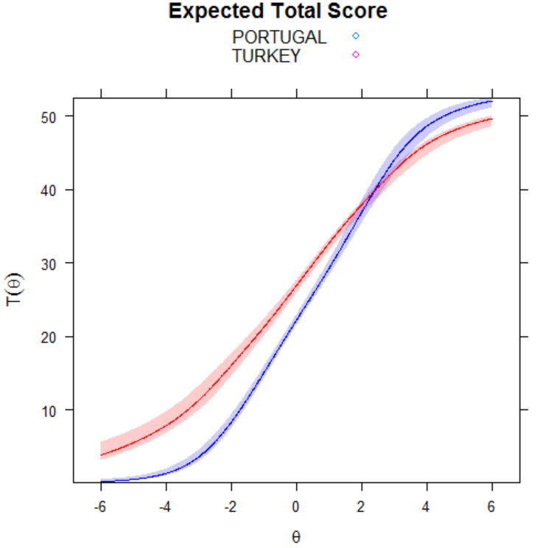

Samples: PORTUGAL – USA
Self-uncompassionate responding
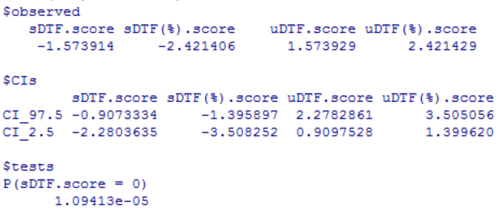
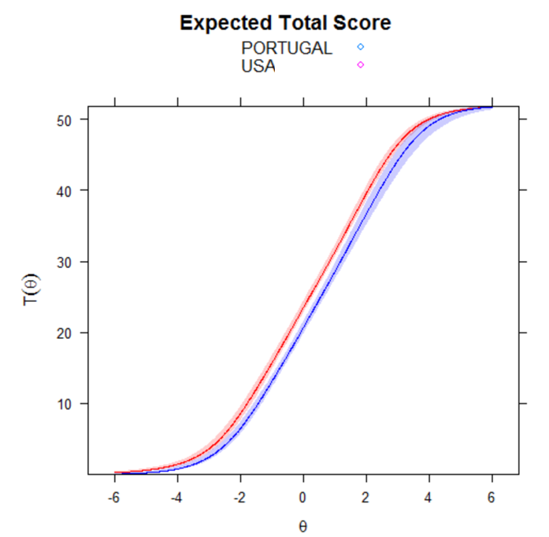

Samples: PORTUGAL – USA
Self-compassionate responding
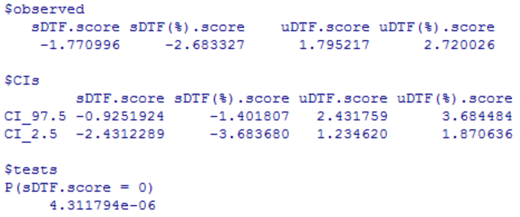
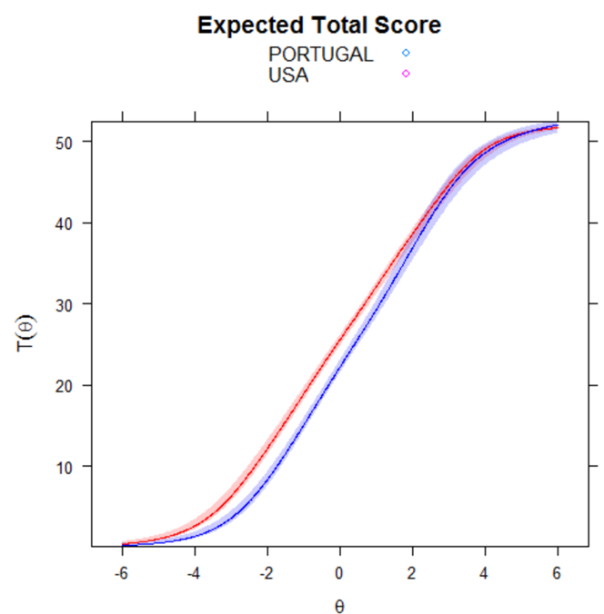

Samples: KOREA – PORTUGAL
Self-uncompassionate responding
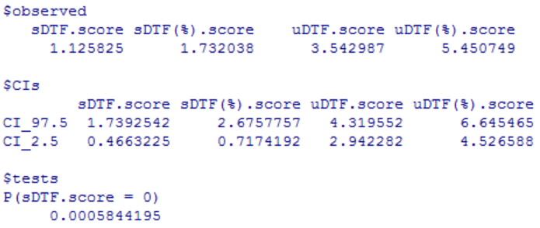
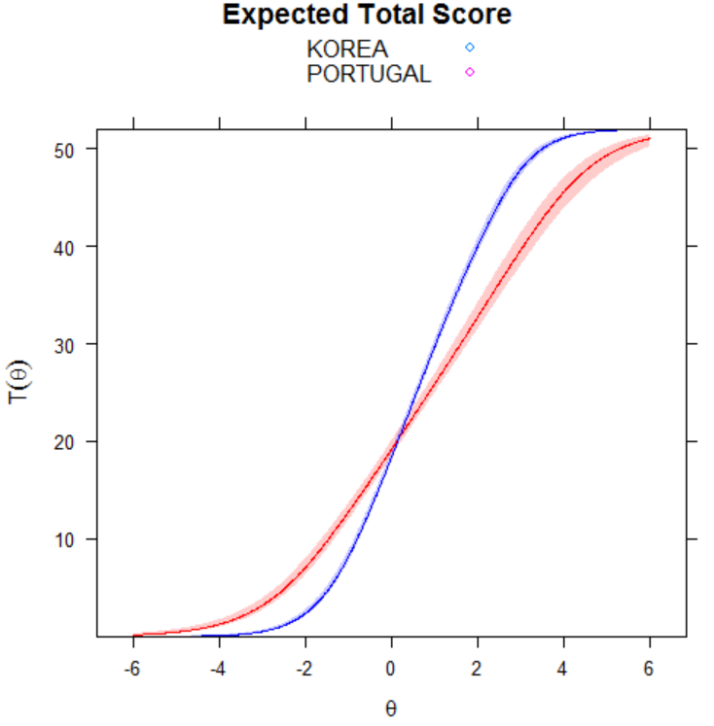

Samples: KOREA – PORTUGAL
Self-compassionate responding
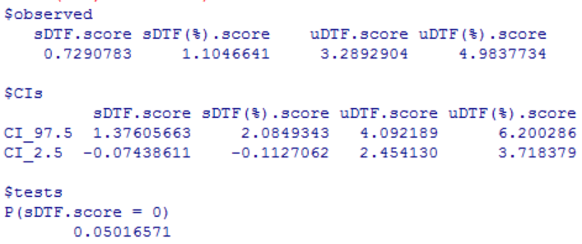
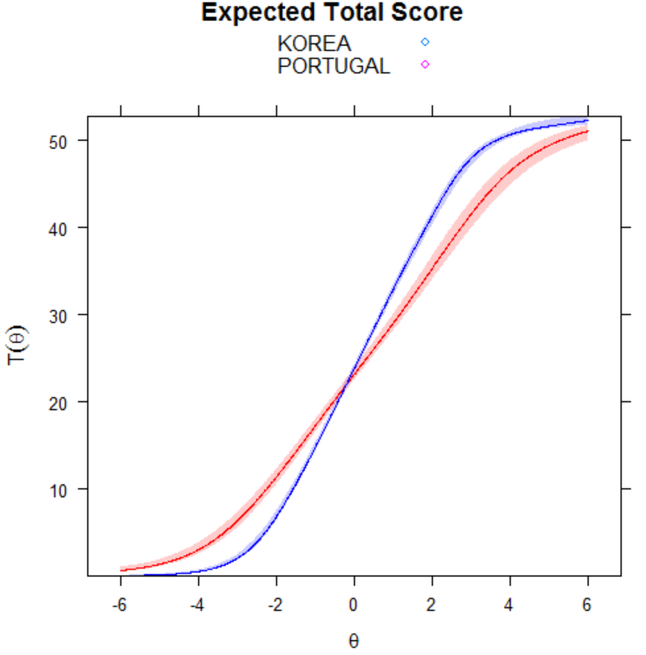

Samples: KOREA – SLOVAKIA
Self-uncompassionate responding
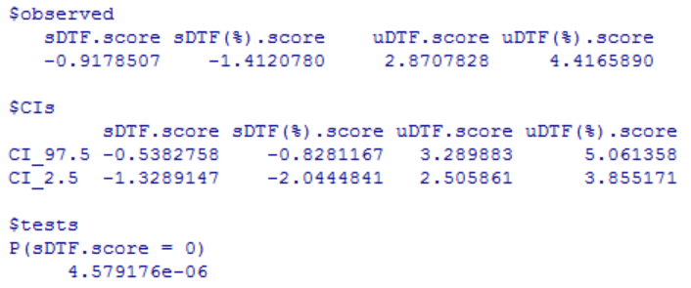
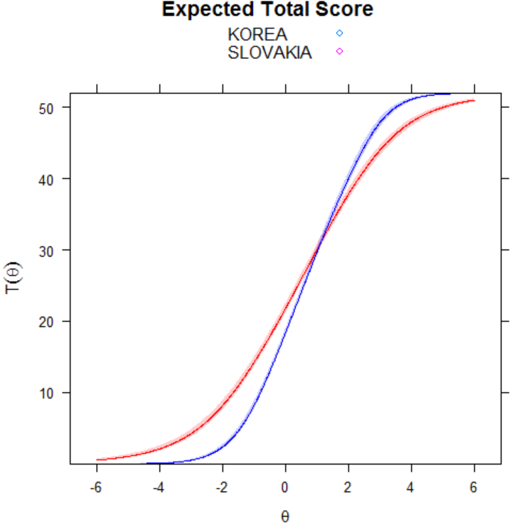

Samples: KOREA – SLOVAKIA
Self-compassionate responding
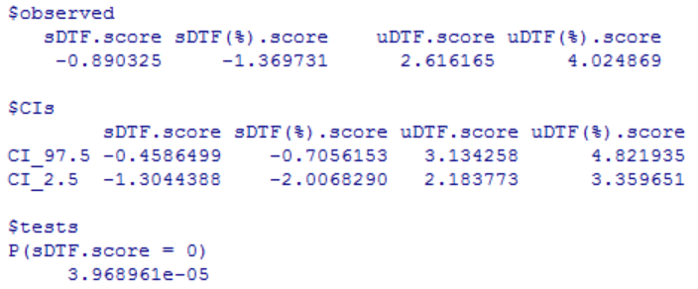
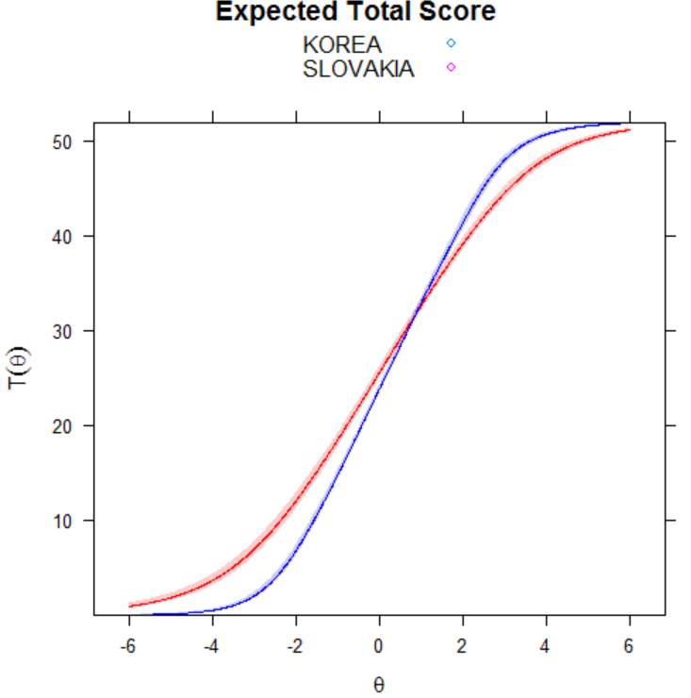

Samples: KOREA – TURKEY
Self-uncompassionate responding
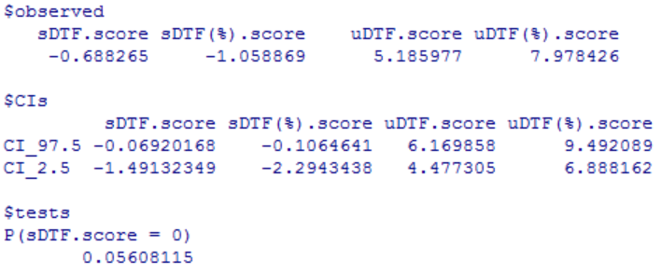
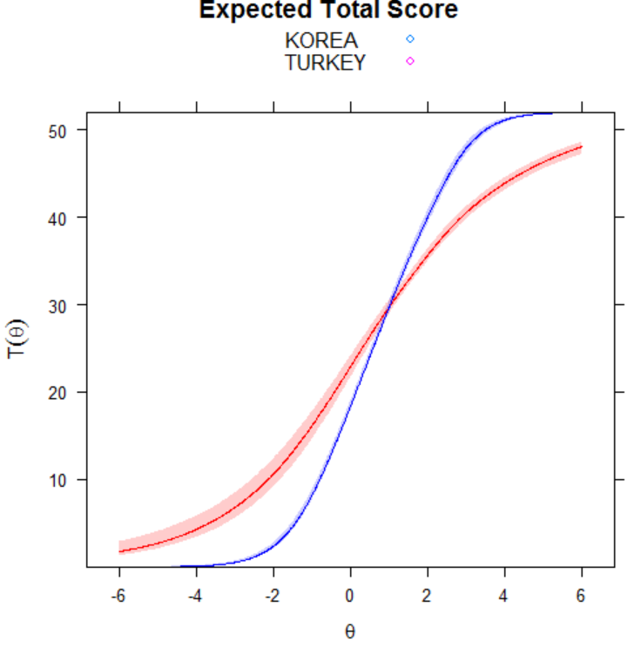

Samples: KOREA – TURKEY
Self-compassionate responding
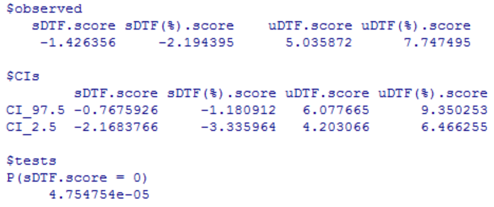
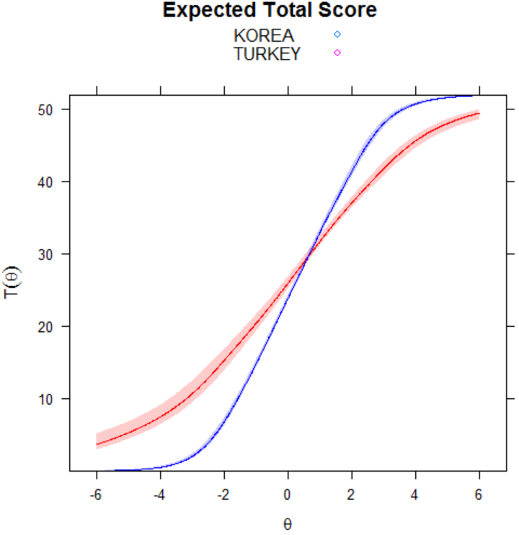

Samples: KOREA – USA
Self-uncompassionate responding
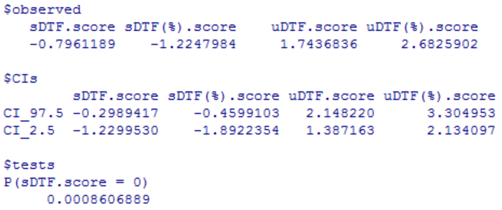
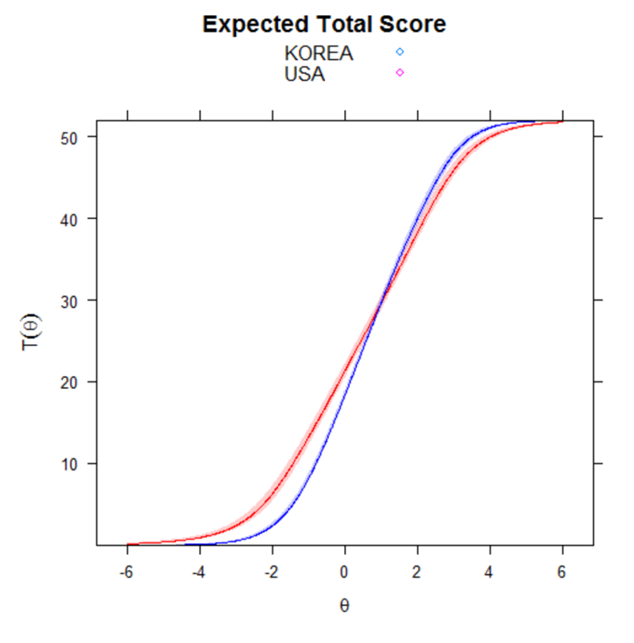

Samples: KOREA – USA
Self-compassionate responding
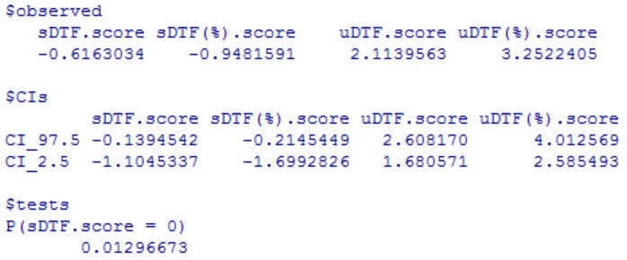
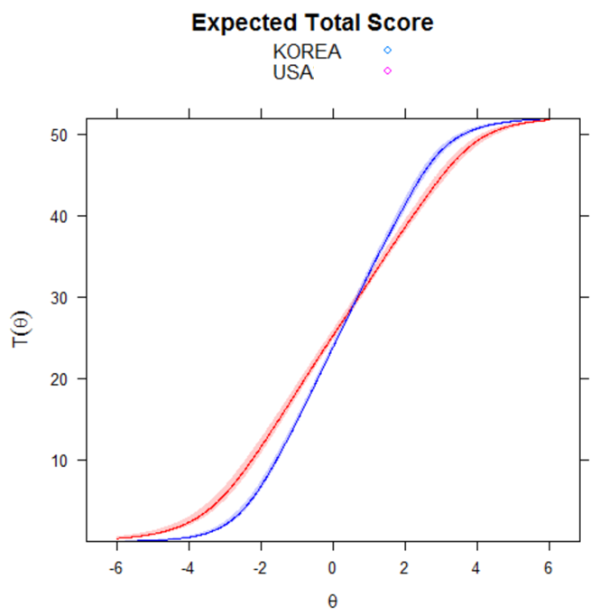

Samples: ITALY – KOREA
Self-uncompassionate responding
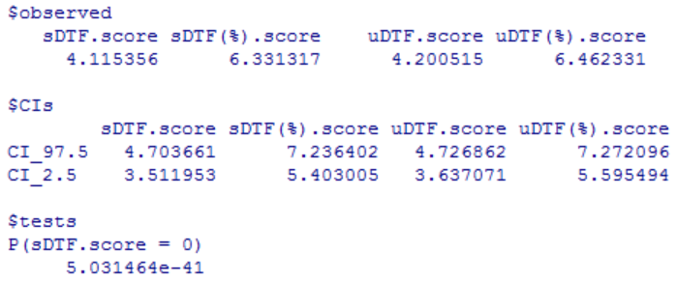
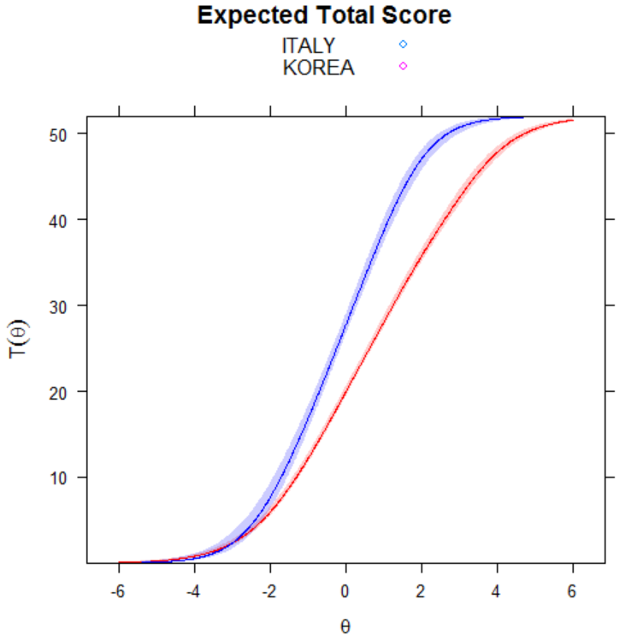

Samples: ITALY – KOREA
Self-compassionate responding
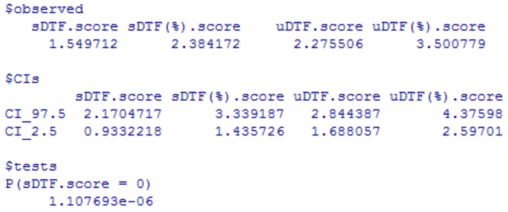
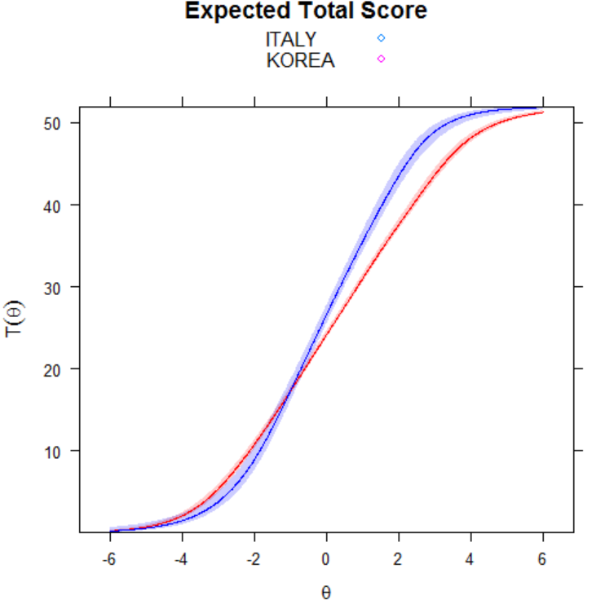

Samples: ITALY – PORTUGAL
Self-uncompassionate responding
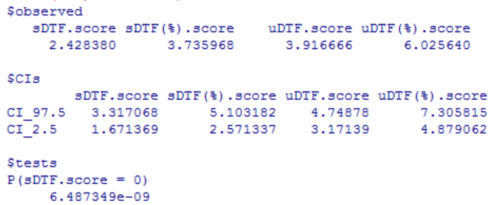
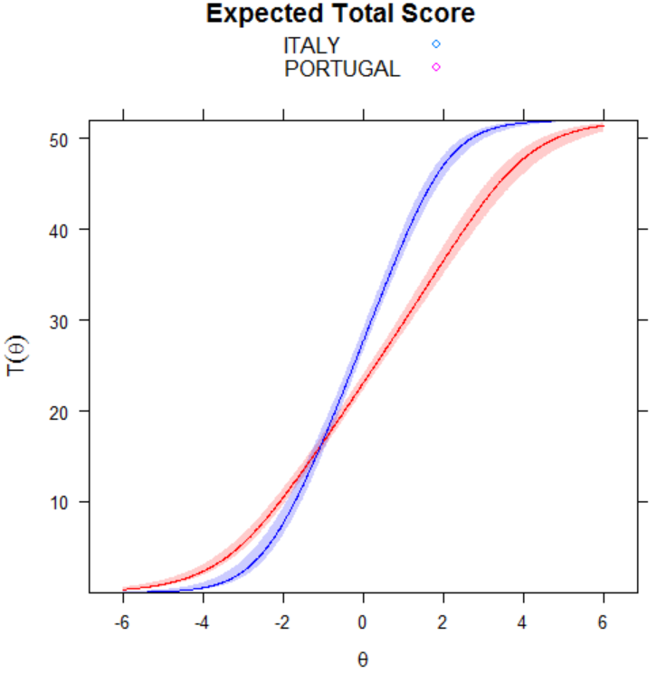

Samples: ITALY – PORTUGAL
Self-compassionate responding
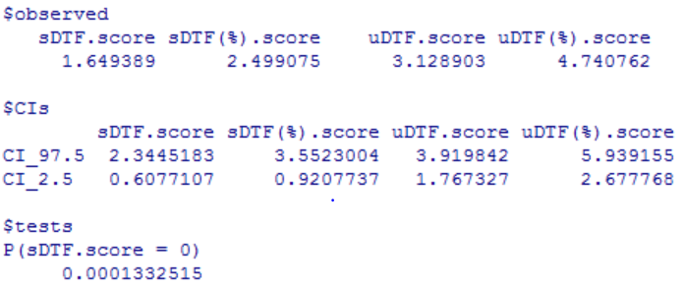
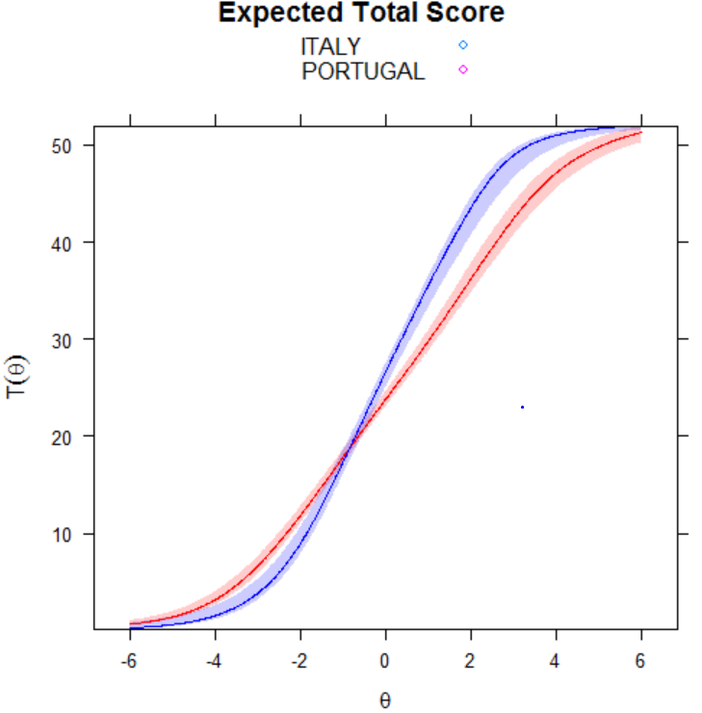

Samples: ITALY – SLOVAKIA
Self-uncompassionate responding
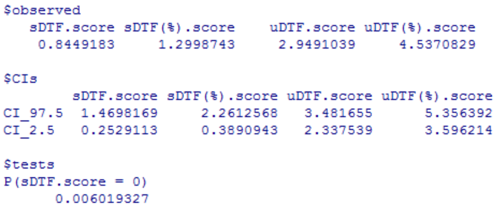
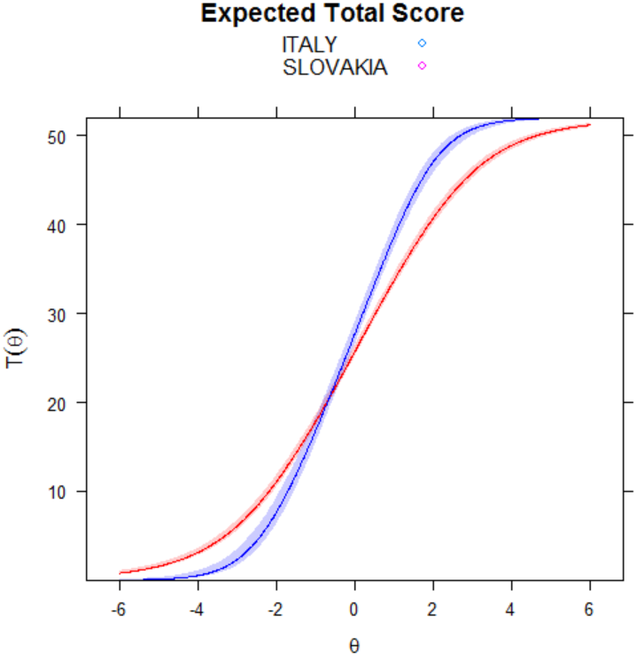

Samples: ITALY – SLOVAKIA
Self-compassionate responding
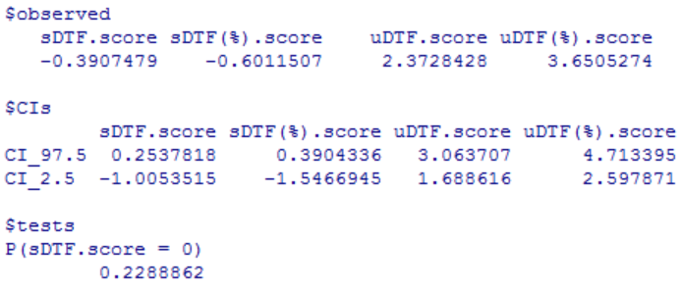
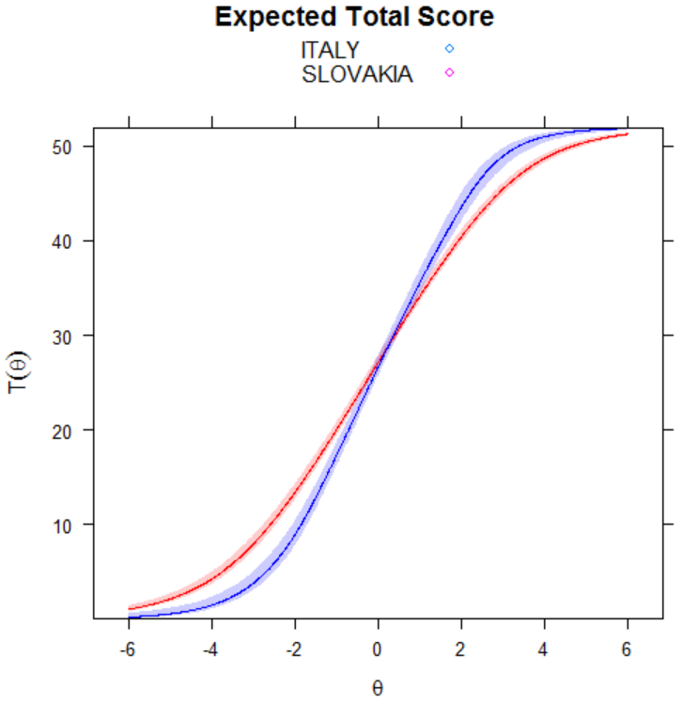

Samples: ITALY – TURKEY
Self-uncompassionate responding
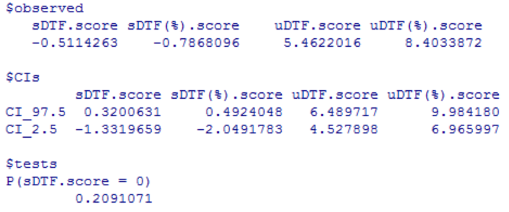
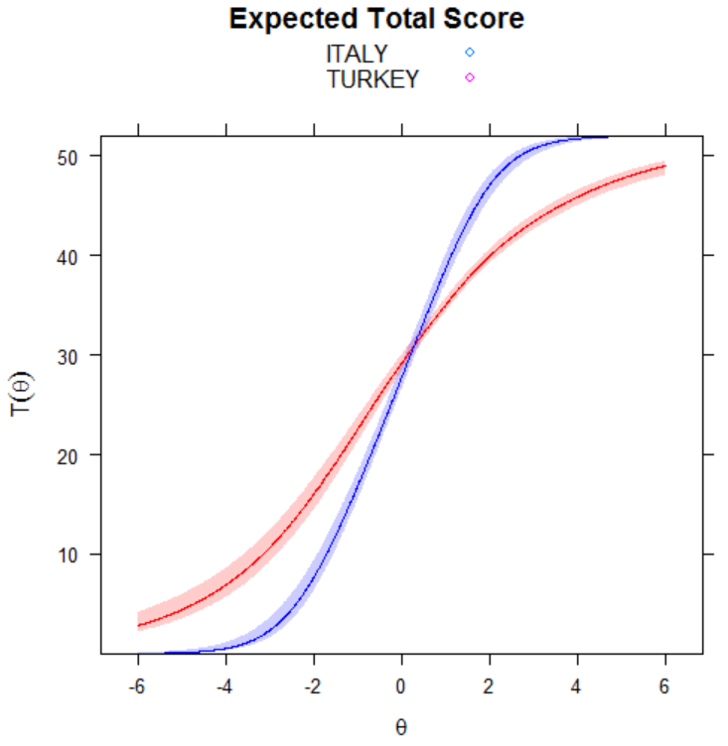

Samples: ITALY – TURKEY
Self-compassionate responding
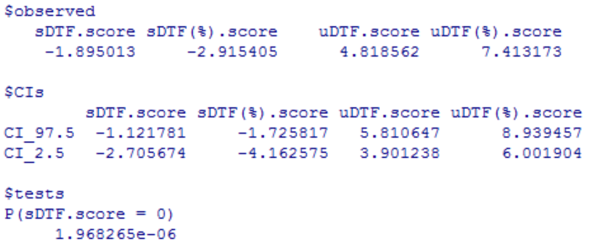
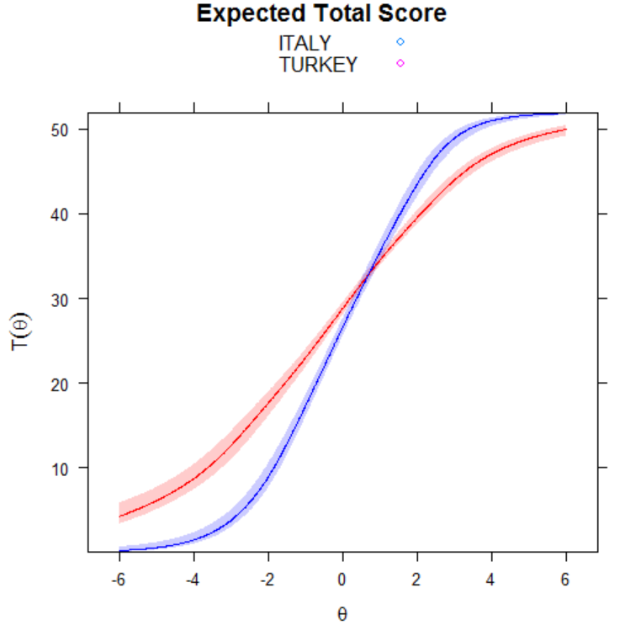

Samples: ITALY – USA
Self-uncompassionate responding
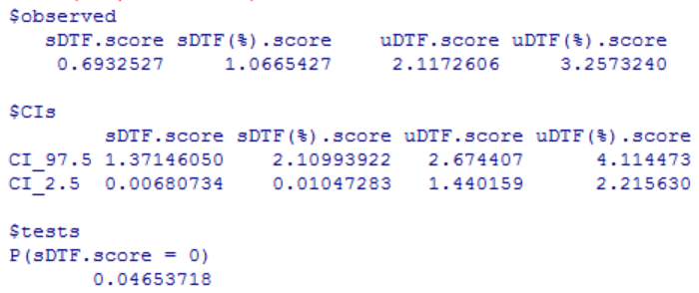
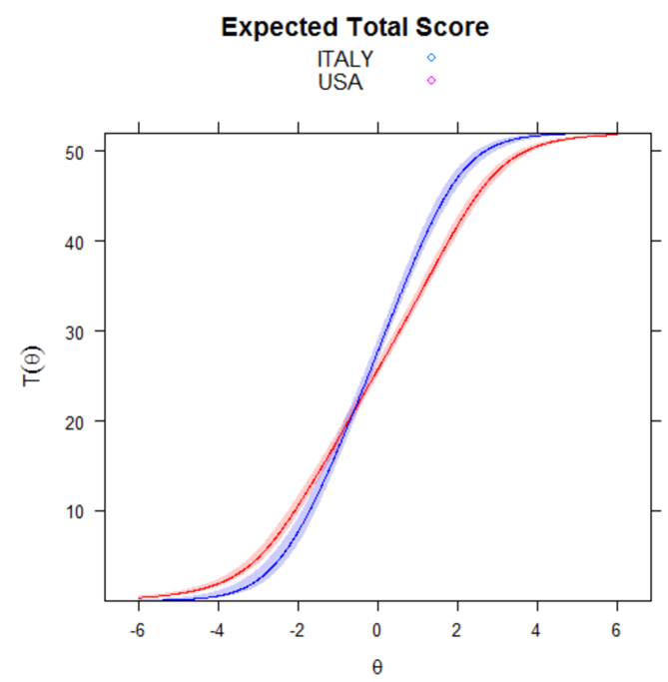

Samples: ITALY – USA
Self-compassionate responding
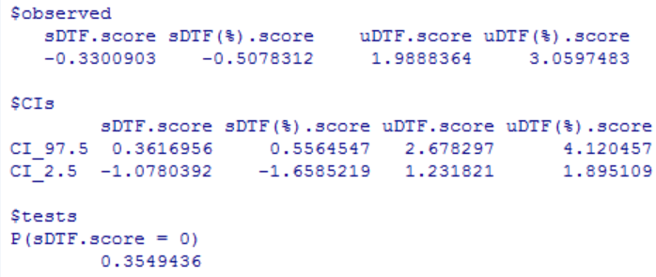
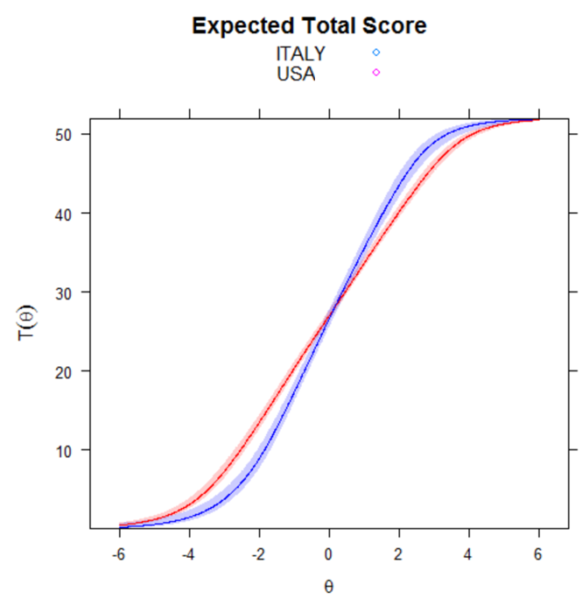

Samples: CHINA – ITALY
Self-uncompassionate responding
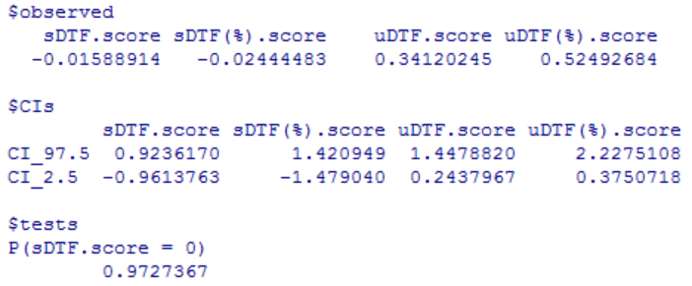
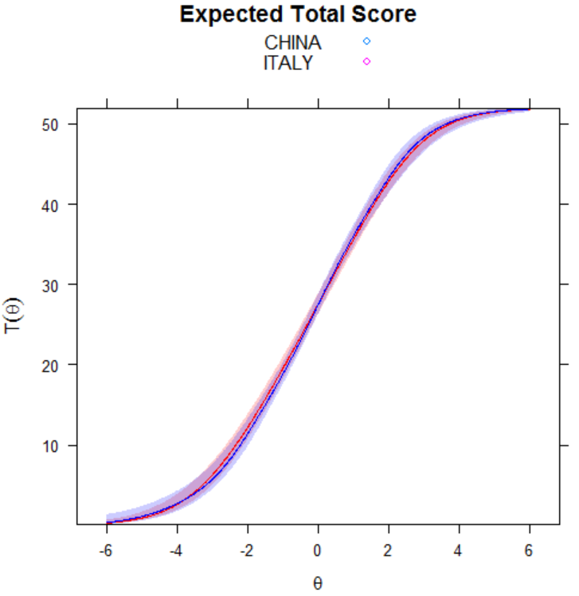

Samples: CHINA – ITALY
Self-compassionate responding
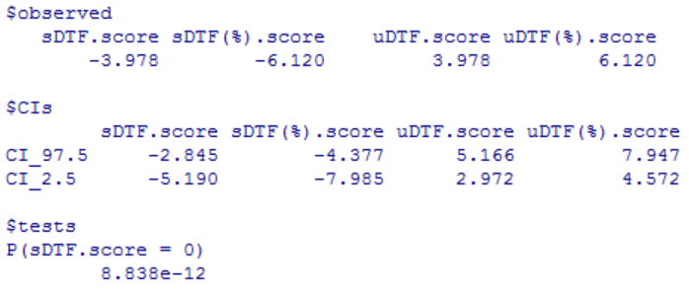
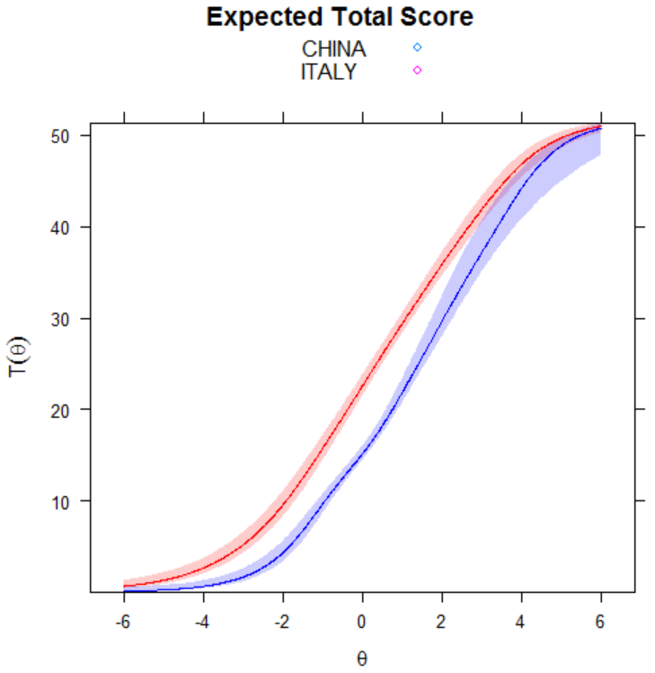

Samples: CHINA – KOREA
Self-uncompassionate responding
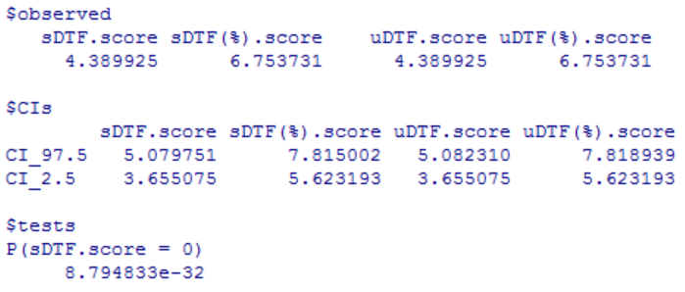
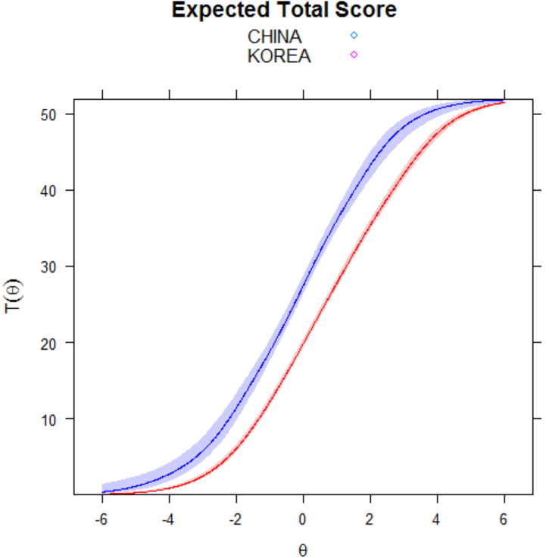

Samples: CHINA – KOREA
Self-compassionate responding
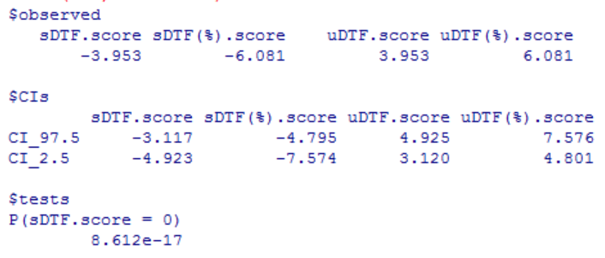
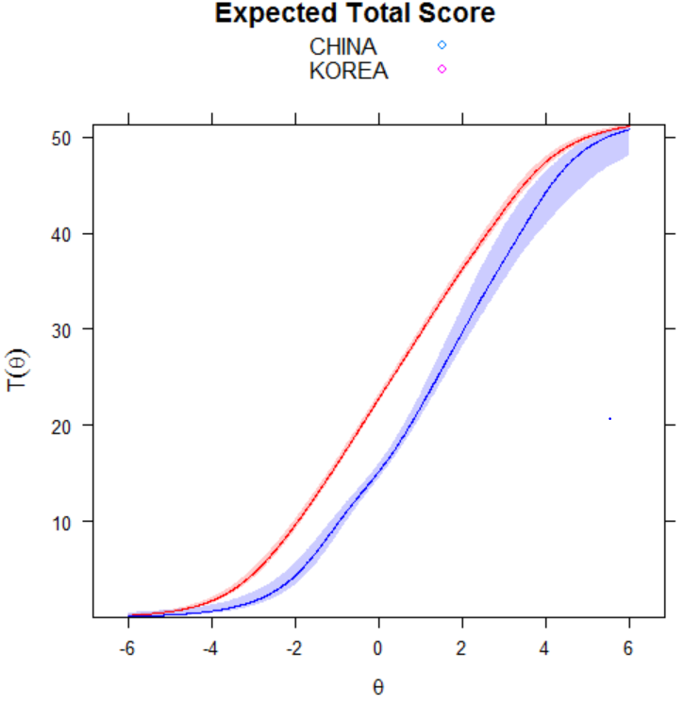

Samples: CHINA – PORTUGAL
Self-uncompassionate responding
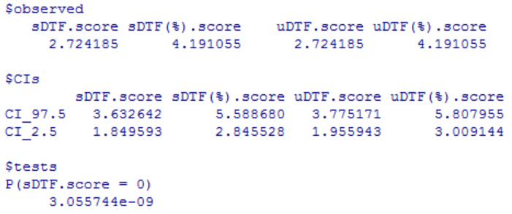
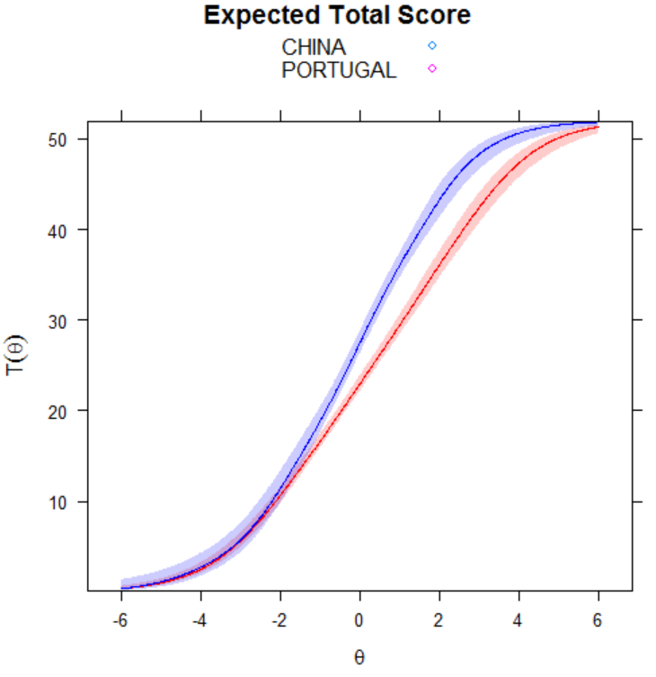

Samples: CHINA – PORTUGAL
Self-compassionate responding
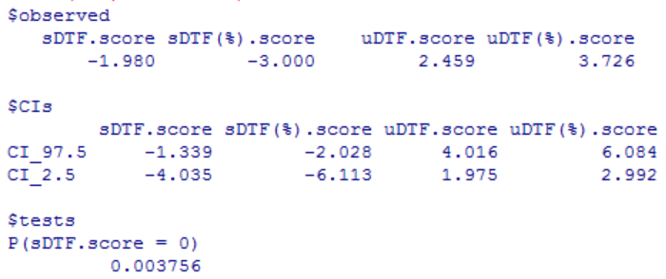
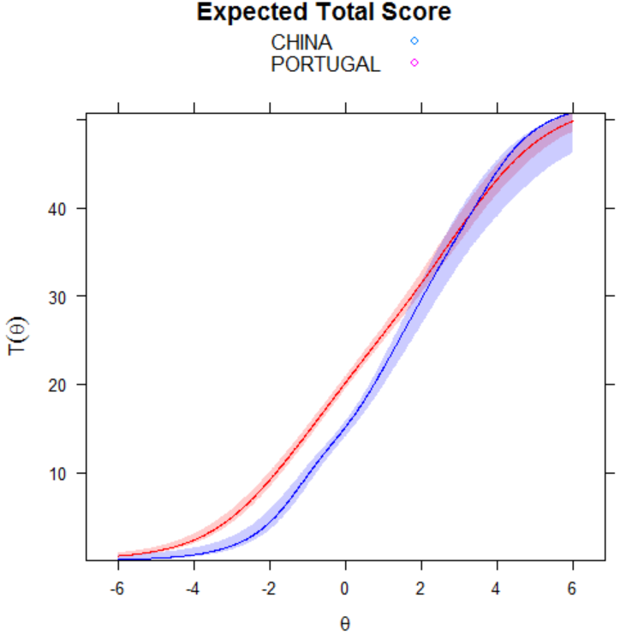

Samples: CHINA – SLOVAKIA
Self-uncompassionate responding
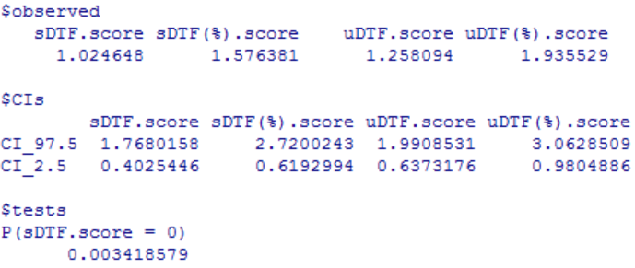
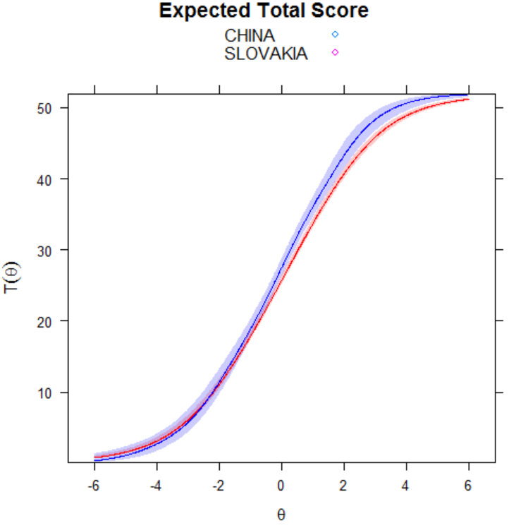

Samples: CHINA – SLOVAKIA
Self-compassionate responding
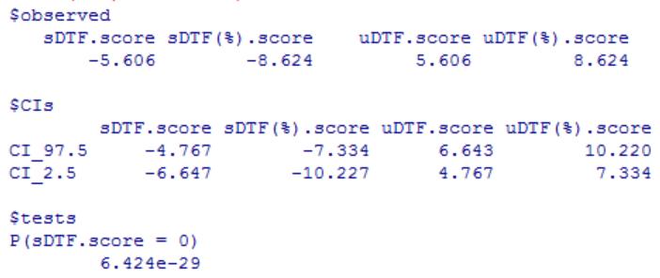
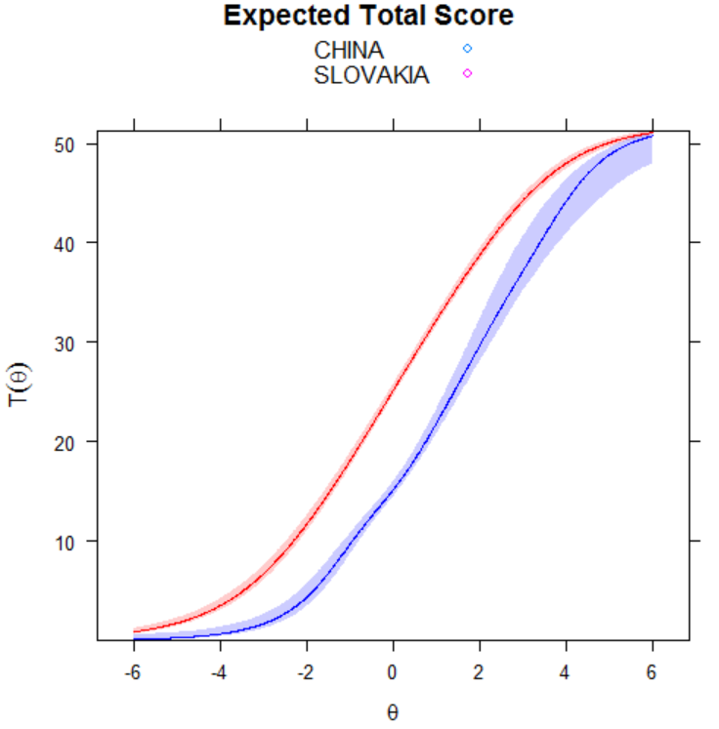

Samples: CHINA – TURKEY
Self-uncompassionate responding
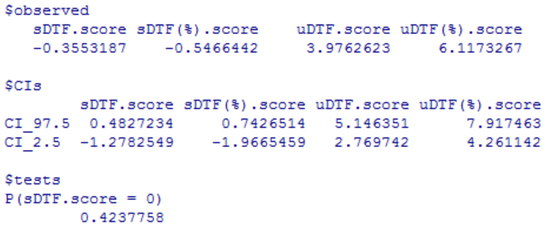
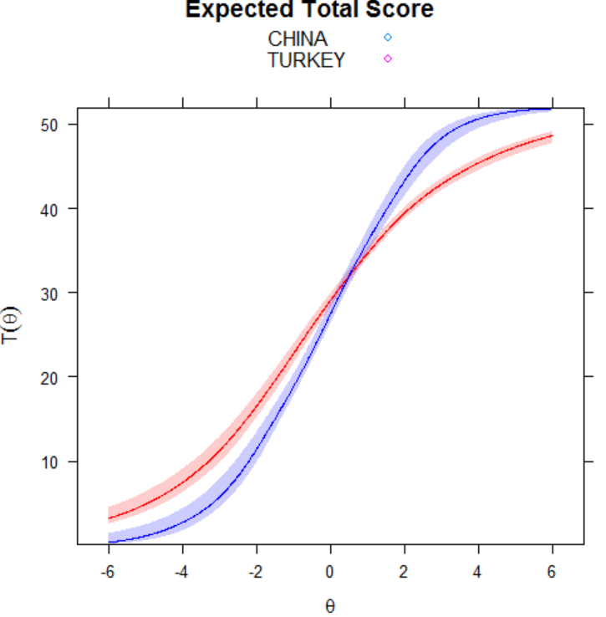

Samples: CHINA – TURKEY
Self-compassionate responding
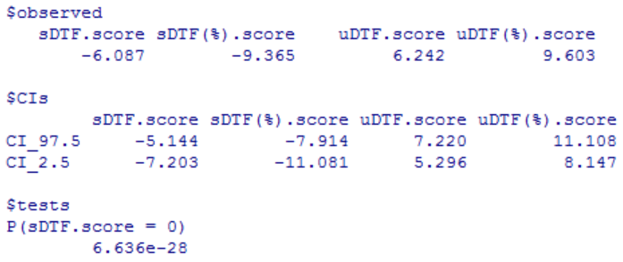
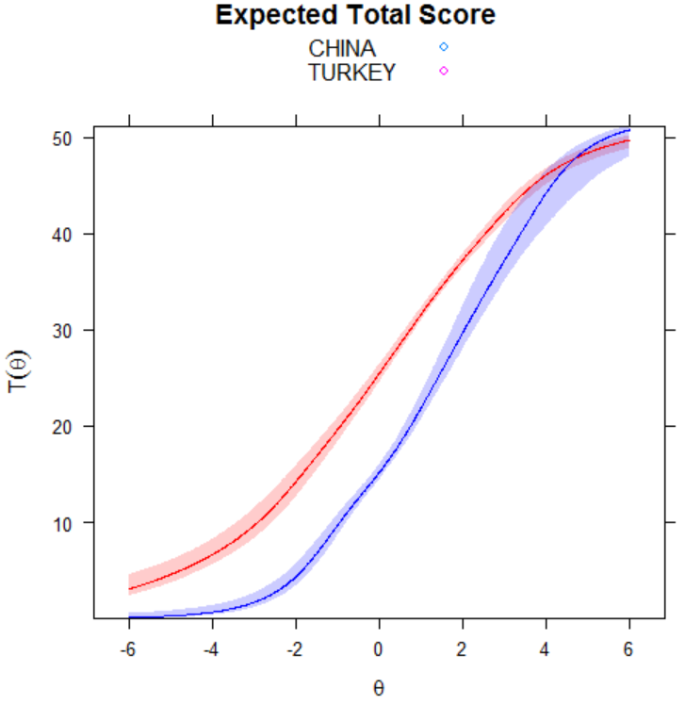

Samples: CHINA – USA
Self-uncompassionate responding
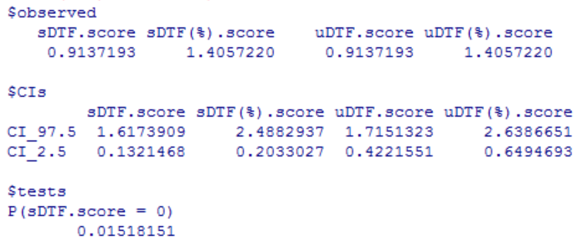
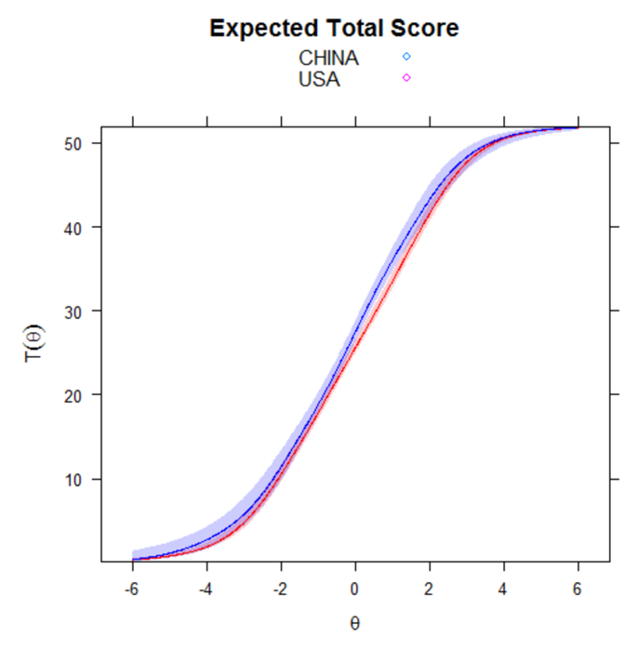

Samples: CHINA – USA
Self-compassionate responding
