Sleep texting: a systematic review

Mariano Indelicato , Vera Cantavenera² Daniela Cusimano² Patrizia Santagati²

¹ Università degli Studi di Messina; ² Pronto Soccorso Psicologico Italia

Background: Nowadays, more and more young people are affected by a worrying new syndrome called sleep-texting. This term refers to the use of a cell phone to send text messages while asleep. This almost automatic behavior of responding to "text messages" during the night interrupts sleep and, in the long term, causes considerable damage to health, especially of adolescents. In this work, through a systematic qualitative analysis, we wanted to probe a precise scientific definition of the phenomenon.
Method: To this end, 18 articles were selected through a search on the Scopus database and reviewed with the analysis of Rodgers' evolutionary concept (Rodgers, 2000 - 2018) integrating it with the integrative review methodology which involves the inclusion of both theoretical and empirical sources or qualitative and quantitative data (Whittemore and Knafl, 2005).
Results: The attributes of the concept within the various studies and various research are sleep disorders; physical symptoms; mental health and school results.
Conclusion: The studies and research analyzed all focused on the effects, but do not entirely explain the phenomenon, leaving a series of open questions. The hope is that future research can clarify whether sleep texting is a parasomnia or simply an incorrect behavior, such as the excessive use of new technologies.

Keywords: sleep disorders; Parasonnias; night text messages; sleep quality; massive use of technologies.
___________________________________________________________________________________________________________
* Corresponding author:
E-mail address: mindelicato@unime.it
doi https://10.13129/3035-1383/asmc-5057

© 2024 by the Author(s); licensee Journal Addiction & Social Media Communications, Messina, Italy.
This article is an open access article, licensed under a Creative Commons Attribution 3.0 Unported License.

Introduction

Starting from the second decade of the 2000s, with the advent of the massive use of smartphones that make it possible to send messages every moment, even unconsciously during sleep, scholars have coined a new term capable of describing the "Sleep Texting" phenomenon. Advent and its development are linked to the proliferation of mobile telecommunication devices in recent years, in particular among teenagers and young adults (Lenhart et al., 2010). As reported by Murdock (2013), according to a Pew Internet Project report, in 2010, 96% of university students owned a cell phone compared to 82% of adults (Smith, Rainie & Zickuhr, 2011). In an extensive multi-institutional study, 62% of university students approved possession of a smartphone in 2012, with an increase of 7% compared to 2011 and an increase of 5545% compared to 2004 (Dahlström, 2012). University students use text messaging more than any other form of mobile telecommunication and consider it an essential aspect of their social life (Skierkowski & Wood, 2012). Smith (2011) highlighted that in 2011 the owners of cell phones aged between 18 and 24 years of age reported an average of 109.5 text messages on a typical day and Duggan & Rainie (2012) notes that among 18 -year -old adults and more, the percentage of owners of cell phones that used the device to send text messages has increased from 50% in 2007 to 80% in 2012.
Over time, it has become increasingly common to send and respond to messages, even during sleep, keeping connected. Sleep-texting refers to the use of a mobile phone to send text messages while asleep. Some messages are often sent in response to a text notice coming; This happens most of the time, when for example sleep with the phone in bed, or even on the bedside table, in this way access is facilitated and the "incorrect" behavior is almost automatic the acoustic signal or the hum of the mobile phone that indicates the arrival of a wake -up call who sleeps, who instinctively approaches and responds to the message. This action can occur one or more times during the sleep cycle, negatively influencing the quality and duration of sleep (Dowdell & Clayton, 2018). This trend has also been observed among teenagers; Lenhart (2012) reported that the average number of daily text messages from children aged between 14 and 17 increased from 60 in 2009 to 100 in 2011.
Some research had already evaluated the time and frequency of the use of the mobile phone in bed, especially before falling asleep. Exelmans & Van Den Bulck (2016) investigated the association between the use of the cell phone in bed before sleeping and the characteristics of sleep in adults.
The results to which they came, after checking demographic variables and lifestyles, are that:

a) The use of the mobile phone in bed is associated with delays in the falling time.
b) The greater the time spent with the phone before sleeping, the worse the quality of the perceived sleep.
c) The frequent use of the mobile phone in bed is related to greater difficulty falling asleep and shorter sleep.
Levenson et al. (2016), in a study with young people between 19 and 30 years of age, examined the relationship between the use of social media and sleep disorders, identifying a strong correlation between the intense use of the former and the alteration of the rhythms of the latter. As demonstrated by several studies, sleep is essential for the growth and physical development of adolescents, as well as for socio-emotional development and well-being (Sivertsen, Glozier et al., 2015; Perkinson-Gloor, Lemola and Grob, 2013; Sivertsen, Harvey and Lundervold, 2014; Dewald, 2010). In the United States, the National Sleep Foundation (NSF) (2016) recommends from 8 to 10 hours of night sleep for teenagers. The use of the smartphone also at night involves insomnia and sleep disorders. It is no coincidence that Sleep Texting is considered a non-REM parasomnia of sleep, such as night terror, Pavor Nocturnus, and sleepwalking and confusion.
Furthermore, it also shows similarities with sleeping cars because the incidental responses of "text messages" in sleep are generally answers to messages received in the immediate, rather than a

message sent above. Most of the time, that bell or the sound of a new "text message" that draws our attention during the vigil "disturbs us," even during sleep, and so automatically we find ourselves grabbing the phone and typing an answer. Unfortunately, during sleep, our responses are not as sharp as during the day. We can still recognize the text and coordinate a response by manipulating the phone, but we may make errors, send short messages, or even incomprehensible messages. The "text message" sent would therefore be disconnected from reality, just like speaking in sleep.
In addition to influencing the excessive use of smartphones and social media on sleep, including text messages as in the case of the Sleep Texting, it also affects mental health (Oshima et al., 2012 - Lin et al., 2016 - Twenge et al., 2017 - Keles, McCrae & Grealish, 2020).
In particular, Keles, McCrae & Grealish (2020) in a systematic revision in which 18 quantitative studies conducted between 2014 and 2019 were analyzed, they note that:
a) Most of the studies showed a significant association between the intensive use of social media and increased levels of depression and anxiety in teenagers;
b) excessive use of social media is related to a greater risk of depressive symptoms, anxious, and general psychological distress;
c) Some studies suggest that the type of use (for example, passive use or negative social comparison) can moderate the negative impact;
d) The use of social media can also negatively influence self-esteem and emotional well-being, accentuating the symptoms of psychological distress;
e) On the contrary, some studies indicate that moderate and active use can have neutral or even positive effects, for example, by promoting social support.
In addition, even in the absence of evident disorders, sending text messages produces changes in physiological parameters such as excitement, heart rate, breathing, skin conductance, and muscle tension (Lin & Peper, 2009). These changes do not promote relaxation and, consequently, sleep both short and medium-term.
From these premises, we wanted to carry out this review to analyze whether sleep texting is a parasomnia or simply an addiction linked to the massive use of new technological tools. To do this, the context and attributes of the concept will be analyzed through the scientific literature produced around this topic.

Method

The review was conducted using the analysis of the evolutionary concept of Rodgers (Rodgers, 2000 - 2018) by integrating it with the supplementary revision methodology, which provides for the insertion of both theoretical and empirical sources or of qualitative and quantitative data (WhitteMore and Knafl, 2005). The method was chosen because it aims to clarify the current use of a concept by identifying its attributes, based on the assumption that the meaning and use of a concept are influenced by time and context.
The search was conducted on Scopus using the keyword "Sleep Texting." This keyword found 63 articles, to which the following inclusion/exclusion criteria were applied, following the PRISMA 2020 guidelines (Table 1):

1. Psychology field
2. No time limit
3. Articles in English

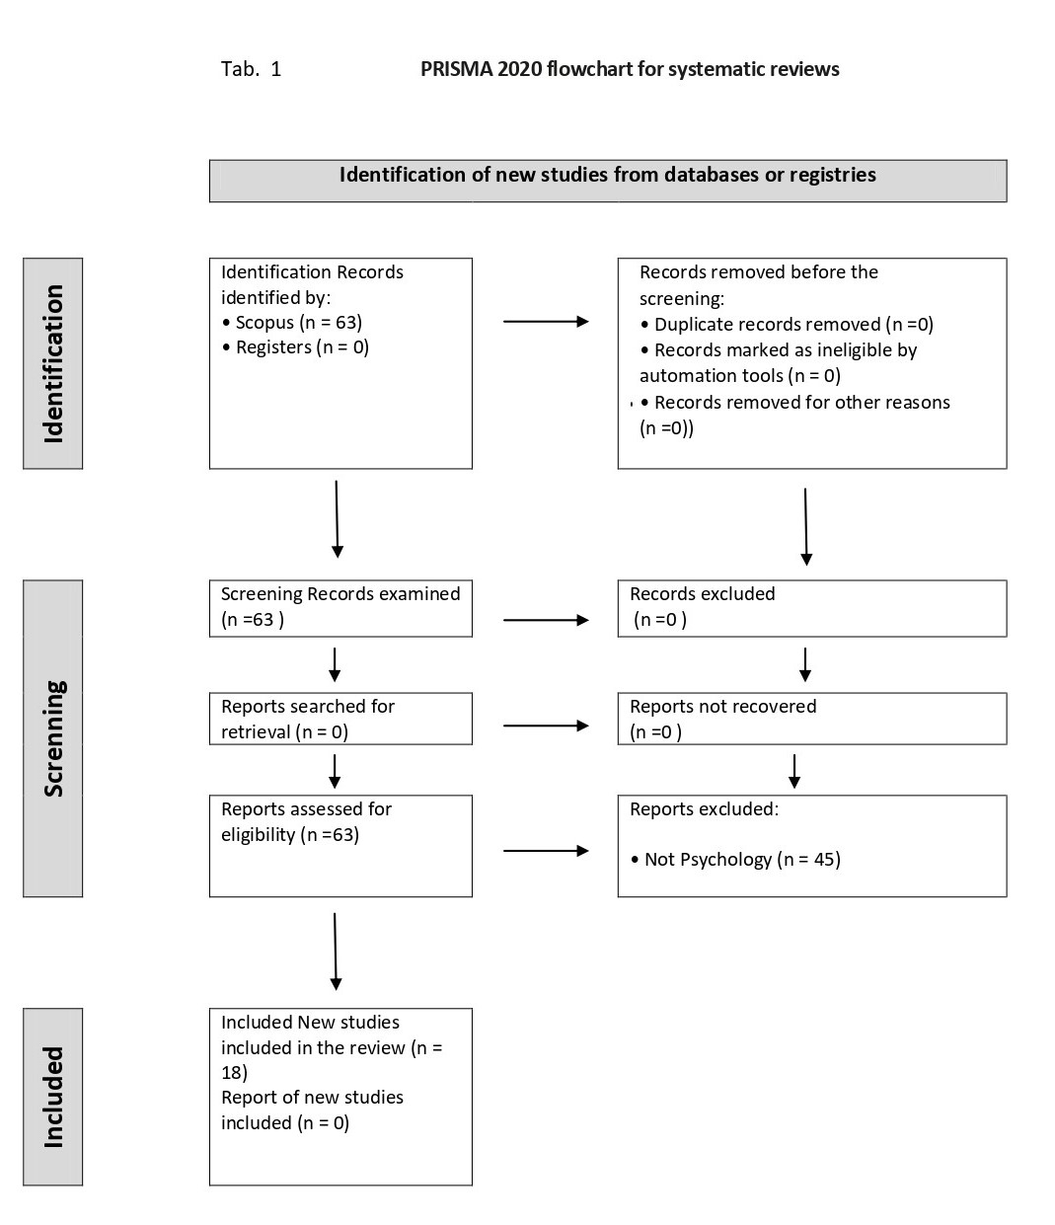

Results
The descriptive information relating to the 18 articles included in the thematic analysis is presented in Table 2.
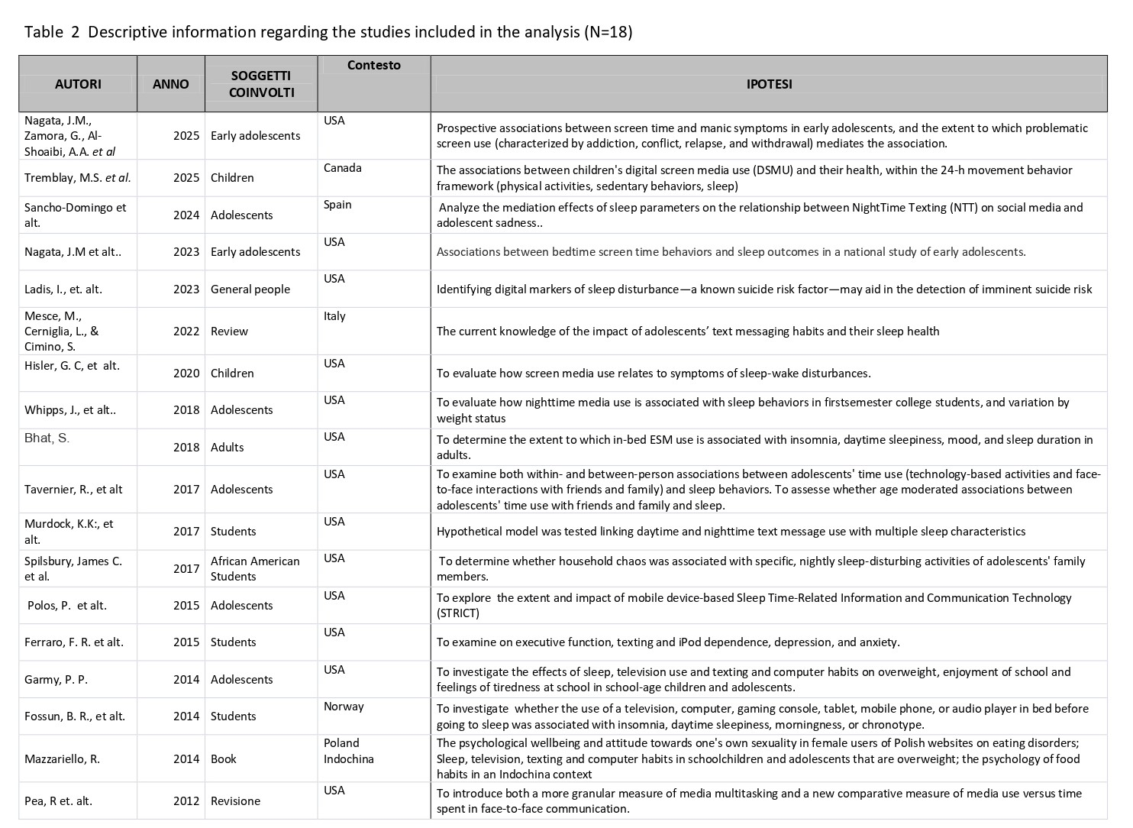

The research has primarily been carried out in the United States of America, with the population mainly consisting of teenagers and students, except for one study (Bath et al., 2018) involving 855 hospital employees. The choice of the population is probably linked to statistical relationships (PEW Research Center (2022): report on the use of smartphones and social media in the USA; Istat (2023): data on the use of Internet and technologies in Italy which indicate that, in developed countries, over 90% of adolescents have a mobile phone and that on average they use it for about 3 - 4 hours a day for social media, the instant messaging, video (YouTube, Tiktok), Games and music. Twege (2019), analyzing the IGEN generation, reveals that the "super-concession" to which the natives were subjected from 1995 to 2012 influenced behaviors, values, mental health, and well-being. In particular, it highlights that the time spent online has increased at the expense of face-to-face interactions and that the massive use of smartphones and social media has radically changed how young people communicate and socialize. These new behavioral methods have had effects on mental health, with a significant increase in anxiety, depression, feelings of solitude, and a worsening of emotional well-being, and a reduction in happiness and satisfaction compared to previous generations. The attributes of the concept, as analyzed by the identified studies, are summarized in Tab. 3 and indicate the results to which the research has come.

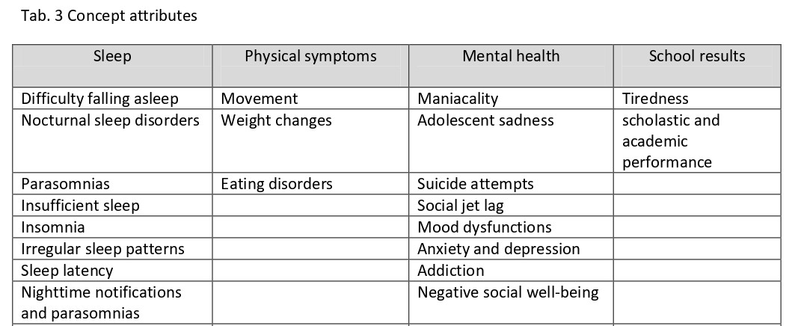

Sleep disorders are the most analyzed (Nagata et al., 2023 – Mesce et al., 2022 – Hisler et al., 2020 - Tavernier et al., 2017 - Murdock et. Al., 2016 - Spilsbury et al., 2017 - Ferraro et. Al, 2015 - Fossum et al. al., 2013). The importance attributed to sleep stems from its role as a fundamental physiological process, necessary for maintaining physical, mental, and cognitive health by influencing various biological, psychological, and neurocognitive aspects. Studies and research on sleep functions indicate that it affects:
a) on the physical restoration. Irwin (2015), in a systematic review, highlights that deep sleep influences the regulation of genes related to tissue regeneration and immune response. Besedovsky et al. (2012) showed that sleep promotes the production of cytokines (essential proteins for communication between immune cells) and antibodies, increasing the body's ability to combat infections and inflammations. In a previous study, Van Cauter et al. (1996) showed that the growing peak of the growth hormone (GH), which stimulates growth and cell repair, takes place mainly during the first hours of deep sleep (phase 3 NREM). Trinder et al. (2001) write that deep sleep promotes parasympathetic predominance, lowering the heart rate, blood pressure, and metabolism and, therefore, creating an environment in favor of cell repair.
b) on the consolidation of memory and learning. Walker & Stickgold (2006) claim that REM sleep facilitates brain reorganization to consolidate complex skills and integrate the emotions associated with memories. Diekelmann & Born (2010) report that during sleep, NREM takes place, the "replay" of the information learned, through synchronized brain oscillations that strengthen the synaptic connections involved in memory. Rasch & Born (2013) underline how sleep acts in a complementary way to support different types of memory.
c) on emotional and psychological regulation. Sleep deprivation increases the activity of the amygdala, a cerebral region involved in negative emotions as fear and anxiety and improves the ability to regulate stress and reduce vulnerability to depression and anxiety disorders (Goldstein & Walker, 2014; Yoo et al., 2007).
d) on the metabolic and energy function. Research in this field indicates that a lack of sleep alters insulin sensitivity, increasing the risk of type 2 diabetes. This, in turn, influences hunger hormones (Grelin and leptin), leading to greater appetite and potential weight gain.
From this, it follows that sleep contributes to the energy balance necessary for daily activities (Spiegel et al., 2004; Tasali & Van Cauter, 2006).
e) on the regulation of the nervous system. During sleep, decreasing brain electricity, synaptic plasticity is favored through which neuronal networks reorganize and, in this way, improve cognitive efficiency and learning capacity (Tononi & Cirelli, 2014).
f) on the function of cerebral detox. Xie et al. (2013) argue that during sleep, the cerebrospinal fluid flows more freely, removing metabolic waste such as beta-amyloid, which is involved in Alzheimer's.

This is why massive use, as happens in the Sleep Texting, of smartphones, computers, tablets, social media, etc. at night and the evening, influences the quantity and quality of sleep, involving disorders on circadian rhythms, which is reflected in physical, mental symptoms, and on school results.
Nagata et alt. (2025), examining the potential associations between time on the screen and maniacal symptoms in the first teenagers and the measure in which the problematic use of the screen (characterized by addiction, conflict, recurrence and retreat) the association, have found significant perspective relationships between time on the screen and maniacal symptoms in early adolescence and highlight the problematic use of the screen, the use of video games and the duration of the sleep potential mediators. Tremblay et. Alt. (2025), on the other hand, associated the use of digital media for children (DSMU) and their health, within 24-H movement behaviors (physical activities, sedentary behaviors, sleep). In the same way, Sancho-Domingo et al. Alt. (2024) found a high correlation between teenagers who commit to using night social media, including instant night messages, and experiencing a worse quality of sleep and increased adolescent sadness. On the same line, Ladis et al. (2023), in trying to identify the digital markers of sleep disorders, including instant night messaging, as suicide risk factors, have ascertained that the communication linked to sleep can differ according to the level of mood within the person. Whipps et al. (2018) have found that the use of night media is associated with sleep behavior in students and the variation of the state of weight. Bath et al. (2018) found that the use of social media during night hours is associated with sleep dysfunction and mood disorders in the adult population. Ferraro et alt. (2015), distinguishing based on the Sleep Quality of Pittsburgh's sleep (PSQI - Buysee, Reynolds, Monk, Berman and Kupfer, 1989) in "good" and "poor", they showed that the highest levels of depression, higher levels of state anxiety and trait, greater dependence on messages and dependence on iPod and more executive performance performance Low. GARMY (2014) and Mazzariello (2014) highlighted the role of the effects of sleep, television use, text messages, and computer habits on overweight, enjoyment of school, and feelings of tiredness at school in school-age children and adolescents. Pea et. Alt. (2012) examined the relationships between social well-being and the media use of girls, including video games, music, reading, e-mails/places on social media, text messages/instant messages, and phones.
Moreover, the phenomenon of sleep texting is part of an "ultra-technological" society. In this technology, —at all levels—has become the instrument upon which most of daily life rests and flows. We are constantly connected to the point that the real world and the virtual world merge, almost becoming one. Moreover, in this oneness, where the boundaries between what is real and what is not are blurred, relationships, emotions, and complex psychological dynamics merge and blur. It is undeniable that the internet, and social media in particular, have changed our lives, allowing us unprecedented connectivity. In the so-called more-personal computer era, the internet is everywhere, and the increasingly faster and easier creation of media means we live and share on social media simultaneously. The internet and social media enable us to stay in constant touch with friends, meet new people from around the world, and keep updated on current events.
They also facilitate our interactions with others, making us more relaxed. They are potent tools, yes, but not yet as powerful as a look, a gesture, or an authentic connection. Furthermore, social media often offers us a distorted view of reality—one might say, a perfected one. (From the web, 2019).
Technology has become so attractive that we cannot do without it, even at night. We should, however, ask ourselves whether "this attraction is nothing more than the expression of an existential and interpersonal unease in the real world" (Galgani, 2014).
Digital natives are increasingly uneasy about genuine, face-to-face relationships, preferring virtual ones instead. Moreover, while the phenomenon is affecting young people more, adults are also affected (May, 2013). Young people prefer "texting rather than talking people are becoming less and less comfortable with interpersonal relationships, preferring brief exchanges to real conversations, and are increasingly intent on doing less than others" (Turkle, 2012).

"The fear of loneliness makes us settle for pseudo-loves, pseudo-acquaintances, pseudo-experiences" (Lo Iacono, 2003). "As trust in technology grows, trust in ourselves and others diminishes, to the point that we become increasingly isolated and alone, to the point of replacing the company of humans with that of sociable robots" (Turkle, 2012).
In this phobia of solitude, many studies and research, as mentioned above, assert that the boundary between wakefulness and sleep is blurring; it's becoming normal to send messages while sleeping and then wake up with a ping to respond. Sleep-texting has become a growing phenomenon among adolescents and young adults, as they overuse it and, to be part of a group, bring their cell phones to bed and chat late into the night, unknowingly, until they fall asleep with their smartphone in hand.
This incorrect behavior leads most to respond almost automatically to incoming messages; in fact, most young people interviewed in an American study reported that they couldn't remember anything. The study, conducted in America, involved 372 students, analyzed by experts at Villanova University. The study, published in the Journal of American College Health, found that this dangerous tendency is mainly due to the habit of sleeping with their cell phones next to the bed. A quarter of the students who participated in the survey (25.6%) reported sending text messages while sleeping.
In comparison, the majority (72%) said they did so but could not remember it upon waking (Dowdell & Clayton, 2018). The researchers revealed that the lack of memory is not surprising, as their sleep study found that people who wake up after sleeping for more than a few minutes are unable to recall the minutes before falling asleep.
In fact, for many, sleep-texting is a source of embarrassment, as well as disrupting the quality of sleep. Sleep deprivation affects performance during the day and can cause emotional imbalance, decreased concentration, and fatigue.

Conclusions

The attributes of the concept of Sleep Texting, as highlighted by the research shown above, highlight that it is a relatively new behavior, and there are no valid studies that provide clear explanations for the circumstances under which a person could send messages while they sleep.
The research and studies analyzed focus on the effects of using new multimedia tools on sleep and, consequently, on individual well-being. They don't answer some questions: during sleep, could there be an overlap with the vigil? Could someone sleeping be partially woken by the arrival warnings, grab the phone, and send a message without full awareness? Is it possible that some people could be completely awake while sending text messages and not remember when they wake up? What, however, the research highlights is that this probable new syndrome is mainly due to the use, or better to say, the abuse of technology, and that this attitude has a significant impact on sleep. Whether you wake up due to Sleep-Texting or are awakened by a simple warning on your mobile phone, sleep is stopped, compromising its quality with the consequences previously described.
The hope is that future research will address the unanswered questions about whether Sleep Texting is a parasomnia or merely an incorrect behavior, given the widespread use of new technologies.

Limitations
The review was designed to determine whether journalistic use of the term "sleep texting" is supported by scientific literature. The results demonstrate that the phenomenon has not yet been the subject of scientific research and, therefore, requires further investigation.

Declaration of Conflicting Interests
None of the authors has any conflicts of interest regarding the work performed.
Funding
The authors received no funding for their research or for the publication of this article.

References

- Besedovsky, L., Lange, T., & Born, J. (2012). “Sleep and immune function.” Pflugers Archiv - European Journal of Physiology, 463(1), 121–137. DOI: 10.1007/s00424-011-1044-0

- Bhat, S., Pinto-Zipp, G., Upadhyay, H., & Polos, P. G. (2018). “To sleep, perchance to tweet”: in-bed electronic social media use and its associations with insomnia, daytime sleepiness, mood, and sleep duration in adults. Sleep Health, 4(2), 166-173.

- Buysse, D. J., Reynolds III, C. F., Monk, T. H., Berman, S. R., & Kupfer, D. J. (1989). The Pittsburgh Sleep Quality Index: a new instrument for psychiatric practice and research. Psychiatry research, 28(2), 193-213.

- Dahlstrom, E. (2012). ECAR Study of Undergraduate Students and Information Technology, 2012. Retrieved from http://net.educause.edu/ir/library/pdf/ ERS1208/ERS1208.pdf

- Dewald JF, Meijer AM, Oort FJ, Kerkhof GA, Bögels SM. (2010). The influence of sleep quality, sleep duration and sleepiness on school performance in children and adolescents: A meta-analytic review. Sleep Med Rev. 14(3):179-89. doi: 10.1016/j.smrv.2009.10.004

- Diekelmann, S., & Born, J. (2010). “The memory function of sleep.” Nature Reviews Neuroscience, 11(2), 114–126.DOI: 10.1038/nrn2762

- Dowdell, E. B. & Clayton, B. Q. (2018): Interrupted sleep: College students sleeping with technology, Journal of American College Health, DOI: 10.1080/07448481.2018.1499655

- Duggan, M., & Rainie, L. (2012). A Pew Internet & American Life Project Report. Retrieved from http://pewinternet.org/Reports/2012/Cell-Activities/ Main-Findings.aspx. Retrieved May 30, 2013

- Exelmans, L., & Van den Bulck, J. (2016). Bedtime mobile phone use and sleep in adults. Social Science & Medicine, 148, 93-101.

- Ferraro, F. R., Holfeld, B., Frankl, S., Frye, N., & Halvorson, N. (2015). Texting/iPod dependence, executive function and sleep quality in college students. Computers in Human Behavior, 49, 44-49.

- Ferraro, F. R., Holfeld, B., Frankl, S., Frye, N., & Halvorson, N. (2015). Texting/iPod dependence, executive function and sleep quality in college students. Computers in Human Behavior, 49, 44-49.

- Fossum, I. N., Nordnes, L. T., Storemark, S. S., Bjorvatn, B., & Pallesen, S. (2013). The Association Between Use of Electronic Media in Bed Before Going to Sleep and Insomnia Symptoms, Daytime Sleepiness, Morningness, and Chronotype. Behavioral Sleep Medicine, 12 (5), 343–357. https://doi.org/10.1080/15402002.2013.819468

- Galgani, F., 2014. “Solitudine e Contesti virtuali”. URL http://www.galgani.it/solitudine-internet/

- Garmy, P. (2014). Sleep, television, texting and computer habits and overweightness in schoolchildren and adolescents.

- Goldstein, A. N., & Walker, M. P. (2014). “The role of sleep in emotional brain function.” Annual Review of Clinical Psychology, 10, 679–708. DOI: 10.1146/annurev-clinpsy-032813-153716

- Hisler, G. C., Hasler, B. P., Franzen, P. L., Clark, D. B., & Twenge, J. M. (2020). Screen media use and sleep disturbance symptom severity in children. Sleep Health, 6(6), 731-742.

- Irwin, M. R. (2015). “Sleep and inflammation: partners in sickness and in health.” Nature Reviews Immunology, 15(11), 652–660. DOI: 10.1038/nri3843

- ISTAT (2023): dati sull’uso di internet e tecnologie in Italia.

- Jason M. Nagata, Gurbinder Singh, Joanne H. Yang, Natalia Smith, Orsolya Kiss, Kyle T. Ganson, Alexander Testa, Dylan B. Jackson, Fiona C. Baker, Bedtime screen use behaviors and sleep outcomes: Findings from the Adolescent Brain Cognitive Development (ABCD) Study, Sleep Health, Volume 9, Issue 4, 2023, Pages 497-502, ISSN 2352-7218, https://doi.org/10.1016/j.sleh.2023.02.005

- Keles, B., McCrae, N., & Grealish, A. (2020), A systematic review: The influence of social media on depression, anxiety and psychological distress in adolescents. Journal of Affective Disorders, 275, 101-109.

- Ladis, I., Valladares, T. L., Coppersmith, D. D. L., Glenn, J. J., Nobles, A. L., Barnes, L. E., & Teachman, B. A. (2023). Inferring sleep disturbance from text messages of suicide attempt survivors: A pilot study. Suicide and Life-Threatening Behavior, 53, 39–53. https://doi.org/10.1111/sltb.12920

- Lenhart, A., Ling, R., Campbell, S., & Purcell, K. (2010). Teens and mobile phones. A Pew Internet & American Life Project Report. Retrieved from http://pewinternet.org/Reports/2010/Teens-andMobile-Phones.aspx

- Levenson, J. C., Shensa, A., Sidani, J. E., Colditz, J. B., & Primack, B. A. (2016). The association between social media use and sleep disturbance among young adults. Preventive Medicine, 85, 36-41.

- Lin, I. M., & Peper, E. (2009). Psychophysiological patterns during cell phone text messaging: A preliminary study. Applied Psychophysiology and Biofeedback, 34, 53–57. doi:10.1007/s10484-009- 9078-1

- Lin, L. Y., Sidani, J. E., Shensa, A., Radovic, A., Miller, E., Colditz, J. B., ... & Primack, B. A. (2016), Association between social media use and depression among U.S. young adults. Depression and Anxiety, 33(4), 323-331.

- Lo Iacono, A., (2003) “Psicologia della solitudine”. Editori riuniti, 2003. ISBN 9788835952732. URL http://books.google.it/books?id=NCTpAAACAAJ.

- Mazzariello, R., & Mazzariello, R. (2014). Psychology of habits. Nova Publishers.

- May, C., (2013), Always Connected: dopo la generazione X e i nativi digitali della generazione Y, ecco la generazione URL http://thebizloft.com/always-connected-generazione-c.

- Mesce, M., Cerniglia, L., & Cimino, S. (2022). Do text messages impact adolescents’ sleep? A Narrative Review. Psychology Hub, 39(3), 7–16. https://doi.org/10.13133/2724-2943/17728

- Murdock, K. K., (2013), Texting While Stressed: Implications for Students’ Burnout, Sleep, and Well-Being, Psychology of Popular Media Culture © American Psychological Association 2013, Vol. 2, No. 4, 207–221, DOI: 10.1037/ppm0000012

- Murdock, K. K., Horissian, M., & Crichlow-Ball, C. (2016). Emerging Adults’ Text Message Use and Sleep Characteristics: A Multimethod, Naturalistic Study. Behavioral Sleep Medicine, 15(3), 228–241. https://doi.org/10.1080/15402002.2015.1120203

- Nagata, J.M., Zamora, G., Al-Shoaibi, A.A. et al. Screen time and manic symptoms in early adolescents: prospective findings from the Adolescent Brain Cognitive Development Study. Soc Psychiatry Psychiatr Epidemiol 60, 1479–1487 (2025). https://doi.org/10.1007/s00127-025-02814-6

- Oshima, N., Nishida, A., Shimodera, S., Tochigi, M., Ando, S., Yamasaki, S., Okazaki, Y., & Sasaki, T. (2012). The suicidal feelings, self-injury, and mobile phone use after lights out in adolescents. Journal of Pediatric Psychology, 37, 1023–1030. doi: 10.1093/jpepsy/jss072

- Pea, R., Nass, C., Meheula, L., Rance, M., Kumar, A., Bamford, H., Nass, M., Simha, A., Stillerman, B., Yang, S., & Zhou, M. (2012). Media use, face-to-face communication, media multitasking, and social well-being among 8- to 12-year-old girls. Developmental Psychology, 48(2), 327–336. https://doi.org/10.1037/a0027030

- Perkinson-Gloor, N., Lemola, S., & Grob, A. (2013). Sleep duration, positive attitude toward life, and academic achievement: The role of daytime tiredness, behavioral persistence, and school start times. Journal of Adolescence, 36, 311–318. doi:10.1016/j.adolescence.2012.11.008

- Pew Research Center (2022): report sull’uso degli smartphone e social media negli USA

- Rasch, B., & Born, J. (2013). “About sleep’s role in memory.” Physiological Reviews, 93(2), 681–766.
DOI: 10.1152/physrev.00032.2012

- Rodgers, B. L. (2000). Concept analysis. An evolutionary view, chapter 6. In B. L. Rodgers, & K. A. Knaf (Eds.), Concept development in nursing: Foundation techniques, and applications (2nd ed., pp. 77–102). Philadelphia: W-B Saunders Company

- Sancho-Domingo, C., Garmy, P., & Norell, A. (2024). Nighttime Texting on Social Media, Sleep Parameters, and Adolescent Sadness: A Mediation Analysis. Behavioral Sleep Medicine, 22(4), 488–498. https://doi.org/10.1080/15402002.2024.2314281

- Sivertsen B, Glozier N, Harvey AG, Hysing M. (2015). Academic performance in adolescents with delayed sleep phase. Sleep Med. 16(9):1084-90. doi: 10.1016/j.sleep.2015.04.011.

- Sivertsen B, Harvey AG, Lundervold AJ, Hysing M. (2014). Sleep problems and depression in adolescence: results from a large population-based study of Norwegian adolescents aged 16-18 years. Eur Child Adolesc Psychiatry. 23(8):681-9. doi: 10.1007/s00787-013-0502-y.

- Skierkowski, D., & Wood, R. M. (2012). To text or not to text? The importance of text messaging among college-aged youth. Computers in Human Behavior, 28, 744 –756. doi:10.1016/j.chb.2011.11 .023

- Smith, A. (2011). Americans and text messaging. A Pew Internet & American Life Project Report. Retrieved from http://www.pewinternet.org/ Reports/2011/Cell-Phone-Texting-2011.aspx.

- Smith, A., Rainie, L., & Zickuhr, K. (2011). College students and technology. A Pew Internet & American Life Project Report. Retrieved from http:// www.pewinternet.org/Reports/2011/Collegestudents-and-technology.aspx

- Spiegel, K., Tasali, E., Penev, P., & Van Cauter, E. (2004). “Sleep and metabolic function.” PLoS Medicine, 1(3), e62.DOI: 10.1371/journal.pmed.0010062

- Spilsbury, J. C., Patel, S. R., Morris, N., Ehayaei, A., & Intille, S. S. (2017). Household chaos and sleep-disturbing behavior of family members: results of a pilot study of African American early adolescents. Sleep health, 3(2), 84-89.

- Tasali, E., & Van Cauter, E. (2006). “Sleep-disordered breathing and the current epidemic of obesity, diabetes, and metabolic syndrome.” Current Opinion in Endocrinology, Diabetes and Obesity, 13(3), 161–169.DOI: 10.1097/01.med.0000233755.19050.06

- Tavernier, R., Heissel, J. A., Sladek, M. R., Grant, K. E., & Adam, E. K. (2017). Adolescents' technology and face-to-face time use predict objective sleep outcomes. Sleep Health, 3(4), 276-283.

- Tononi, G., & Cirelli, C. (2014). “Sleep and the price of plasticity: from synaptic and cellular homeostasis to memory consolidation and integration.” Neuron, 81(1), 12–34. DOI: 10.1016/j.neuron.2013.12.025

- Tremblay, M.S. et al. (2025). Digital Screen Media Use, Movement Behaviors, and Child Health. In: Christakis, D.A., Hale, L. (eds) Handbook of Children and Screens. Springer, Cham. https://doi.org/10.1007/978-3-031-69362-5_10

- Trinder, J., Kleiman, J., Carrington, M., Smith, S., Breen, S., Tan, N., & Kim, Y. (2001). “Autonomic activity during human sleep as a function of time and sleep stage.” Journal of Sleep Research, 10(4), 253–264.DOI: 10.1046/j.1365-2869.2001.00253.x

- Turkle, S. (2012), Insieme ma soli. Perché ci aspettiamo sempre di più dalla tecnologia e sempre meno dagli altri. Codice, 2012. URL http://books.google.it/books?id=A2zRygAACAAJ.

- Twenge, J. M. (2019), iGen: Why Today’s Super-Connected Kids Are Growing Up Less Rebellious, More Tolerant, Less Happy, Atria Books

- Twenge, J. M., Joiner, T. E., Rogers, M. L., & Martin, G. N. (2017), Increases in depressive symptoms, suicide-related outcomes, and suicide rates among U.S. adolescents after 2010 and links to increased new media screen time. Clinical Psychological Science, 6(1), 3-17.

- Van Cauter, E., Plat, L., & Refetoff, S. (1996). “Alterations of circadian rhythmicity and sleep in the endocrine changes of aging.” Advances in Experimental Medicine and Biology, 403, 69–80. DOI: 10.1007/978-1-4899-0295-4_7

- Walker, M. P., & Stickgold, R. (2006). “Sleep, memory, and plasticity.” Annual Review of Psychology, 57, 139–166.DOI: 10.1146/annurev.psych.56.091103.070307

- Whipps, J., Byra, M., Gerow, K. G., Guseman, E. H., (2018), Evaluation of Nighttime Media Use and Sleep Patterns in First-semester College Students, American Journal of Health Behavior, Volume 42, Number 3, May 2018, pp. 47-55(9 ) DOI: https://doi.org/10.5993/AJHB.42.3.5

- Xie, L., Kang, H., Xu, Q., Chen, M. J., Liao, Y., Thiyagarajan, M., ... & Nedergaard, M. (2013). “Sleep drives metabolite clearance from the adult brain.” Science, 342(6156), 373–377. DOI: 10.1126/science.1241224

- Yoo, S. S., Hu, P. T., Gujar, N., Jolesz, F. A., & Walker, M. P. (2007). “A deficit in the ability to form new human memories without sleep.” Nature Neuroscience, 10(3), 385–392. DOI: 10.1038/nn1851

© 2024 by the Author(s); license Journal Addiction & Social Media Communications, Messina, Italy.
This article is an open access article, licensed under a Creative Commons Attribution 3.0 Unported License

